**Hands-on Labs - Day 2**

**Azure AI Agents**

**Overall Estimated Duration: 4 Hours**

**Overview**

This hands-on lab offers a comprehensive introduction to building AI agents using the Azure AI Agent Service SDK. You will begin by creating AI agents with the Azure AI Agent Service. Throughout the lab, you will explore techniques for agent collaboration, automation, and task execution. By the end of this experience, you will have hands-on expertise in designing, deploying, and managing AI agents to build intelligent, scalable, and efficient AI-driven applications.

**Objective**

By the end of this lab, you will be able to:

* **Set Up AI Project and Perform Chat Completion from VS Code:** This hands-on lab will guide you through setting up the environment for building AI Agents. You will begin by configuring an AI Project in Azure AI Foundry, deploying a Large Language Model (LLM) and embedding models. Next, you will connect Visual Studio Code to the AI Project and perform a chat completion call to validate the setup, ensuring seamless integration and functionality.
* **Build a Simple AI Agent:** In this hands-on lab, you will be introduced to AI Agents in Azure and learn how to build a simple AI Agent. You will create an agent that generates a bar chart comparing health benefit plans, leveraging AI capabilities to process data and visualize insights effectively.
* **Develop a Multi-Agent System:** In this hands-on exercise, you will build a multi-agent system where four AI Agents collaborate to generate reports on health plan documents. You will create a Search Agent to retrieve policy information from Azure AI Search, a Report Agent to generate detailed reports, a Validation Agent to ensure compliance with specified requirements, and an Orchestrator Agent to manage communication between all agents. This lab will provide practical experience in designing and coordinating AI agents for complex tasks.

**Prerequisites**

Participants should have:

* **Visual Studio Code (VS Code):** Proficiency in using Visual Studio Code for coding, debugging, and managing extensions for various programming languages and frameworks.
* **Development Skills:** Basic programming knowledge in Python or JavaScript, experience with APIs, SDKs, and working in Visual Studio Code.
* **Azure AI & Cloud Concepts:** Understanding of Azure AI Foundry, AI Agent development, deploying LLMs and embedding models, and working with Azure AI Search for vector-based retrieval.
* **AI & Data Processing:** Knowledge of prompt engineering, chat completion workflows, embedding models, retrieval-augmented generation (RAG), and content filtering techniques.
* **System Design & Multi-Agent Coordination:** Understanding AI agent architectures, designing retrieval, validation, and orchestration agents, and coordinating multi-agent interactions.

**Explanation of Components**

* **Azure AI Foundry:** A cloud-based platform for developing, deploying, and managing AI models. It allows users to configure AI projects, deploy Large Language Models (LLMs), and integrate embedding models to enhance AI applications.
* **Azure AI Hub**: A core component of Azure AI Foundry, is a top-level Azure resource that provides a central, secure, and collaborative environment for teams to build, manage, and deploy AI applications, offering access to various Azure AI services with a single setup.
* **Azure AI Search:** A vector-based search service that enables Retrieval-Augmented Generation (RAG) by indexing and retrieving relevant documents to improve AI-generated responses.
* **Azure AI Services**: A collection of cloud-based AI services that allow developers and data scientists to build intelligent applications, offering pre-built and customizable APIs and models for tasks like speech, vision, language, and knowledge
* **Azure Key Vault**: It is cloud service that securely stores and manages secrets, certificates, and cryptographic keys, allowing authorized users and applications to access them while enhancing security and reducing data breach risks.
* **LLMs and Embeddings:** Understanding Large Language Models (LLMs), their capabilities, and how embeddings are used for text similarity, search, and knowledge retrieval in AI applications.

**xercise 1: Setup AI Project and perform Chat Completion from VS Code**

**Estimated duration : 120 minutes**

**Lab scenario**

In this hands-on lab, you will set up the necessary environment for building AI Agents. You will begin by configuring an AI Project in Azure AI Foundry, followed by deploying a Large Language Model (LLM) and embedding models. Next, you will establish connectivity from Visual Studio Code to the AI Project. Finally, you will perform a simple chat completion call to validate the setup.

**Lab Objectives**

In this lab, you will perform:

* Task 1: Setting up the AI Project in the Azure AI Foundry
* Task 2: Deploying an LLM and embedding models
* Task 3: Install dependencies, create a virtual environment, and create an environment variables file

**Task 1: Setting up the AI Project in the Azure AI Foundry**

In this task, you will create and configure an AI Project within Azure AI Foundry. This involves setting up the necessary resources, defining project parameters, and ensuring that the environment is ready for deploying AI models. By the end of this task, you will have a fully initialized AI Project, serving as the foundation for further development and experimentation.

1. On the Azure Portal page, in the Search resources box at the top of the portal, enter Azure AI Foundry (1), and then select Azure AI Foundry (2) under Services.

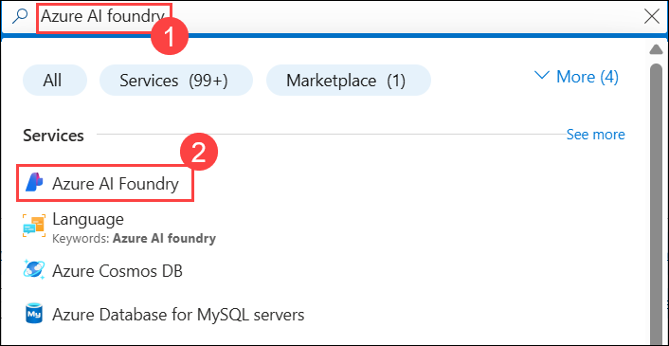

1. In the left navigation pane for the AI Foundry, select **AI Hubs (1)**. On the AI Hubs page, click on **Create (2)** and select **Hub (3)** from the drop-down.

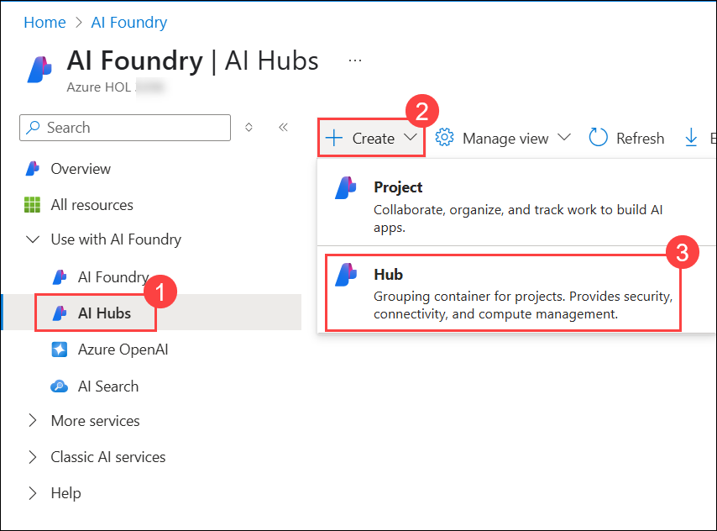

1. On the **Create an Azure AI hub** pane enter the following details:
   * Subscription : **Leave default subscription**
   * Resource Group : **AgenticAI** (1)
   * Region : **westus** (2)
   * Name : **ai-foundry-hub-1746165** (3)

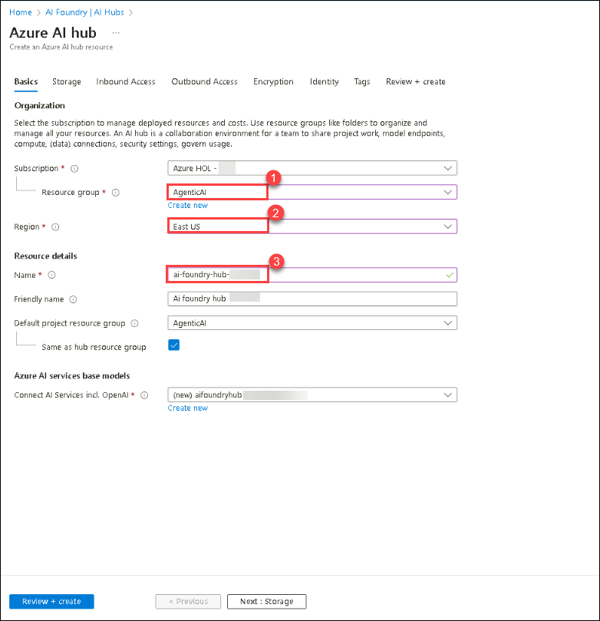

* + Connect AI Services incl. OpenAI : Click on **Create New (1)**.
  + Connect AI Services incl. OpenAI : Provide a name **my-ai-service-1746165 (2)**.
  + Click on **Save (3)**, followed by **Next:Storage (4)**

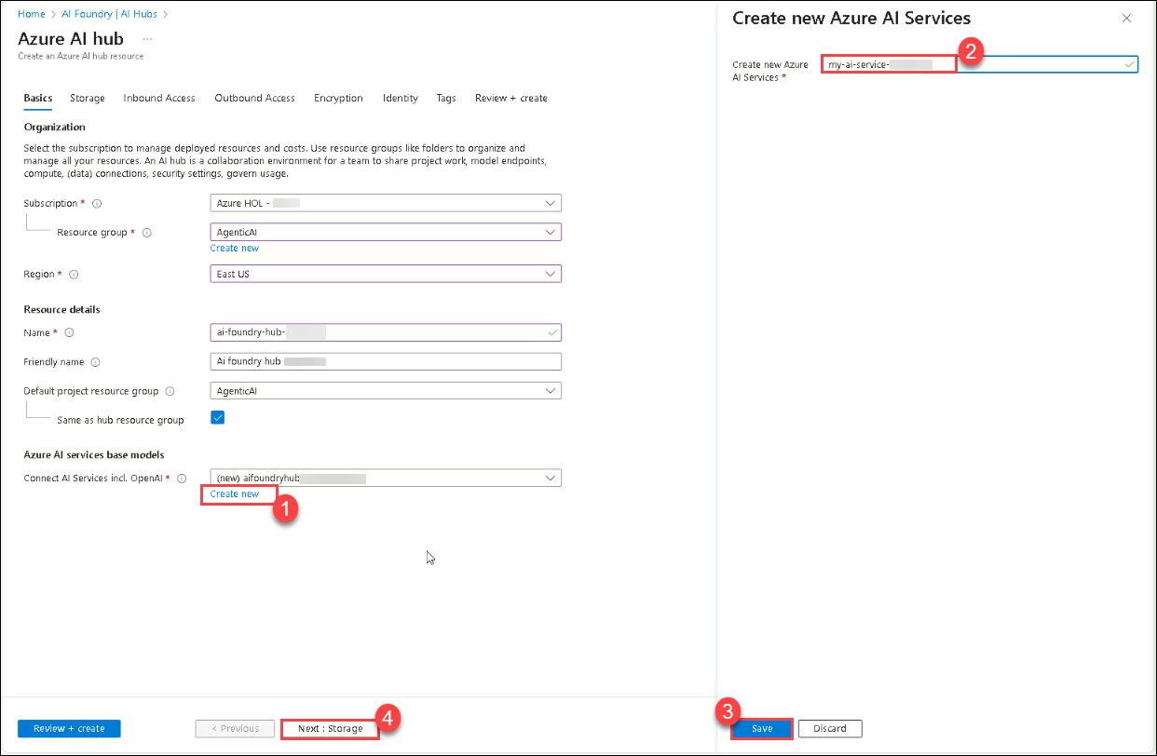

1. Click on **Review + Create** tab followed by **Create.**

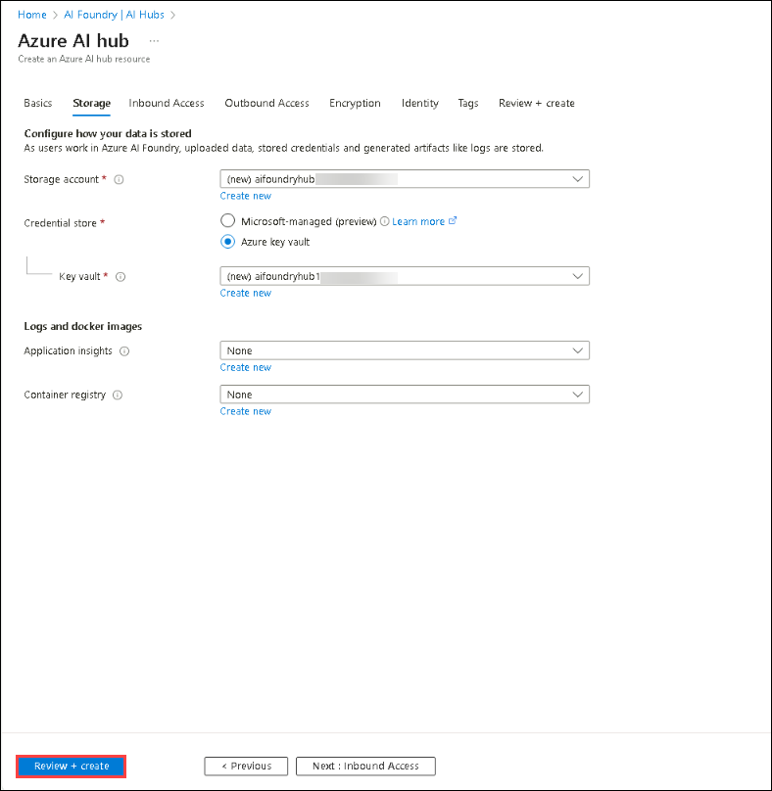

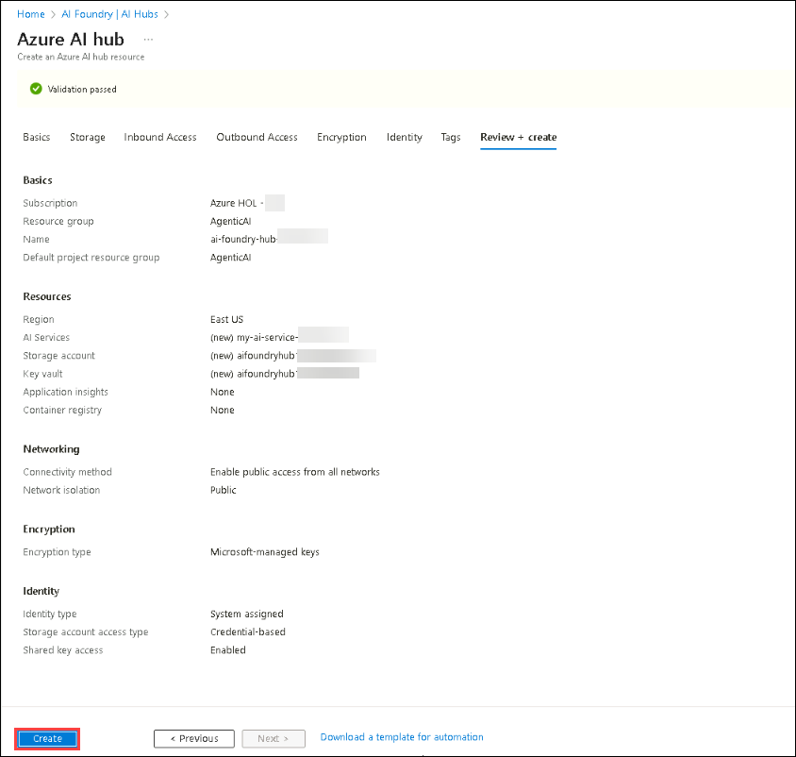

1. Wait for the deployment is completed and then click on **Go to resource**.

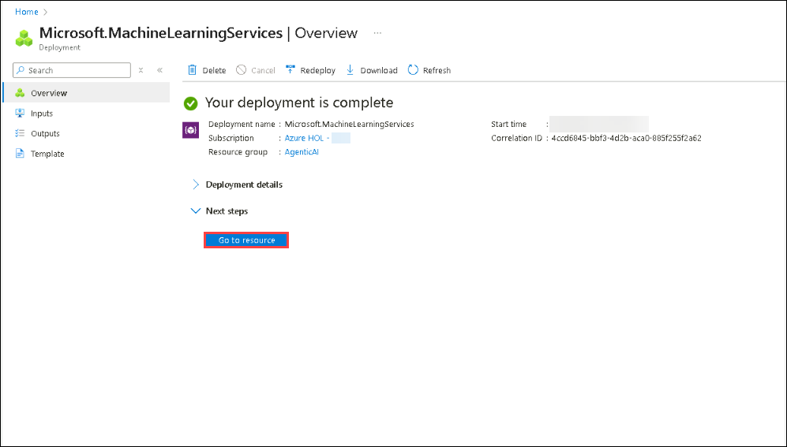

1. On the Overview pane, click on **Launch Azure AI Foundry**. This will navigate you to the Azure AI Foundry portal..

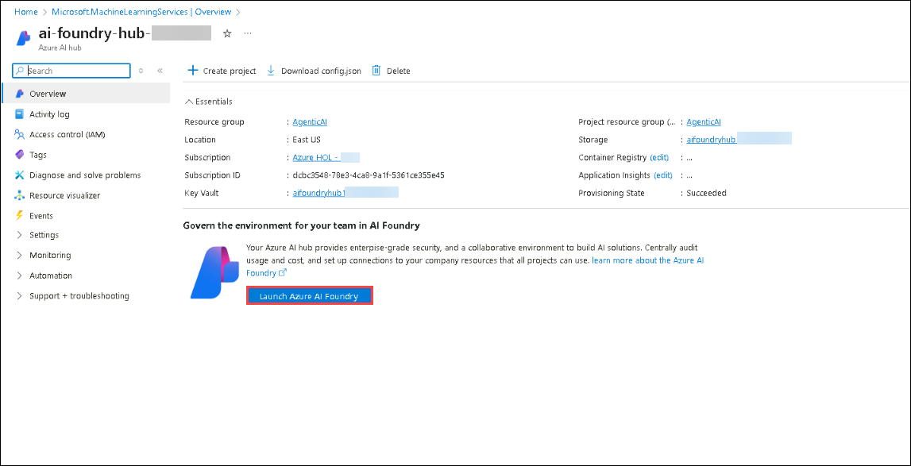

1. Scroll down and click on **+ New project** on the Hub Overview.

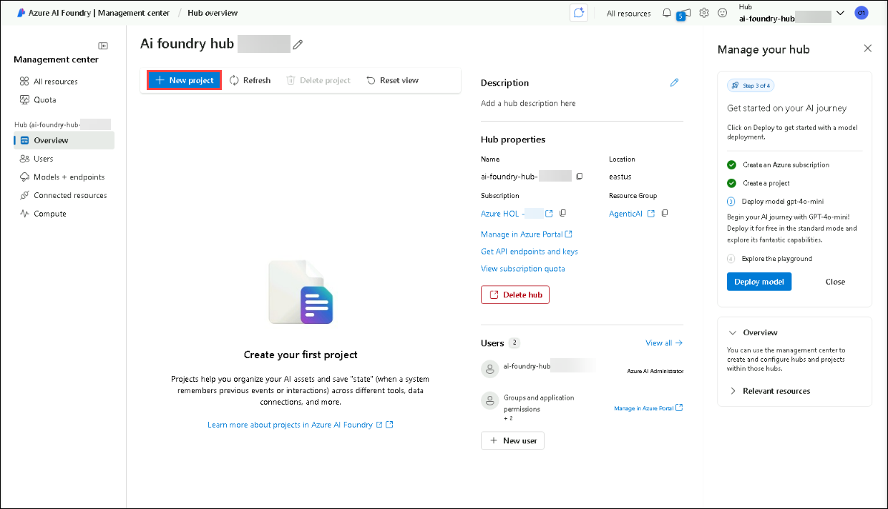

1. Provide the project name as **ai-foundry-project-1746165 ,** then click on **Create (2)**.

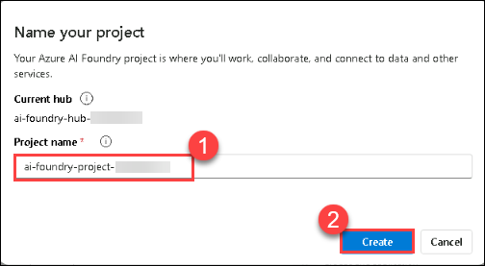

1. Once the project is created, scroll down and copy the **Project connection string**, then paste them into Notepad or a secure location, as they will be required for upcoming tasks.

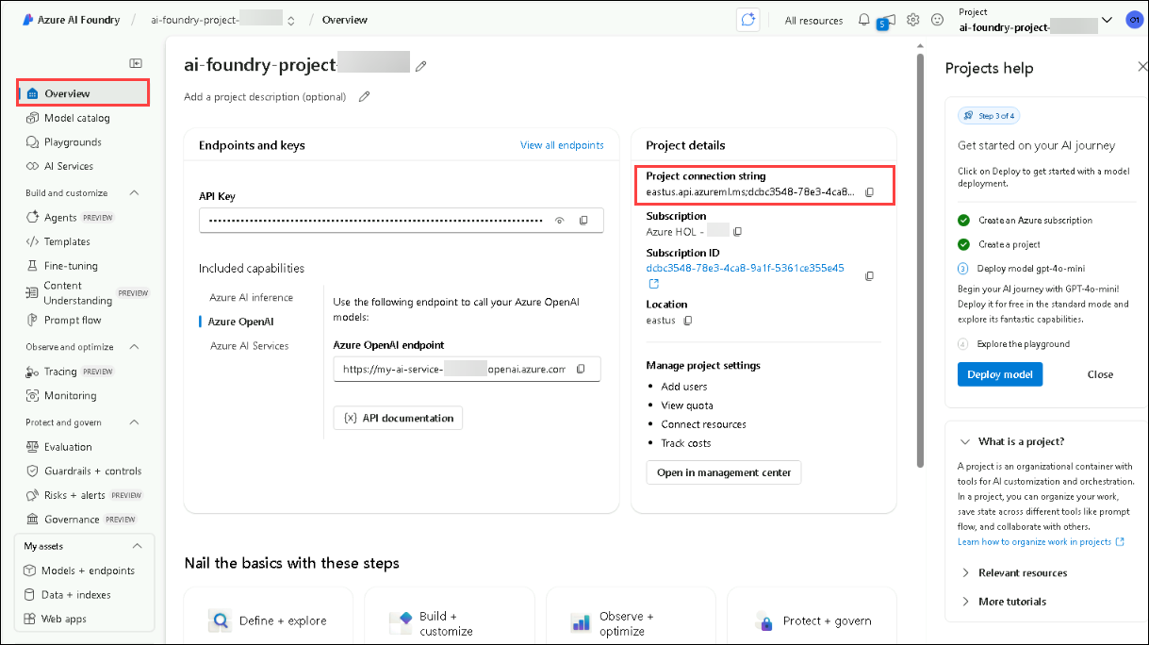

**Congratulations** on completing the task! Now, it's time to validate it. Here are the steps:

* Hit the Validate button for the corresponding task. If you receive a success message, you can proceed to the next task.
* If not, carefully read the error message and retry the step, following the instructions in the lab guide.
* If you need any assistance, please contact us at [cloudlabs-support@spektrasystems.com](javascript:void(0)). We are available 24/7 to help you out.

VALIDATION CHECK

0/20 Points

Exercise 1: Task 1: Setting up the AI Project in the Azure AI Foundry

Validate

**Task 2: Deploying an LLM and embedding models**

In this task, you will deploy a large language model (LLM) and an embedding model within your Azure AI Foundry project. These models will be used for AI-driven applications and vector-based search capabilities in upcoming labs.

1. In your **AI Foundry project**, navigate to the **My assets (1)** section, then select **Models + endpoints (2)**. Click **Deploy model (3)**, and choose **Deploy base model (4)** to proceed.

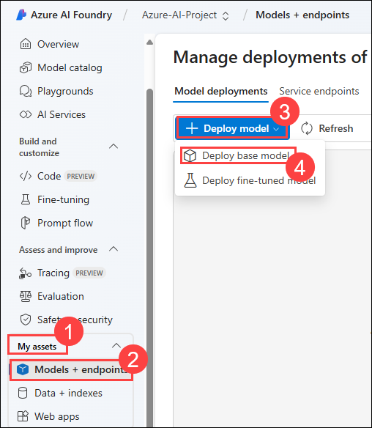

1. On a **Select a model** window, search for **gpt-4o (1)**, select **gpt-4o (2)** and select **Confirm (3)**

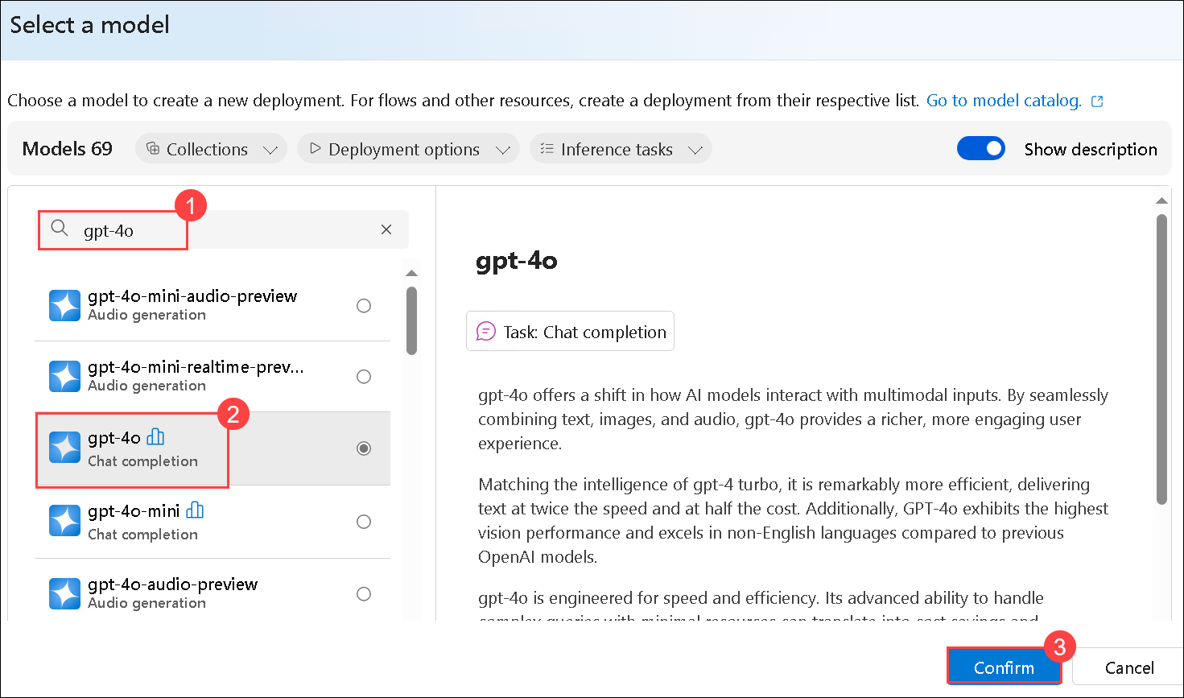

1. On **Deploy model gpt-4o** window, select **Customize**.

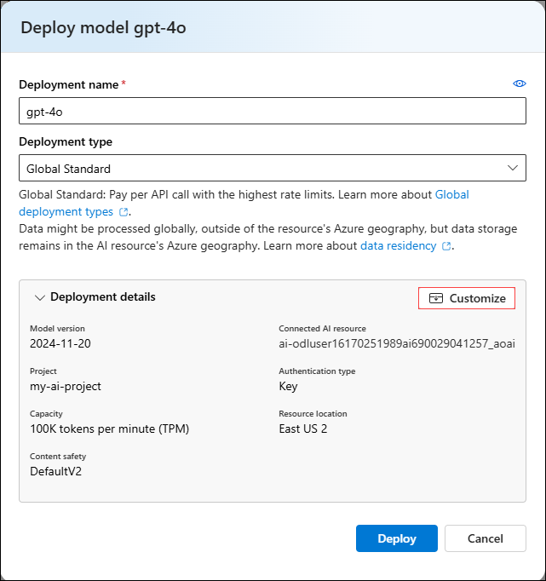

* + Deployment Name: **gpt-4o (1)**
  + Deployment type: **Global Standard (2)**
  + Change the **Model version to 2024-08-06 (Default) (3)**
  + Change the Tokens per Minute Rate Limit to **200K (4)**
  + Click on **Deploy (5)**

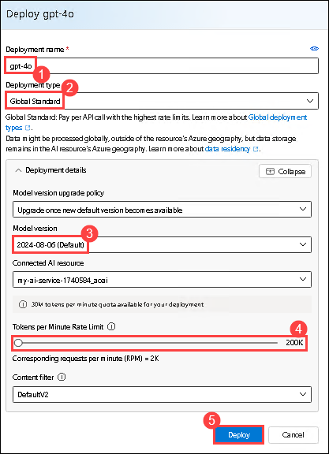

1. Click on **Model + Endpoints (1)**, there you can see the deployed **gpt-4o (2)** model.

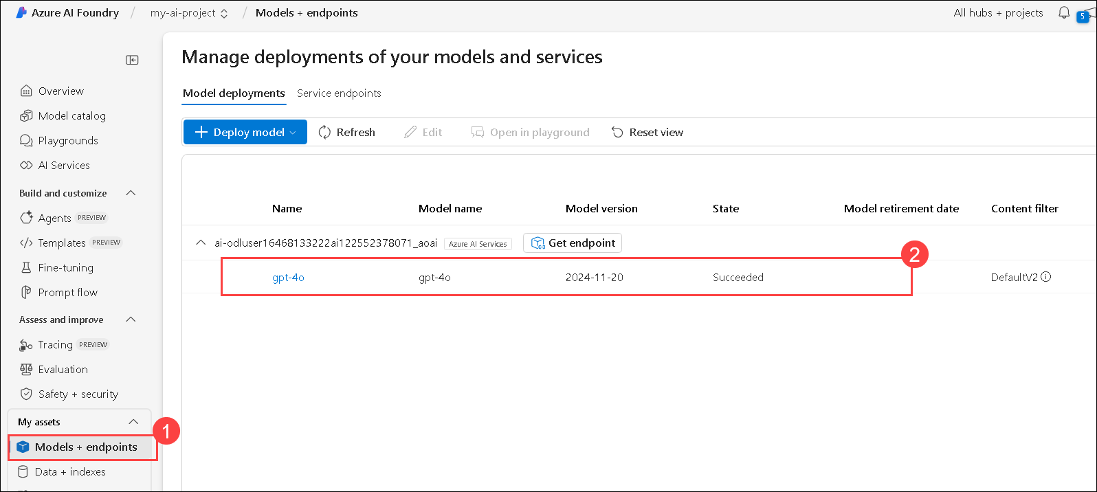

1. Navigate back to **Azure Portal** and search for **Open AI (1)** and select **Azure Open AI (2)** resource.

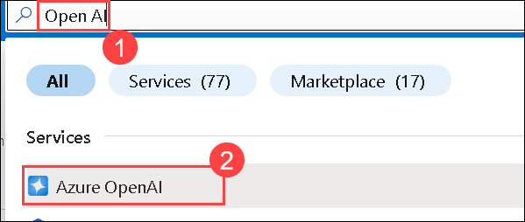

1. On the **AI Foundry | Azure OpenAI** page, select **+ Create** to create Azure OpenAI resource.

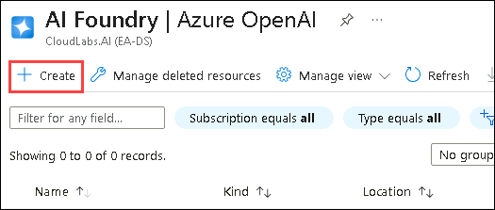

1. On **Create Azure OpenAI** page, provide the following settings and click on **Next (6)**:

| **Setting** | **Value** |
| --- | --- |
| Subscription | Keep the default subscription **(1)** |
| Resource group | **AgenticAI (2)** |
| Region | **East US (3)** |
| Name | **my-openai-service1746165 (4)** |
| Pricing tier | **Standard S0 (5)** |

1. 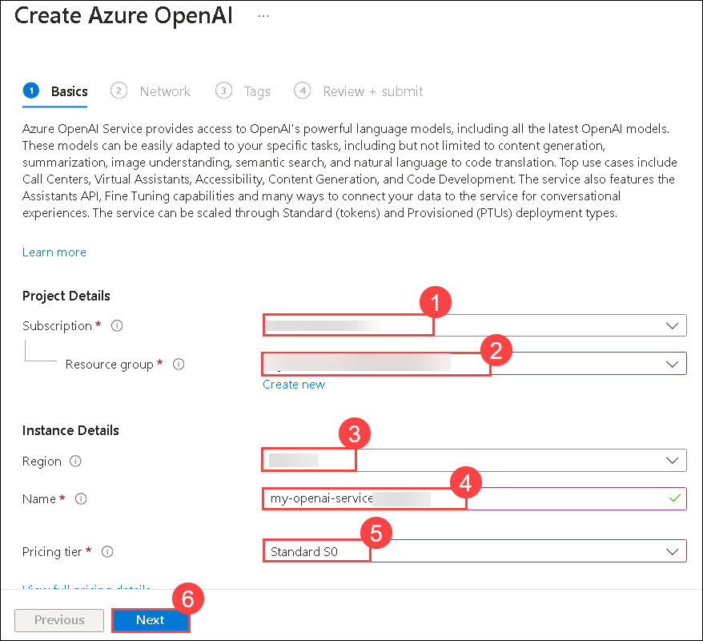
2. Click on **Next** till Review + submit tab appears.
3. On the **Review + submit** page, click on **Create**

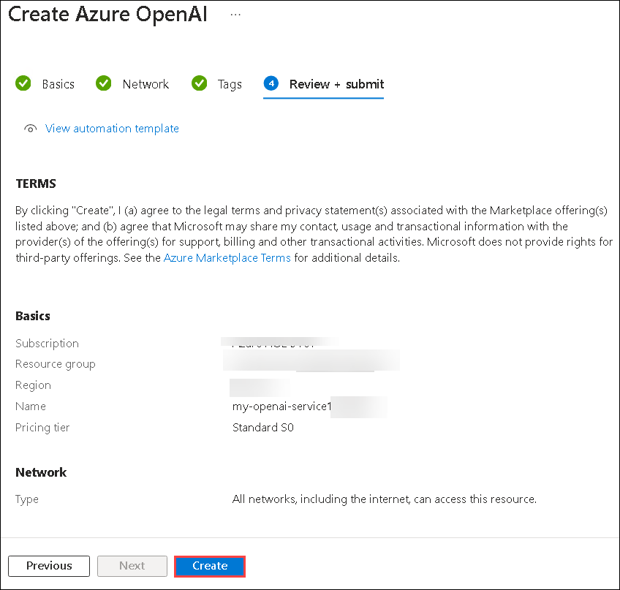

1. Wait until the deployment got succeeded and select **Go to resource**.

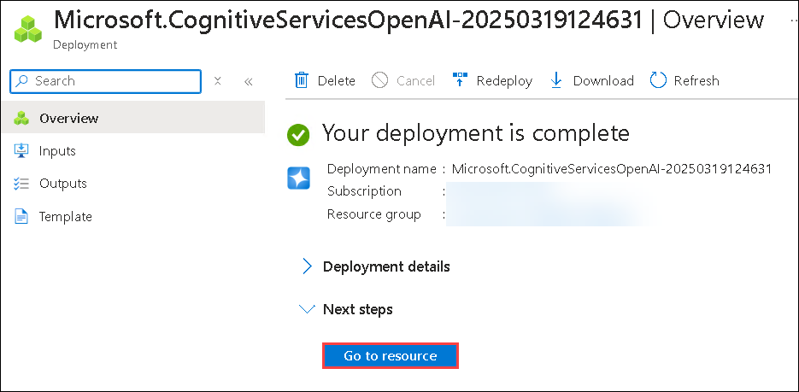

1. On the **my-openai-service1746165** resource page, select **Go to Azure AI Foundry portal**.

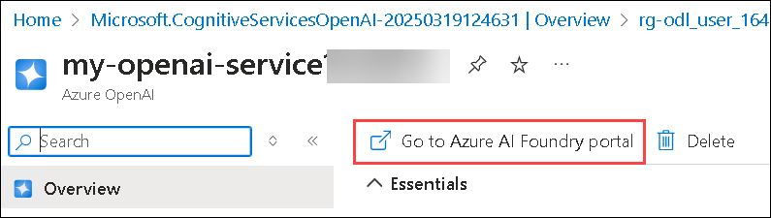

1. In your AI Foundry project, navigate to the **Shared resources** section, then select **Deployments (1)**. Click **Deploy model (2)**, and choose **Deploy base model (3)** to proceed.

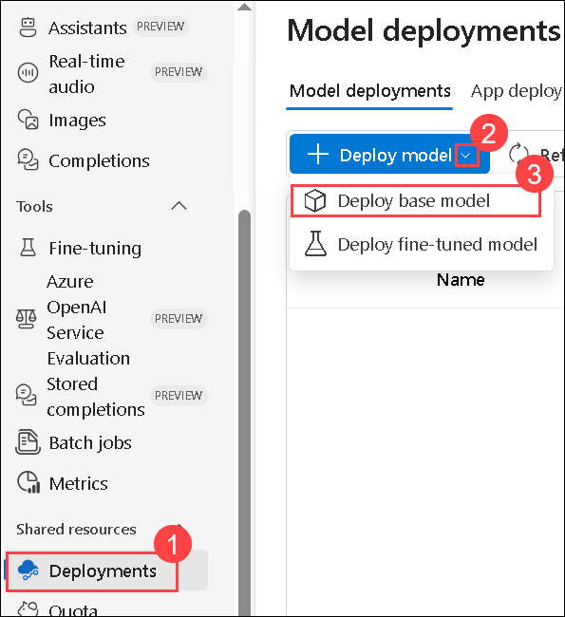

**Note**: The import and vectorize wizard in Azure AI Search, which will be used in subsequent labs, does not yet support text embedding models within your AI Foundry project. Because of this, we need to create an Azure OpenAI service and deploy a text embedding model there. We will use this text embedding model later when we create our vector index.

1. On a **Select a model** window, search for **text-embedding-3-large (1)**, then select **text-embedding-3-large (2)** and select **Confirm (3)**

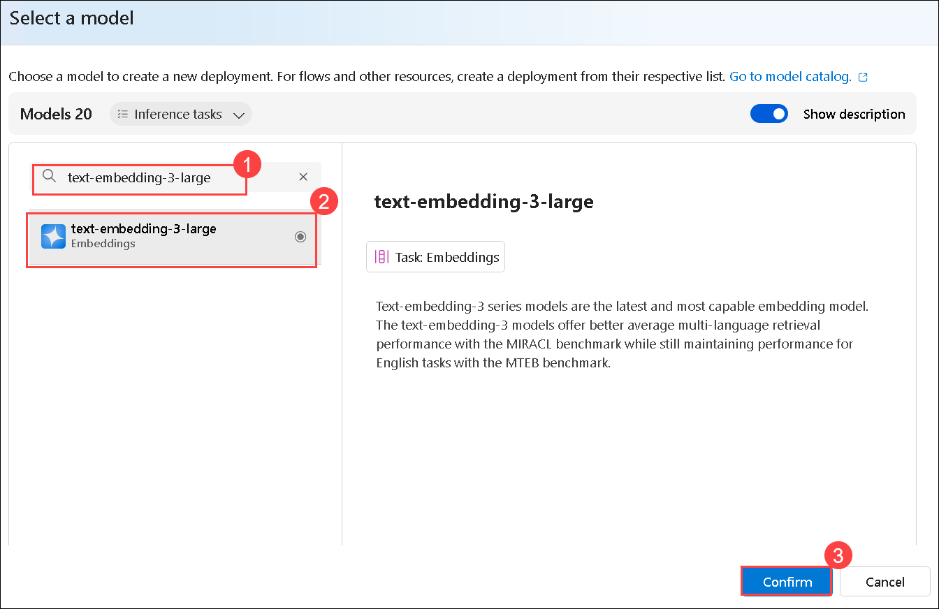

1. On **Deploy model text-embedding-3-large** window,
   * Deployment type: Select **Standard (1)**
   * Tokens per Minutes Rate Limit: **120K (2)**
   * Select **Deploy (3)** to deploy the model.

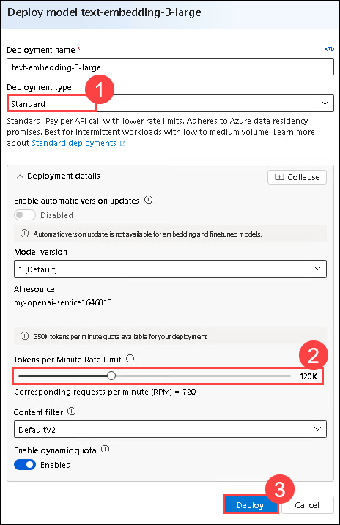

1. Click on **Deployment (1)**, you can see the deployed **text-embedding-3-large (2)** model.

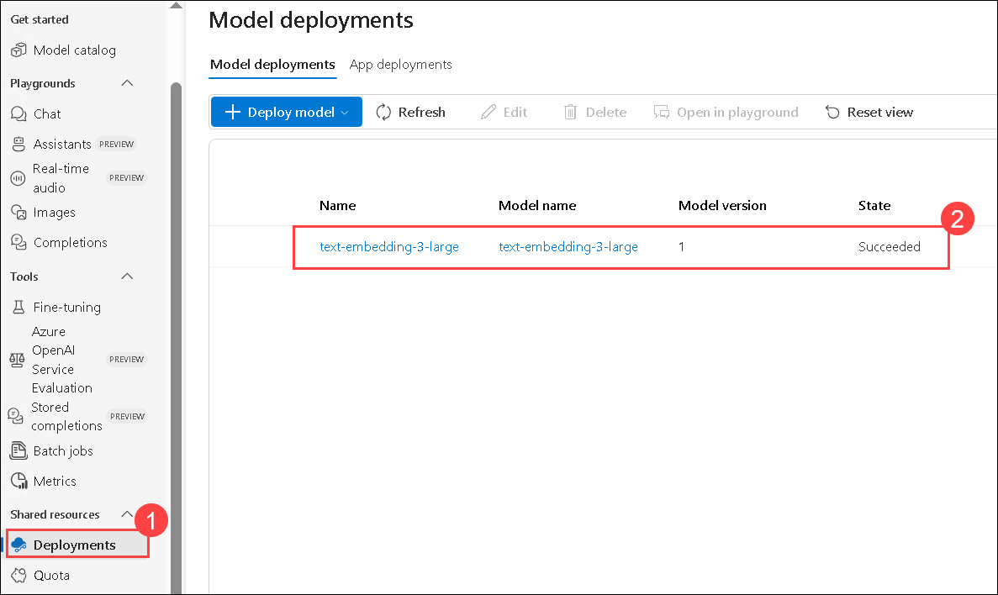

**Congratulations** on completing the task! Now, it's time to validate it. Here are the steps:

* Hit the Validate button for the corresponding task. If you receive a success message, you can proceed to the next task.
* If not, carefully read the error message and retry the step, following the instructions in the lab guide.
* If you need any assistance, please contact us at [cloudlabs-support@spektrasystems.com](javascript:void(0)). We are available 24/7 to help you out.

VALIDATION CHECK

0/20 Points

Exercise 1: Task 2: Deploying an LLM and embedding models

Validate

**Task 3: Install dependencies, create a virtual environment, and create an environment variables file**

In this task, you will install the required dependencies, set up a virtual environment, and create an environment variables file. This ensures a controlled development environment and securely manages configuration settings for your AI project.

1. On your **Lab VM**, launch **Visual Studio Code**.
2. Click on **File (1)**, then **Open Folder**.

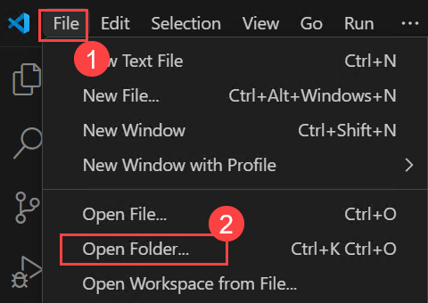

1. Navigate to C:\LabFiles\Day-2-Azure-AI-Agents **(1)**, select the **azure-ai-agents-labs (2)** folder and then click on **Select folder (3)**.

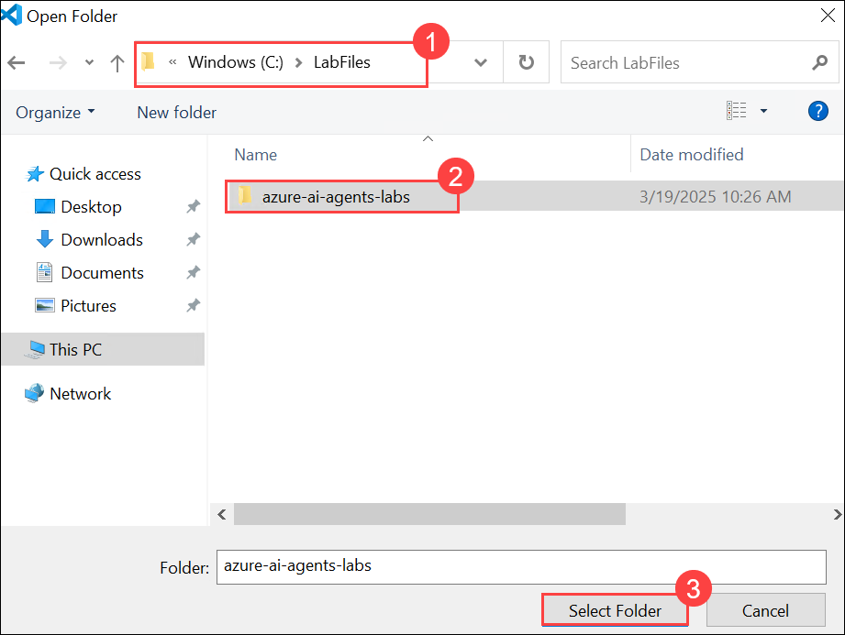

1. Click on **Yes, I Trust the authors**,

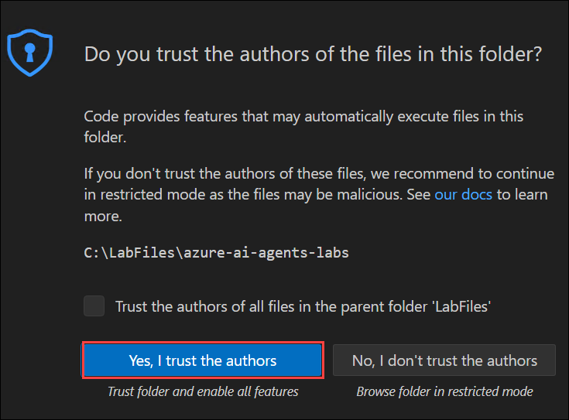

1. Click on the **elipses(...) (1)**, then **Terminal (1)** and then **New Terminal (3)**.

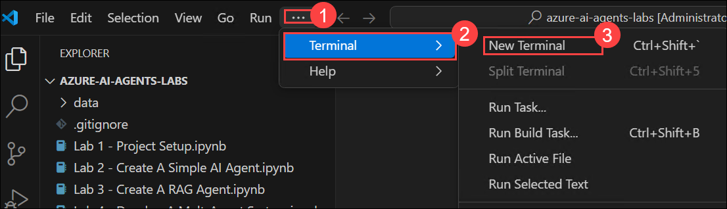

1. Make sure your in **azure-ai-agents-labs** project directory. Run the below powershell commands to create and activate your virtual environment:
2. python -m venv venv

venv/Scripts/activate

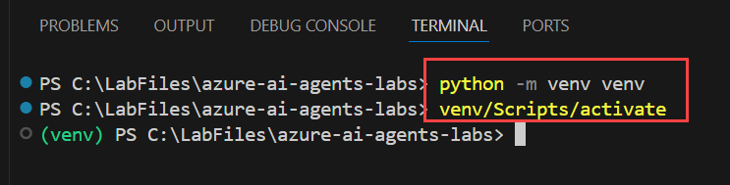

1. Run the below powershell command. This installs all the required packages:
2. pip install -r requirements.txt

pip install azure-ai-ml azure-identity

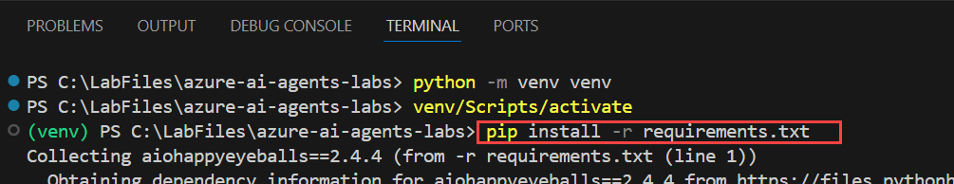

1. Run the below powershell command to install or upgrade pip to the latest version.

python.exe -m pip install --upgrade pip

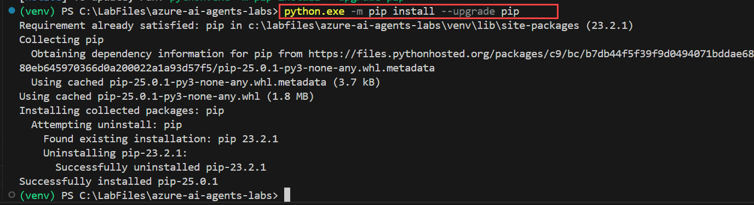

1. Run the below command to log into your Azure account.

az login

1. Select the odl_user_1746165@sandboxailabs1008.onmicrosoft.comodl_user_1746165@sandboxailabs1008.onmicrosoft.com user account to authorize.

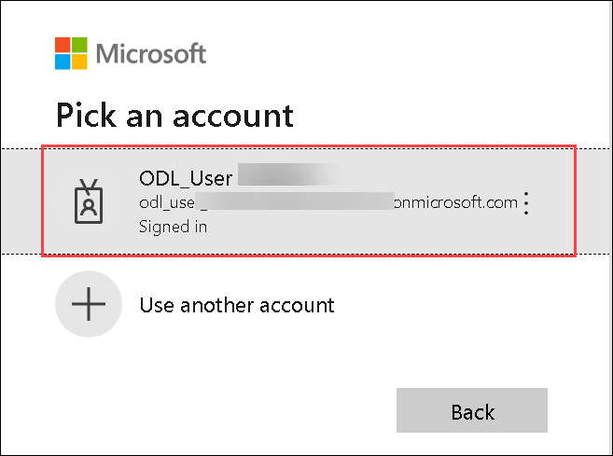

1. Once the Authorization is completed, navigate back to the Visual studio code.

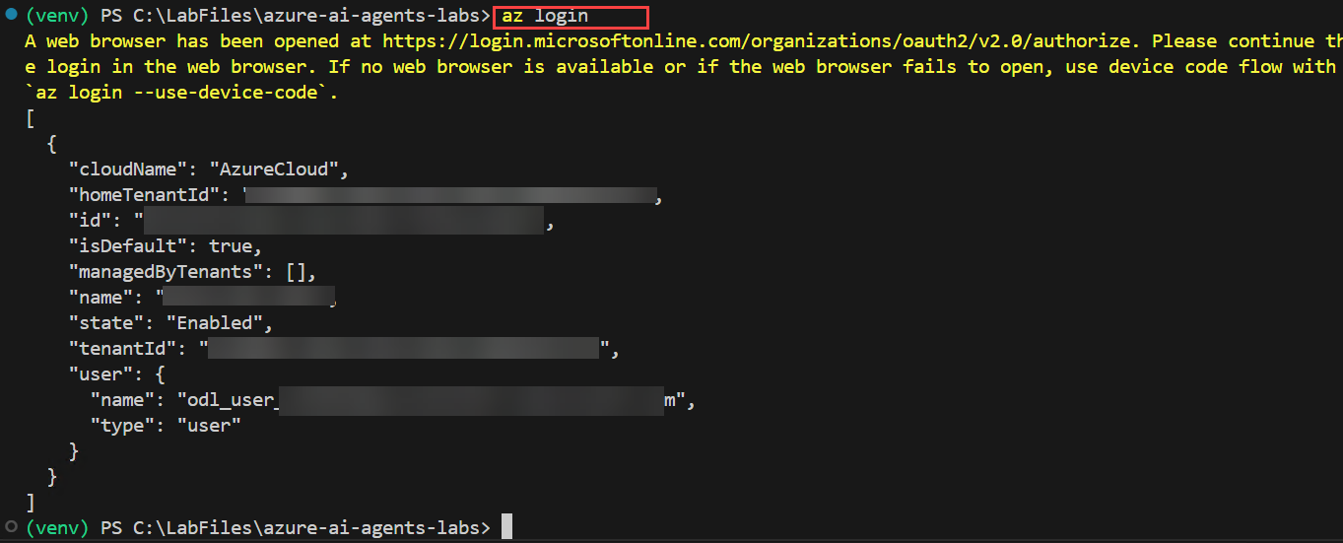

1. Open the **Sample.env** file and provide the necessary environment variables.

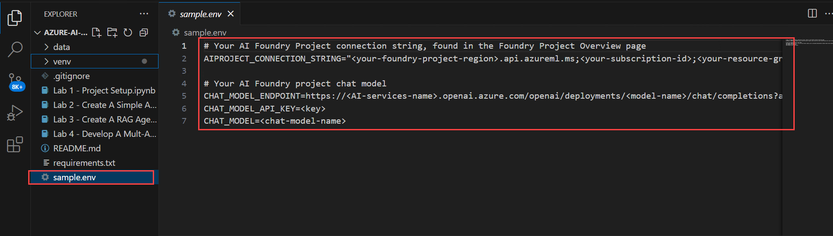

* + Navigate to Azure AI foundry portal, click on **gpt-4o(2)** model from the **Models + endpoints(1)** section under My assets, copy the under **Endpoint** from right pane, copy and paste the **Target URI (1)** and **Key (2)** in a notepad

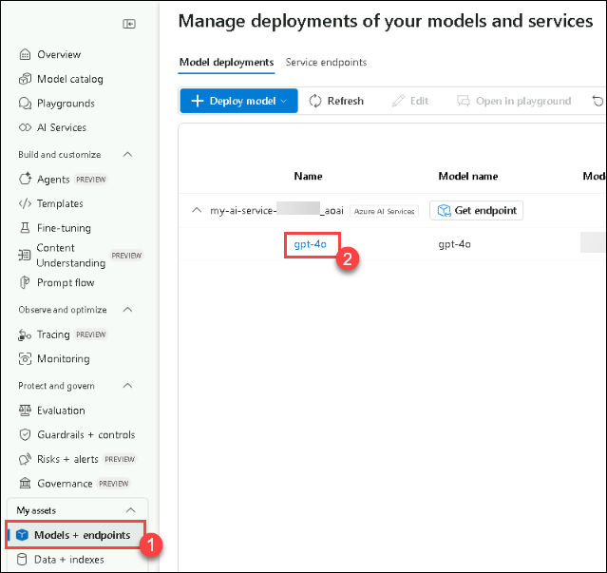 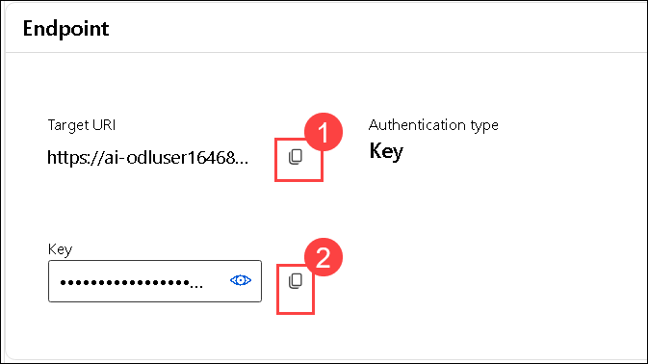

1. On the **Sample.env** file,
   * AIPROJECT_CONNECTION_STRING: Provide **Project connection string** value you have copied in step 9 of Task 1
   * CHAT_MODEL_ENDPOINT: Provide the **Target URI** of **gpt-4o** model you have copied in the previous step
   * CHAT_MODEL_API_KEY: Provide the **Key** value of **gpt-4o** model you have copied in the previous step
   * CHAT_MODEL: **gpt-4o**

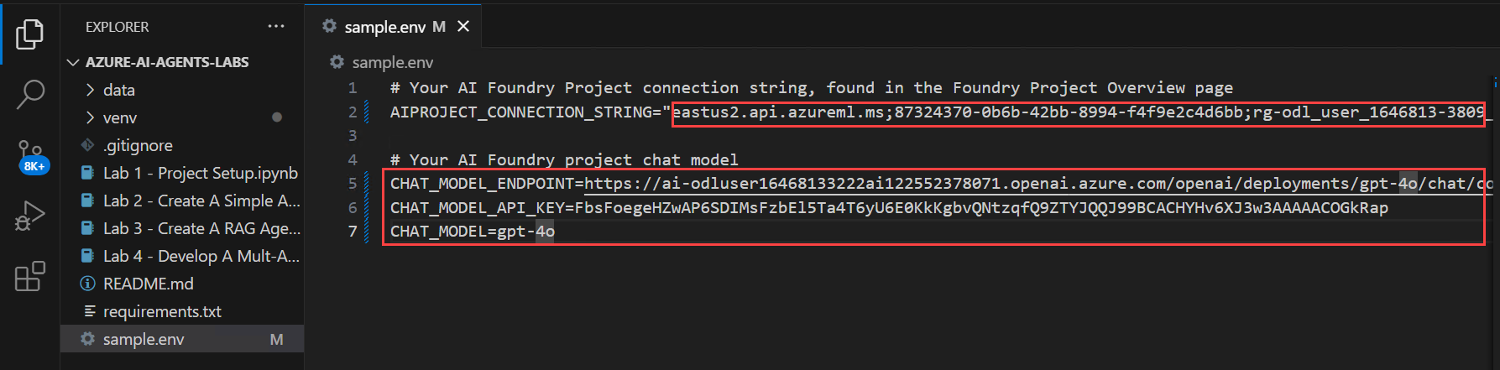

1. Save changes to the **Sample.env** file.
2. Run the below powershell command. This creates your **.env** file:

cp sample.env .env



1. Later Open the **Lab 1 - Project Setup.ipynb** file. The **Lab 1 - Project Setup.ipynb** notebook guides you through setting up an AI Project in Azure AI Foundry, deploying an LLM and embedding models, and configuring VS Code connectivity. It also includes a simple Chat Completion API call to verify the setup. Running this notebook ensures that your environment is correctly configured for developing AI-powered applications.

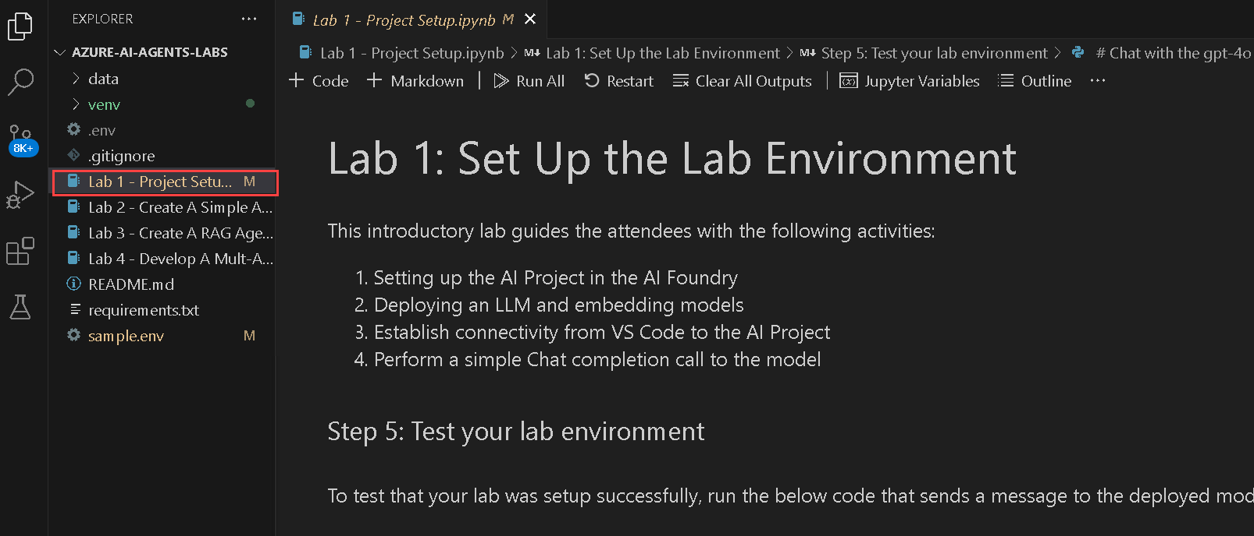

1. Select the **Select kernel (1)** setting available in the top right corner and select **Install/enable selected extensions (python+jupyter) (2)**.

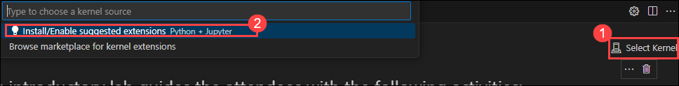

1. Select **Python Environments** to ensure that Jupyter Notebook runs in the correct Python interpreter with the necessary dependencies installed.

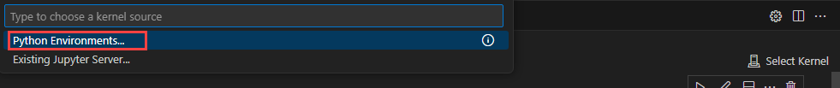

1. Select **venv (Python 3.x.x)** from the list as this version is likely required for compatibility with Azure AI Foundry SDK and other dependencies.

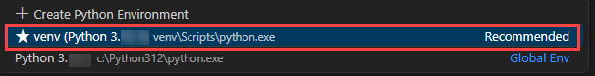

**Note:** If **venv (Python 3.x.x)** does not appear in the list. Close and Open the Visual studio code.

1. Run the first cell to import necessary Python libraries for working with Azure AI services.

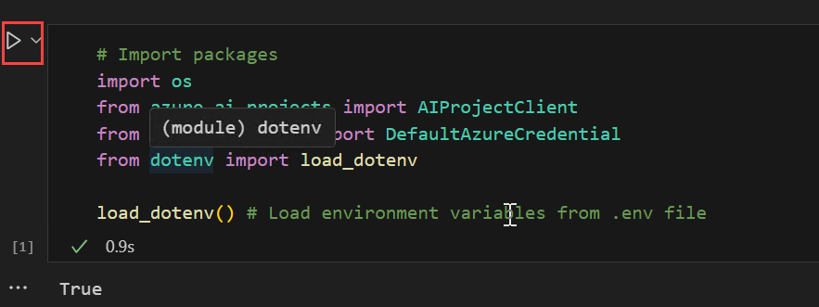

1. Run the below cell to retrieve the project connection string and model name from environment variables. These values are needed to interact with the Large Language Model (LLM) securely, without hardcoding sensitive information.

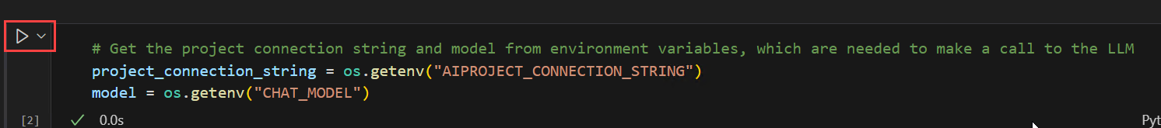

1. Run the below cell to connect to your Azure AI Foundry project using the connection string. This establishes a secure connection with AIProjectClient, enabling interactions with your project resources.

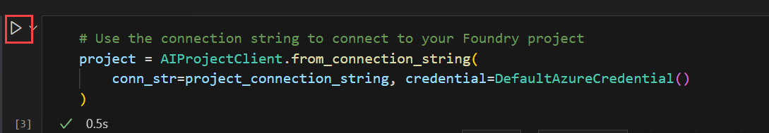

1. Run the below cell to interact with the GPT-4o model using your Azure AI Foundry project. This code initializes a chat client, sends a request for a joke about a teddy bear, and prints the response. Finally see the output provided from the chat model.

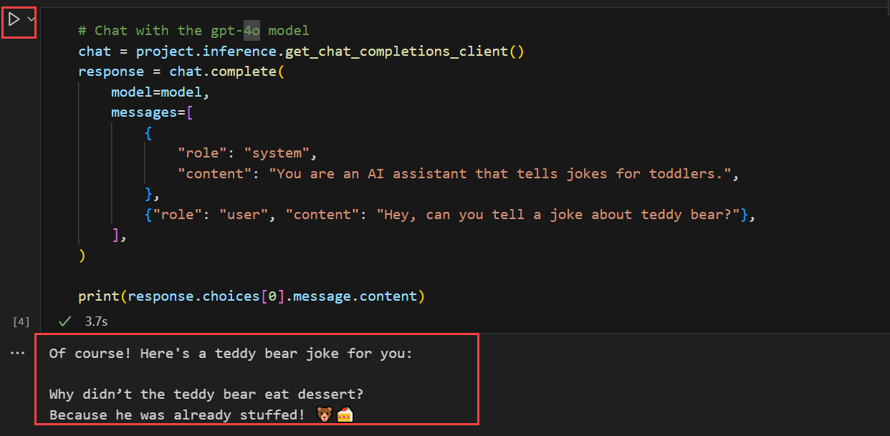

**Review**

In this lab, you have accomplished the following:

* Set up the AI Project in Azure AI Foundry.
* Deployed an LLM and embedding models.
* Established connectivity from VS Code to the AI Project.
* Performed a simple Chat Completion call

--

**Exercise 2: Build a Simple AI Agent**

**Estimated time: 30 minutes**

**Lab scenario**

AI Agents are designed to automate tasks and generate insights based on user input. In this lab, you will learn how to build a simple AI Agent that processes data and generates a bar chart comparing different health benefit plans. This AI Agent leverages Azure AI services to analyze and visualize data efficiently.

**Lab Objective**

In this lab, you will complete the following tasks:

* Task 1: Create a Simple AI Agent

**Task 1: Create a Simple AI Agent**

In this task, you will build a simple AI Agent that processes data and generates a bar chart comparing different health benefit plans using Azure AI services for analysis and visualization.

1. Open the **Lab 2 - Create A Simple AI Agent.ipynb** file. This **Lab 2 - Create A Simple AI Agent.ipynb** notebook guides you through how to build a simple AI Agent that processes data and generates a bar chart comparing different health benefit plans.

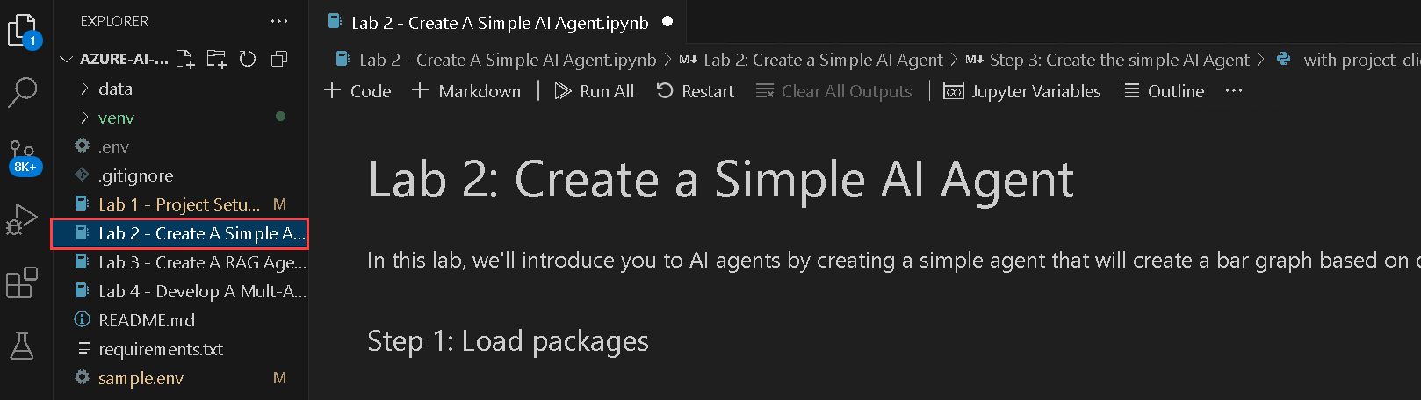

1. Select the **Select kernel** setting available in the top right corner. Select **venv (Python 3.x.x)** from the list.



1. Run the below cell to import necessary libraries and load environment variables for working with Azure AI Projects. This setup enables secure authentication and interaction with Azure AI services.

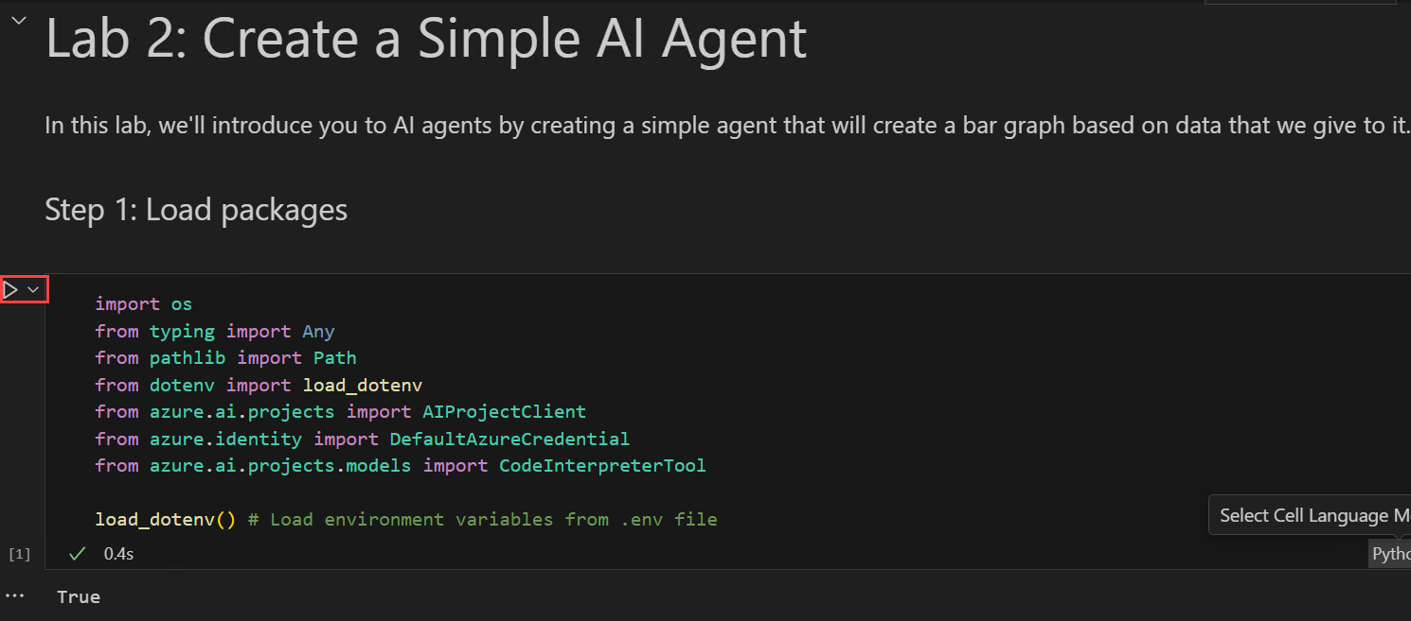

1. Run the below cell to connect to your Azure AI Foundry project and access the deployed **gpt-4o** model. This establishes a secure connection using the project connection string and Azure credentials.

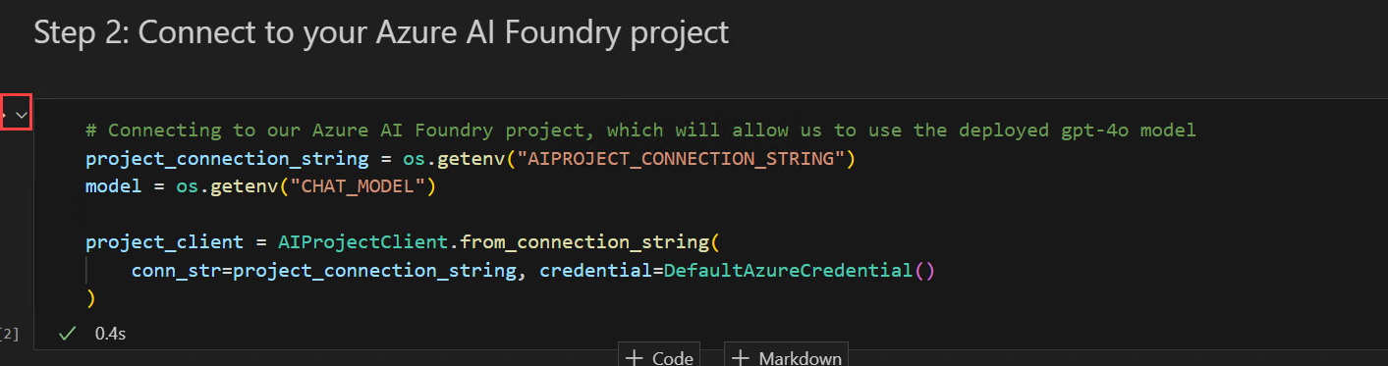

1. Run this cell to create a **simple AI Agent** that processes data and generates a bar chart comparing different health benefit plans using Azure AI Foundry.This script initializes the AI agent, sends a prompt containing health plan data, and requests a bar chart. The agent processes the request, generates the chart, saves the image file, and then cleans up by deleting the agent.

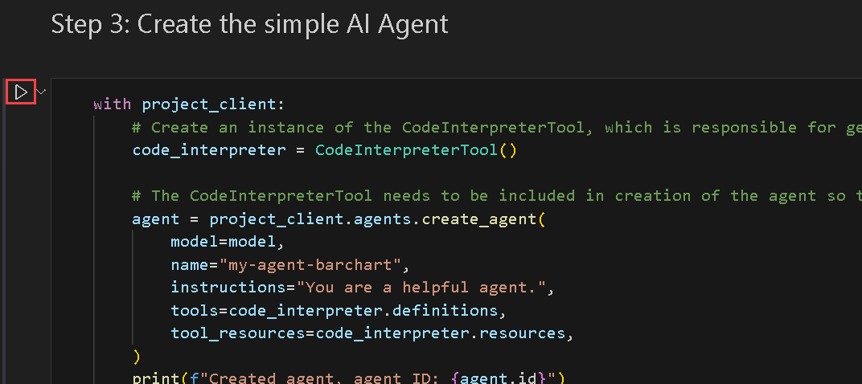

1. Finally observe the output.

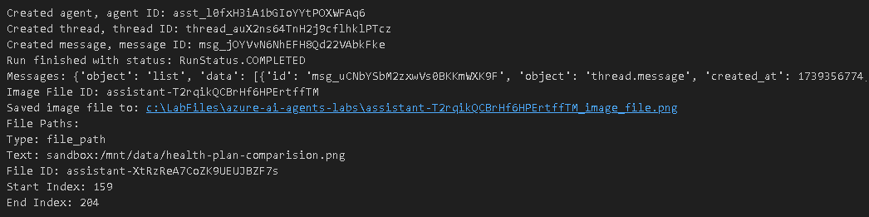

**Review**

In this lab, you have accomplished the following:

* Created a Simple AI Agent

**Exercise 3: Develop a multi-agent system**

**Estimated time: 30 minutes**

**Lab scenario**

In this lab, you will be creating a multi-agent system consisting of 4 agents working together to generate reports about health plan documents. You will build these 4 AI Agents:

* **Search Agent** - This agent will search an Azure AI Search index for information about specific health plan policies.
* **Report Agent** - This agent will generate a detailed report about the health plan policy based on the information returned from the Search Agent.
* **Validation Agent** - This agent will validate that the generated report meets specified requirements. In our case, making sure that the report contains information about coverage exclusions.
* **Orchestrator Agent** - This agent will act as an orchestrator that manages the communication between the Search Agent, Report Agent, and Validation Agent.

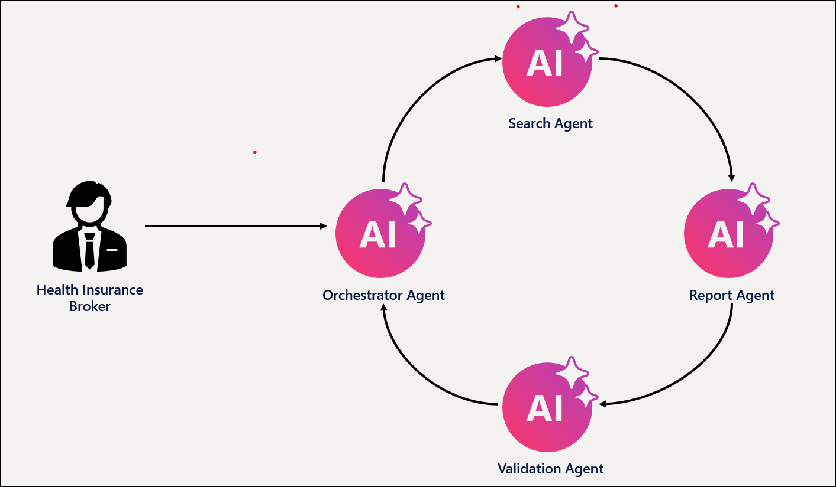

Orchestration is a key part of multi-agentic systems since the agents that we create need to be able to communicate with each other in order to accomplish the objective.

We'll use the Azure AI Agent Service to create the Search, Report, and Validation agents. However, to create the Orchestrator Agent, we'll use Semantic Kernel. The Semantic Kernel library provides out-of-the-box functionality for orchestrating multi-agent systems.

**Lab Objective**

In this lab, you will complete the following tasks:

* Task 1: Create the Azure AI Search Index
* Task 2: Create the Search, Report, and Validation Agents.

**Task 1: Create the Azure AI Search Index**

In this task, you will create an **Azure AI Search index** to store vectorized representations of health insurance plan documents, enabling efficient retrieval for AI-driven search and analysis.

1. Navigate to **Azure portal**, search for **AI Search (1)** and select **AI Search (2)** resource from the services.

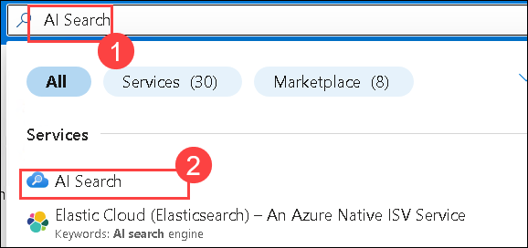

1. This will navigate you to the AI Foundry, within **AI Search** (1), click on **Create**(2).

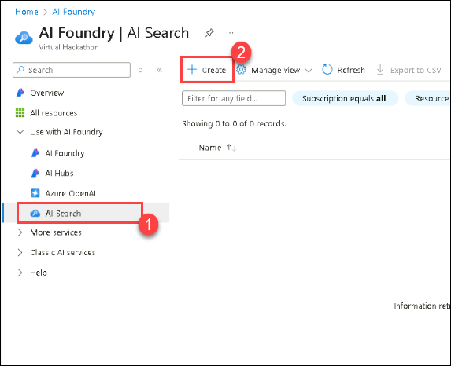

1. On the **Create a Search service** pane enter the following details and click on **Review + Create** (4)
   * Subscription : **Leave default subscription**
   * Resource Group : Select **AgenticAI (1)**
   * Service Name : **my-search-service-1746165 (2)**
   * Location : **westus** **(3)**

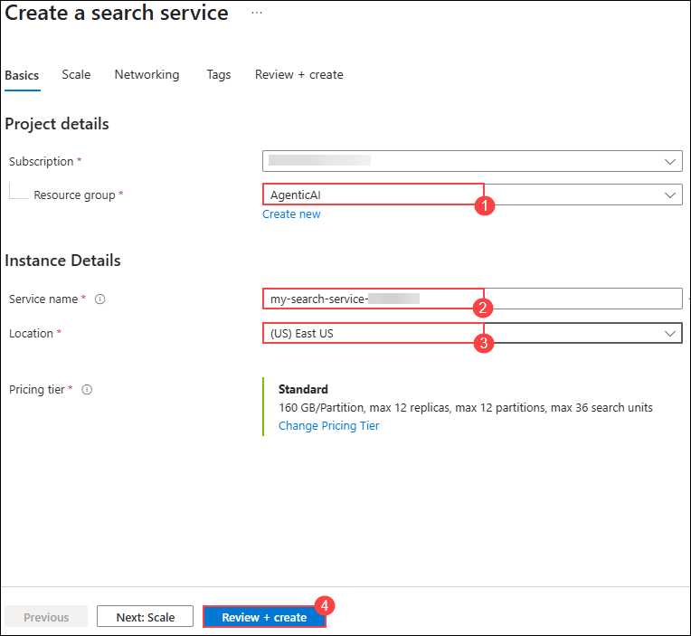

1. On the **Review + Create**, click on **Create**

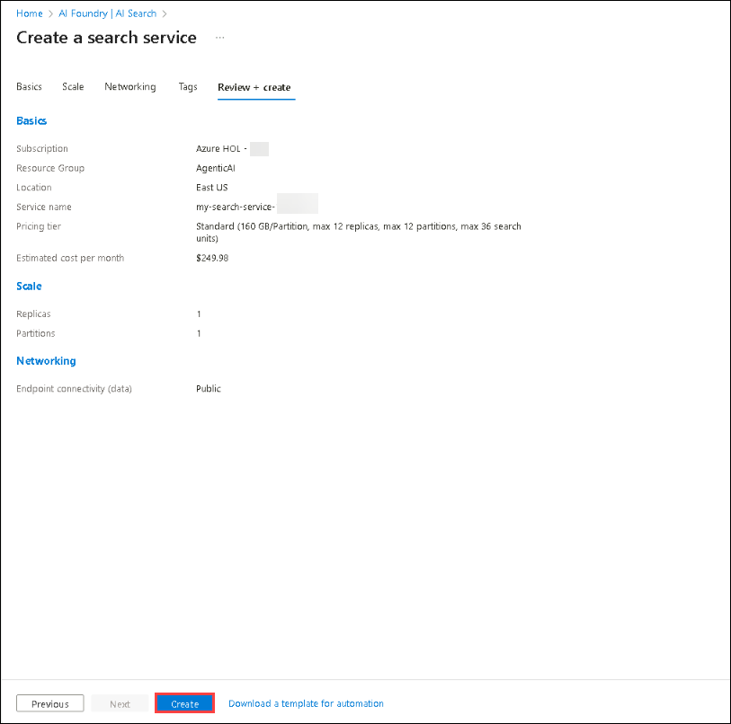

1. Wait for until the deployment is completetd and then click on **Go to resource**

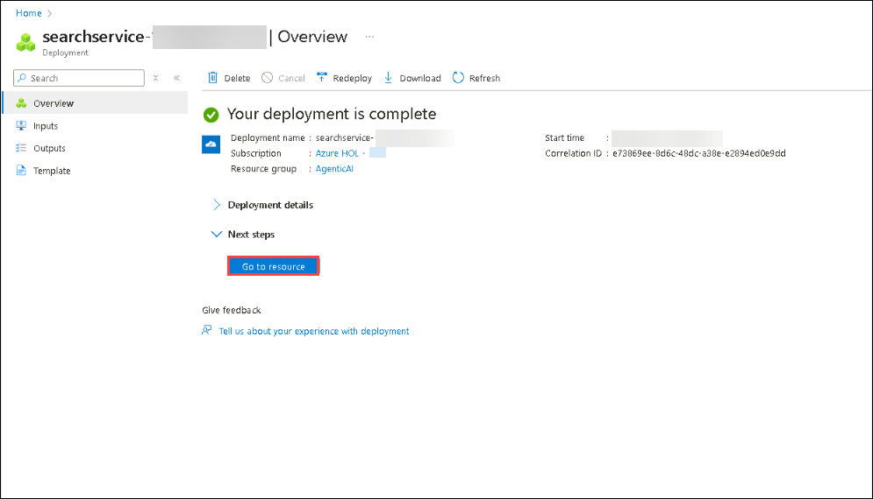

1. Navigate to **Keys (1)** under **Settings** in the left menu. Under **API Access control** select **Both(2)**.

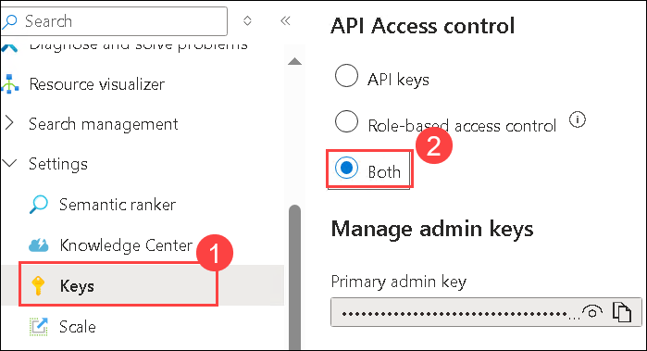

1. Select **Yes** for **Are you sure want to update the API Access Control for this serach service**.

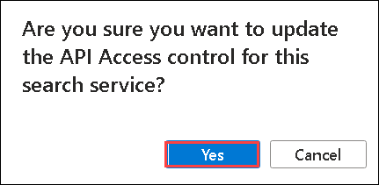

1. Navigate to **Identity(1)** under **Settings**. Under System-assigned set the Status to **On(2)** and click on **Save(3)**.

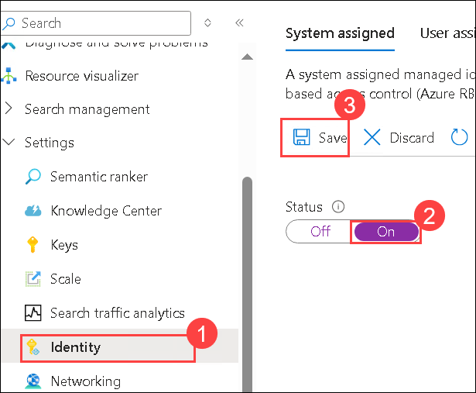

1. Select **Yes** for **Enable System assigned managed identity**.

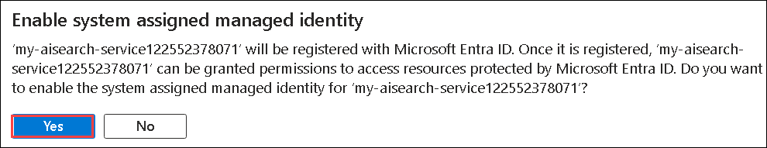

1. On the Azure portal, search for **Storage accounts (1)** and select **Storage accounts (1)** from the services.

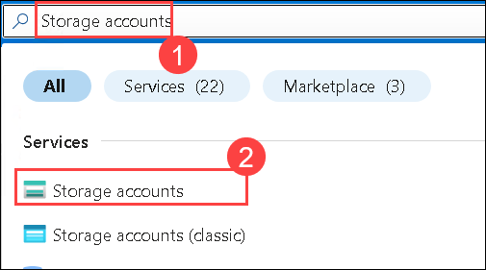

1. Select the storage account that begins with **aifoundry**.

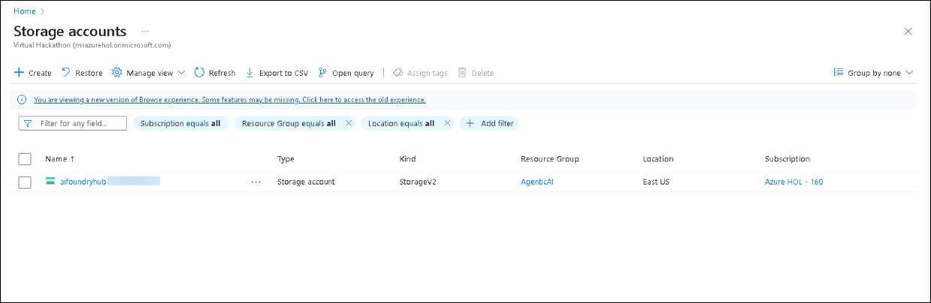

1. Select **Access control (IAM) (1)**, then click on **Add(2)**, and then select **Add role assignment**.

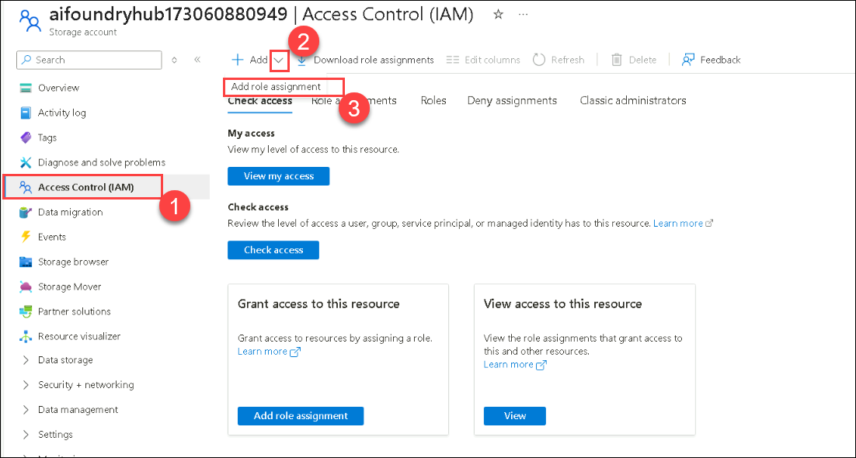

1. Under **Job function roles**, search for **Storage Blob Data Reader (1)**, select **Storage Blob Data Reader (2)**, and then select **Next (3)**.

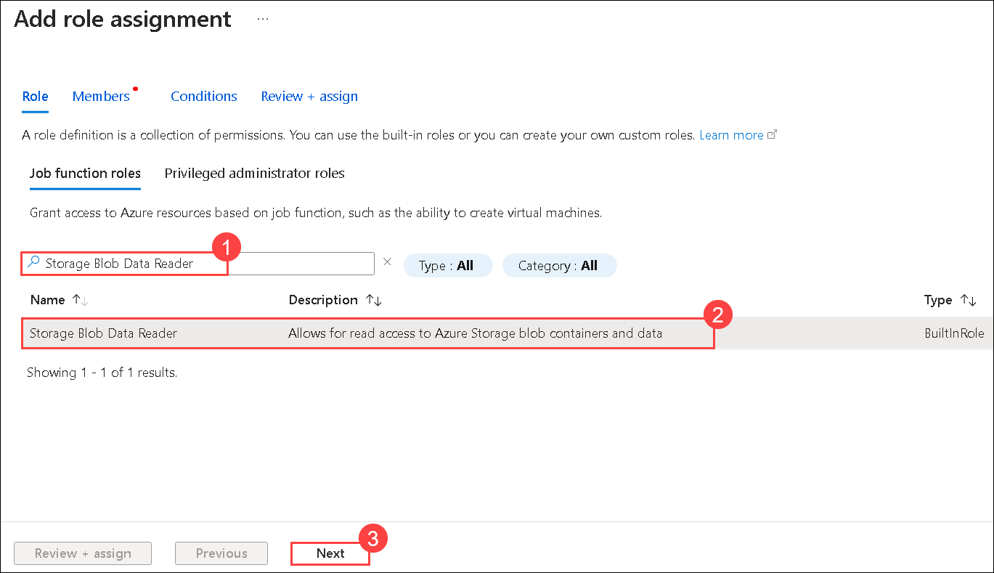

1. On the **Add role assignment** page,
   * Under Members, select **Managed identity(1)**
   * Select **Members (2)**
   * Managed identity: **search service(1)** **(3)**
   * Then select **my-search-service-1746165**(4) search service.
   * Click on **Select (5)**

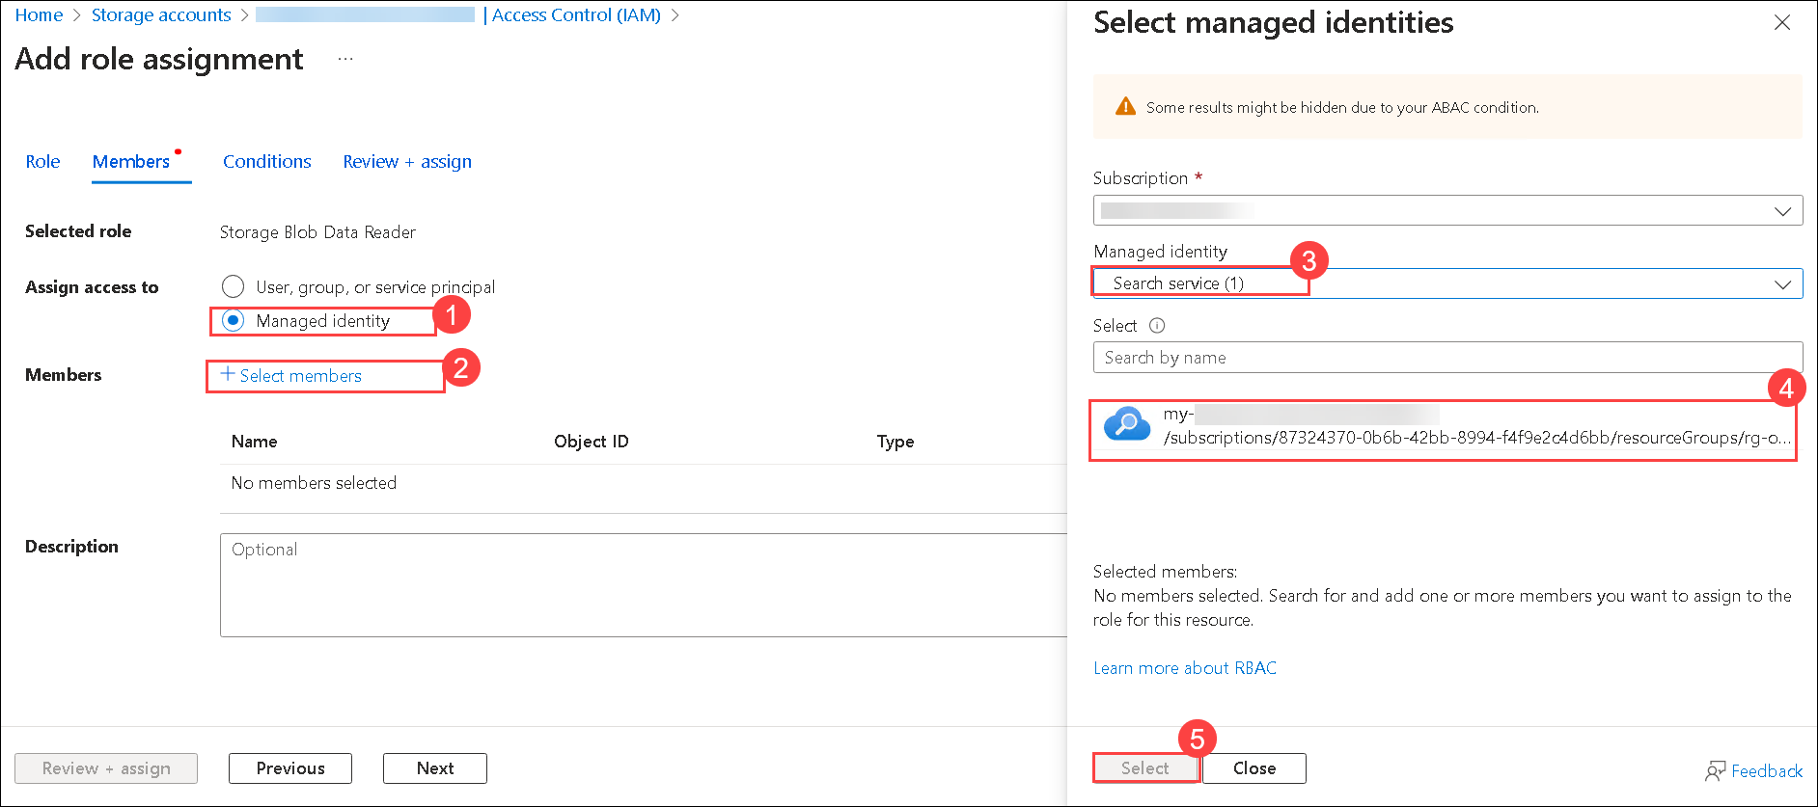

1. Click on **Review + assign** twice.

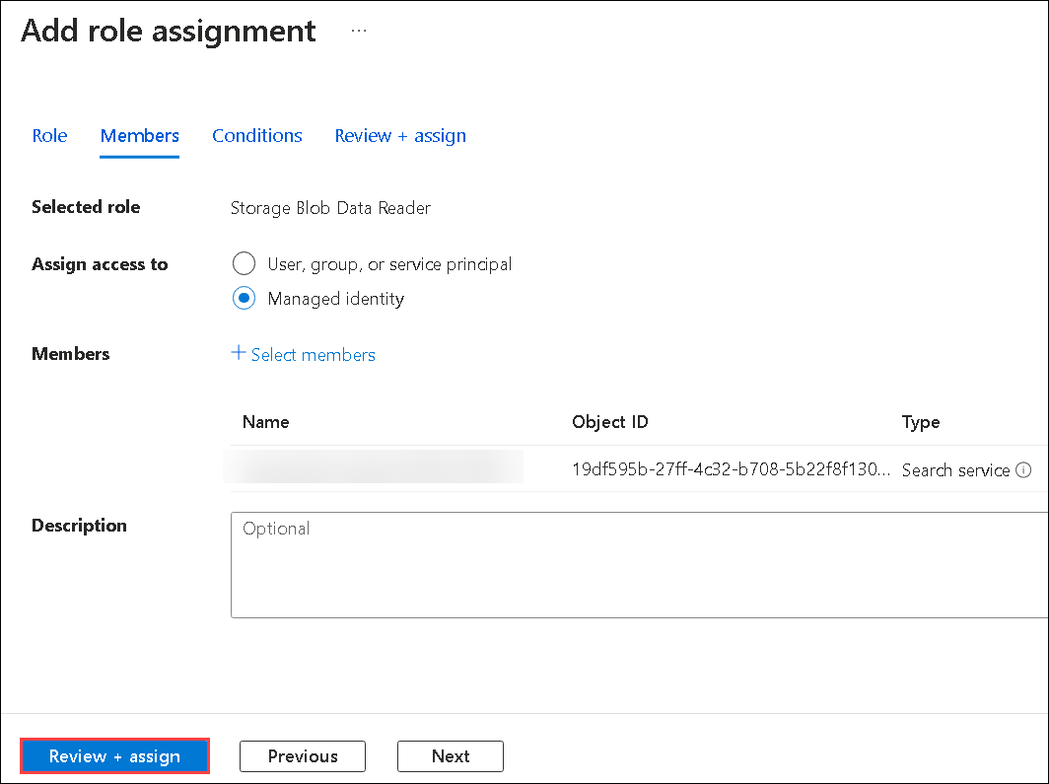

1. Go to the **Azure OpenAI**, **my-openai-service1746165**.

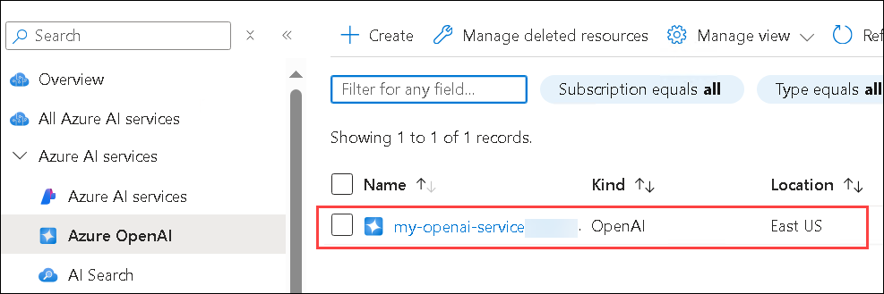

1. Select **Access control (IAM) (1)**, then click on **Add(2)**, and then select **Add role assignment**.

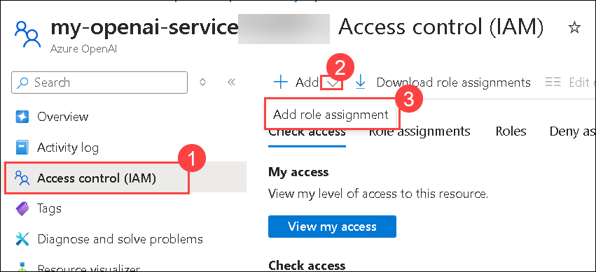

1. Under **Job function roles**, search for **Cognitive Services OpenAI User (1)**, select **Cognitive Services OpenAI User (2)**, and then select **Next (3)**.

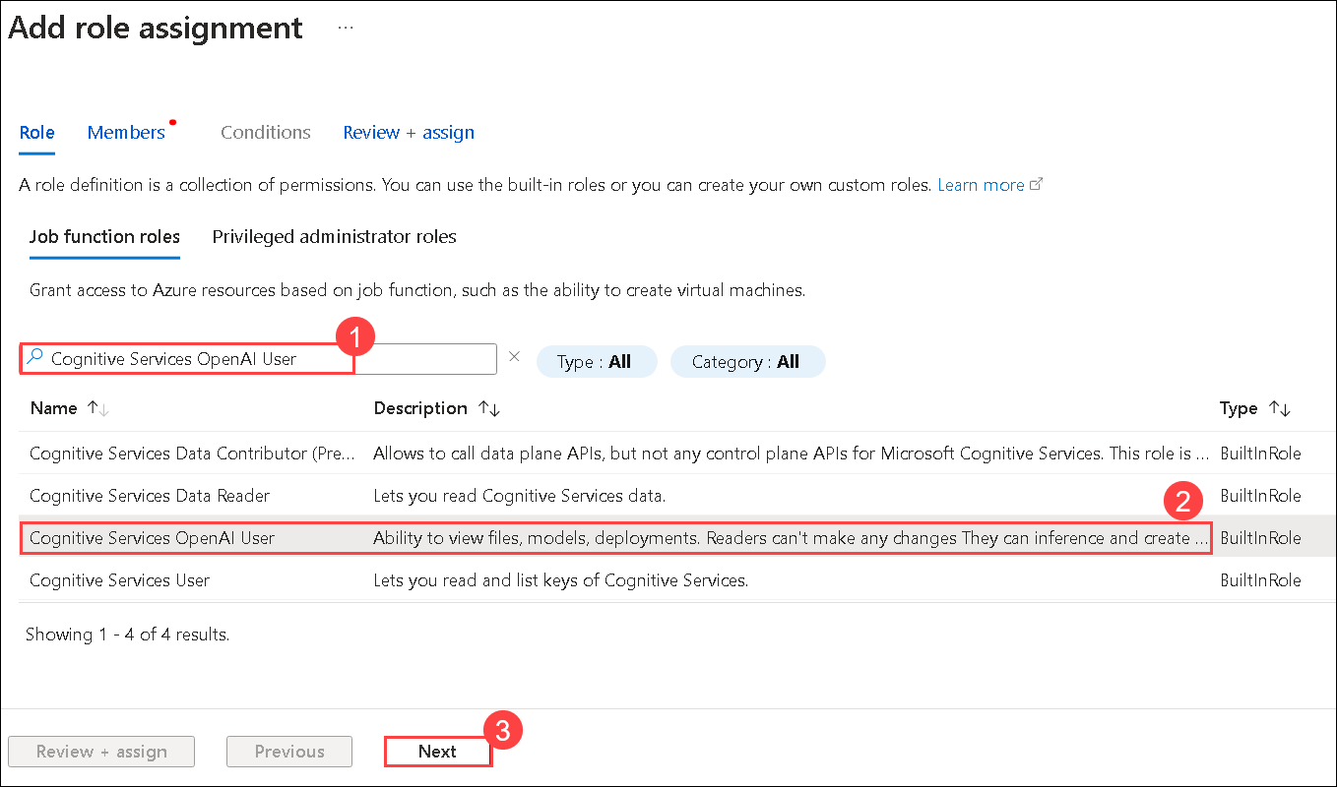

1. On the **Add role assignment** page,
   * Under Members, select **Managed identity(1)**
   * Select **Members (2)**
   * Managed identity: **search service(1)** **(3)**
   * Then select **my-search-service-1746165**(4) search service.
   * Click on **Select (5)**

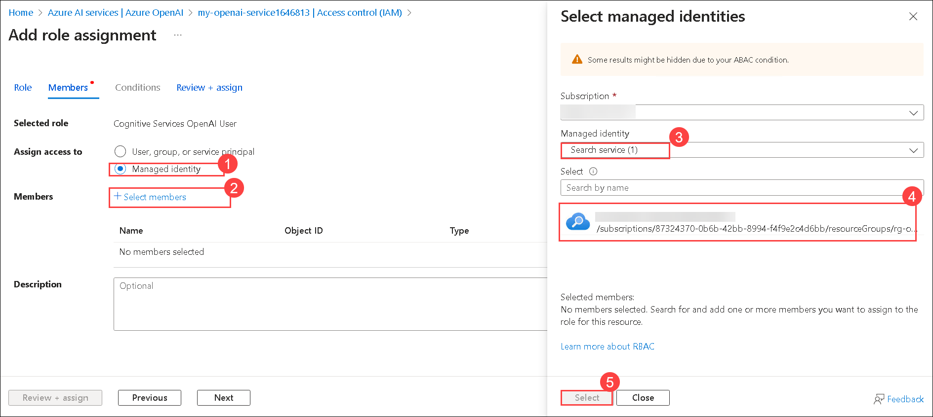

1. Select **Review + assign** twice.

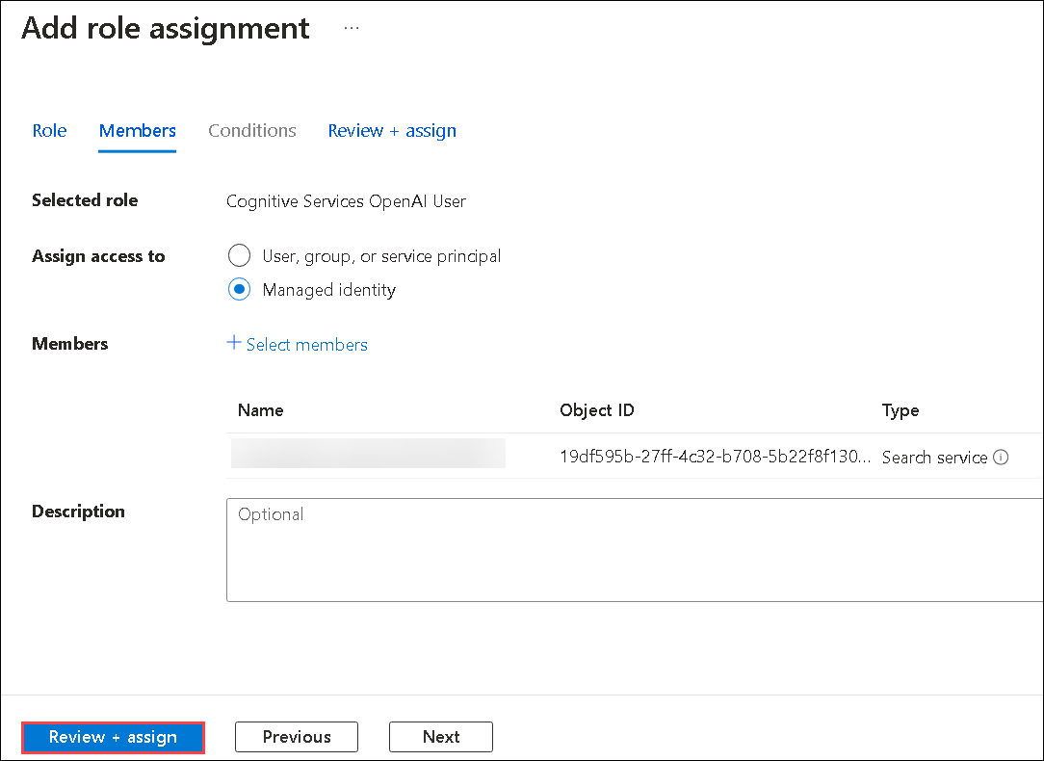

1. Navigate to **Azure Portal**, search for **Storage account (1)** and select the **Storage account (2)**.



1. Select the Storage account that starts with **aifoundryhub**.

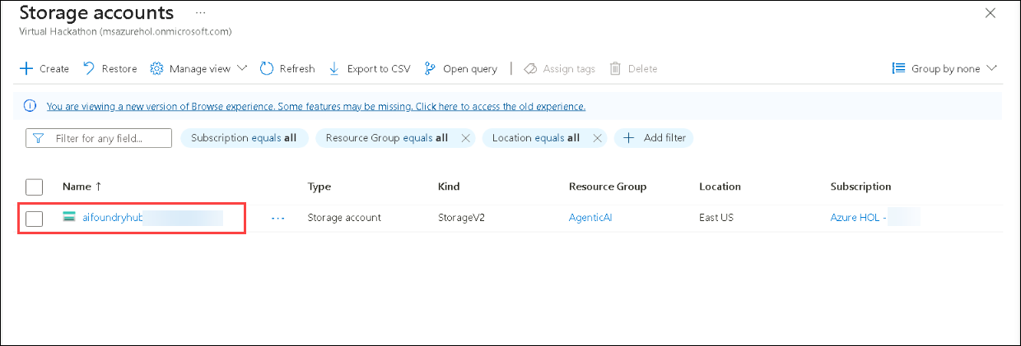

1. Click on **Containers (1)** under data storage, then select **+Container(2)**.

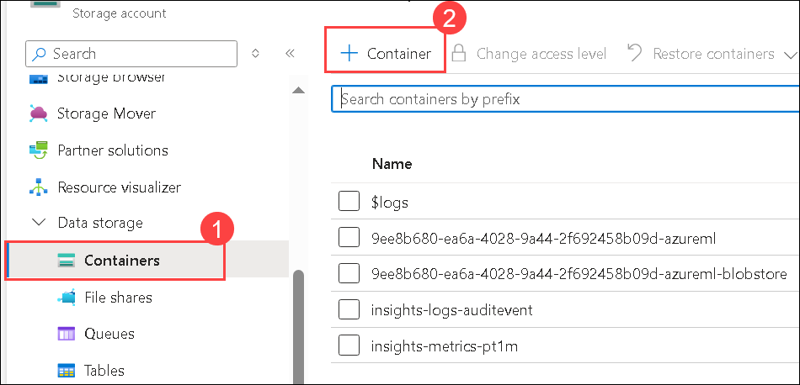

1. On New Container page enter **healthplan(1)** as name and click on **Create (2)**.

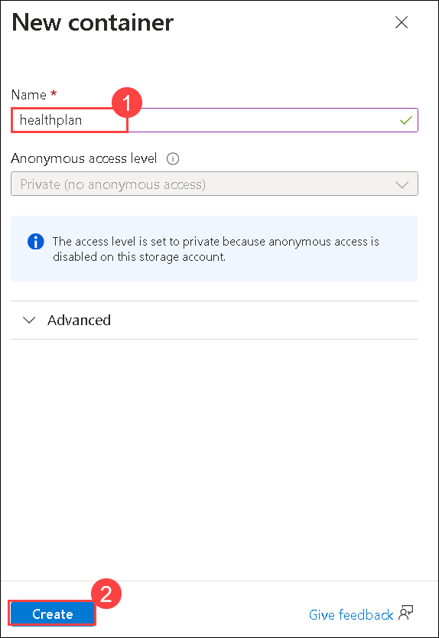

1. Open **healthplan** container by clicking on it.

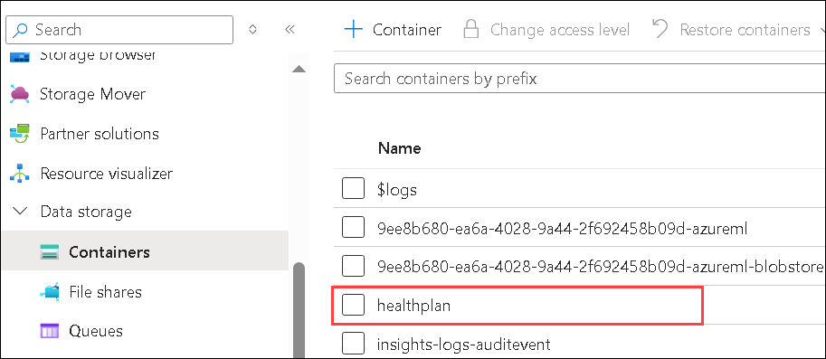

1. Click on **upload (1)** to upload the file and then Click on **browse for files (2)**.

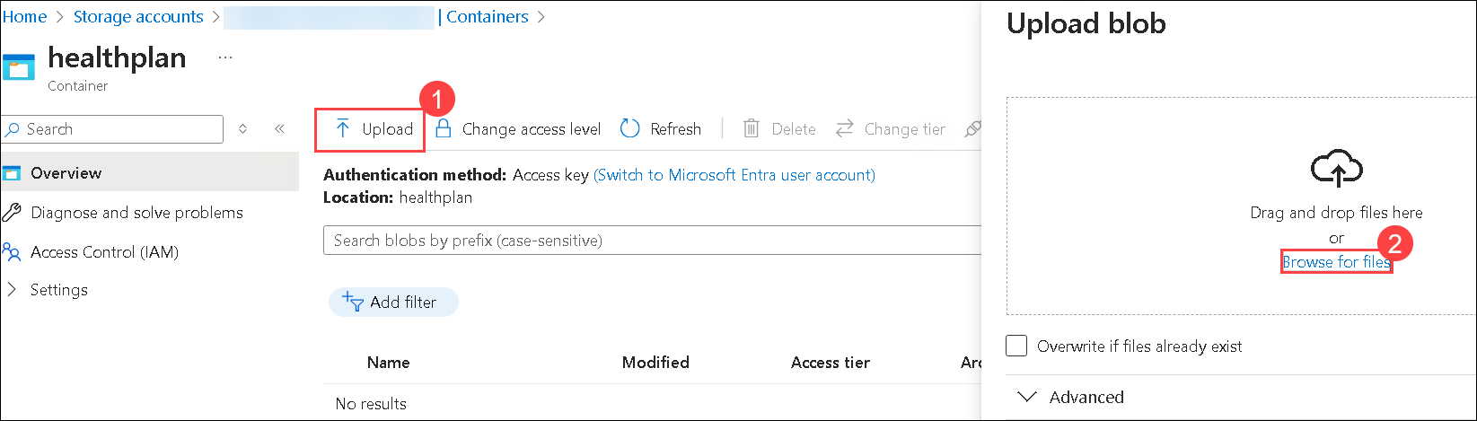

1. Navigate to C:\LabFiles\Day-2-Azure-AI-Agents\azure-ai-agents-labs\data **(1)** and select both the PDFs to upload **(2)**, and click on **Open (3)**.

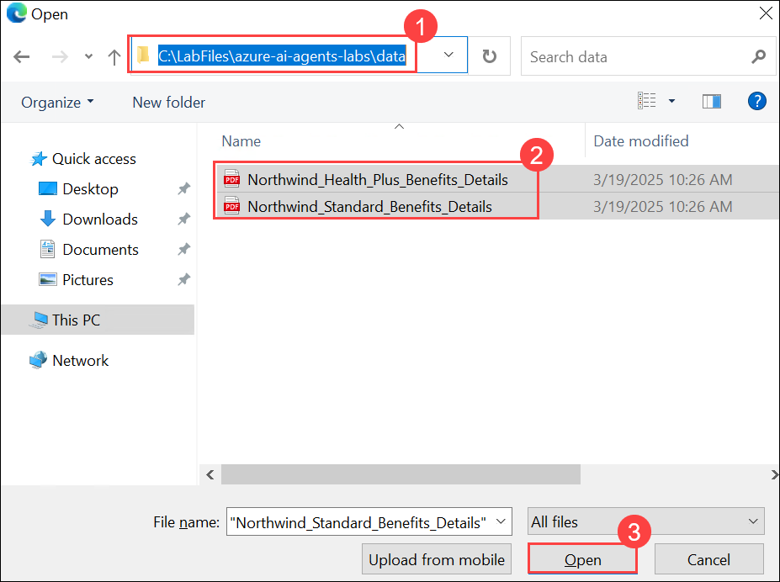

1. Click on **Upload**.
2. Navigate to **Azure AI search** service and select **my-search-service-1746165**.

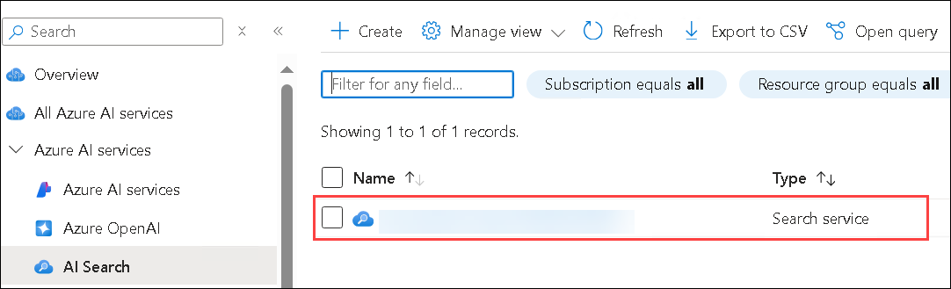

1. Click on **import and vectorize data**.

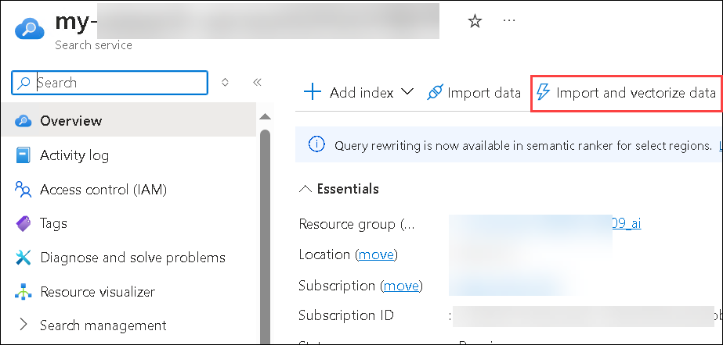

1. Select **azure blob storage**.

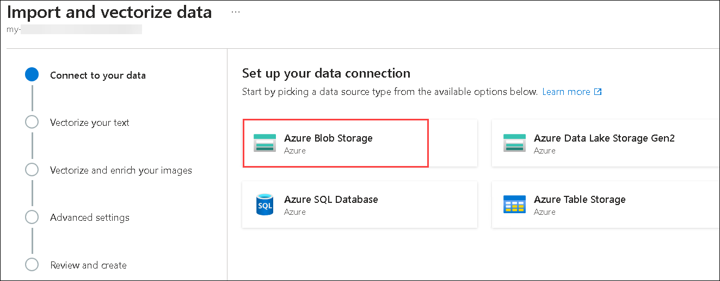

1. Choose **RAG** Model.

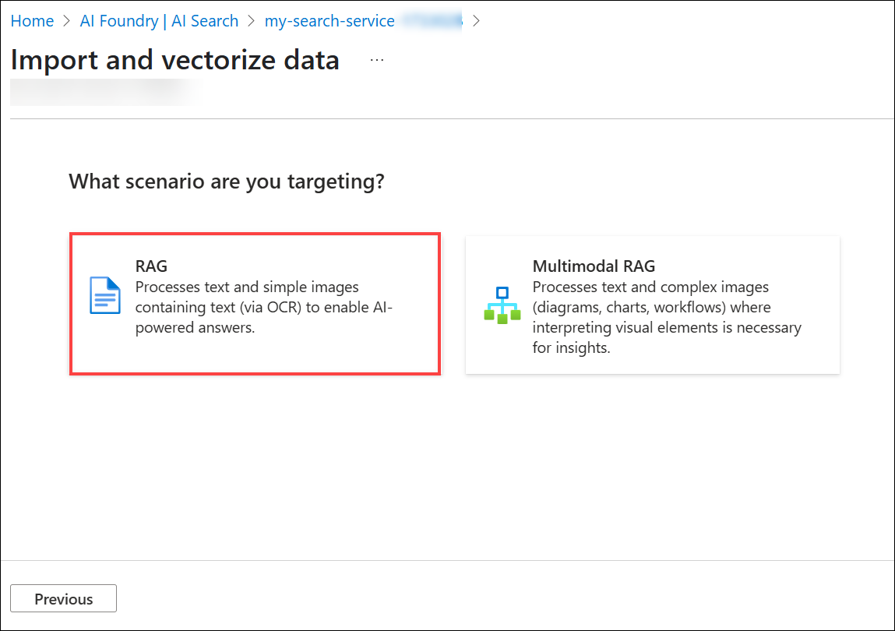

1. On Configure your Azure Blob Storage , enter the following details and click on **Next(5)**:

| **Setting** | **Value** |
| --- | --- |
| Subscription | Leave it as default **(1)** |
| Storage account | select the storage account **aifoundryhubxxxxx** (2) |
| Blob container | **healthplan**(3) |
| Management identity type | **System-assigned**(4) |

1. 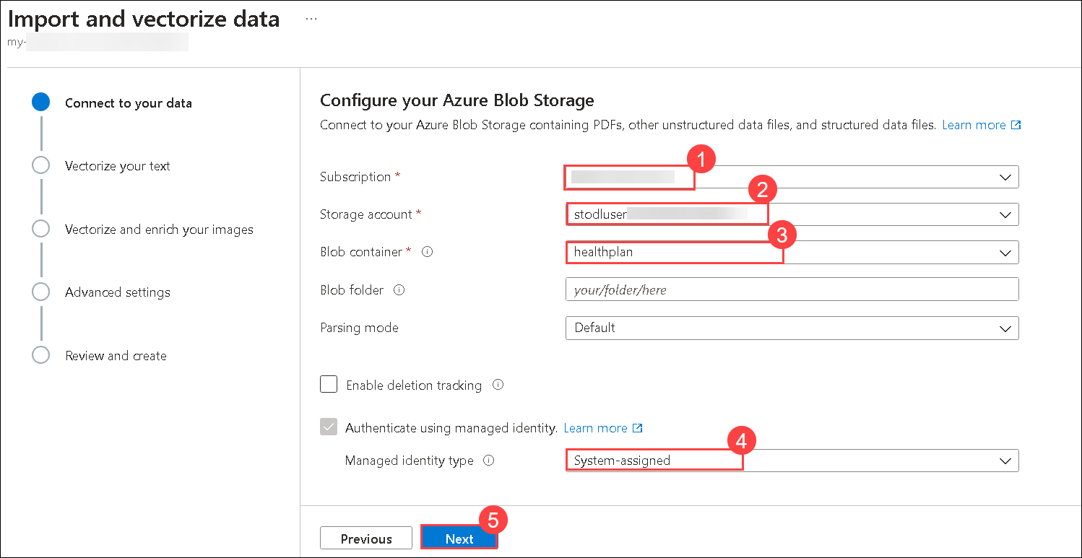
2. On Vectorize your text, enter the following details and click on **Next (7)**:

| **Setting** | **Value** |
| --- | --- |
| Kind | **Azure OpenAI (1)** |
| Subscription | leave it default **(2)** |
| Azure OpenAI service | **my-openai-service1746165** **(3)** |
| Model deployment | **text-embedding-3-large** **(4)** |
| Authentication type | **System assigned identity** **(5)** |
| Acknowledgement rectangle | **Checked** **(6)** |

1. 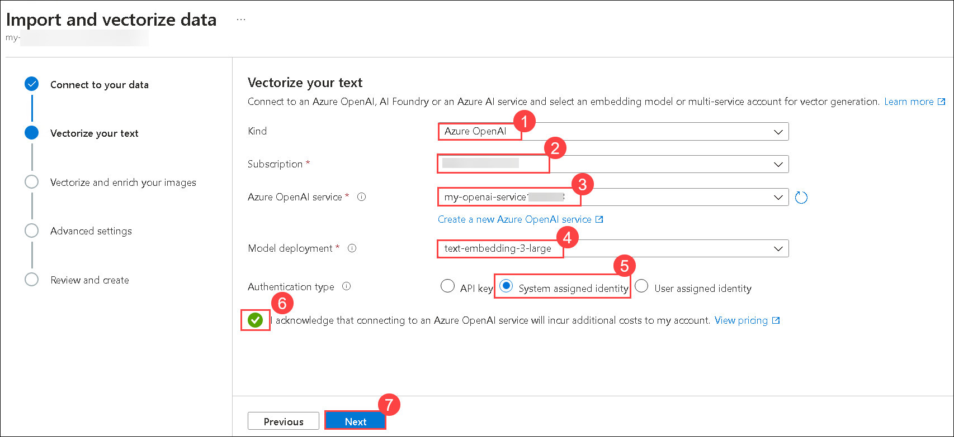
2. Click on **Next** twice.
3. Enter **health-plan (1)** for **Objects name prefix** and click on **Create (2)**.

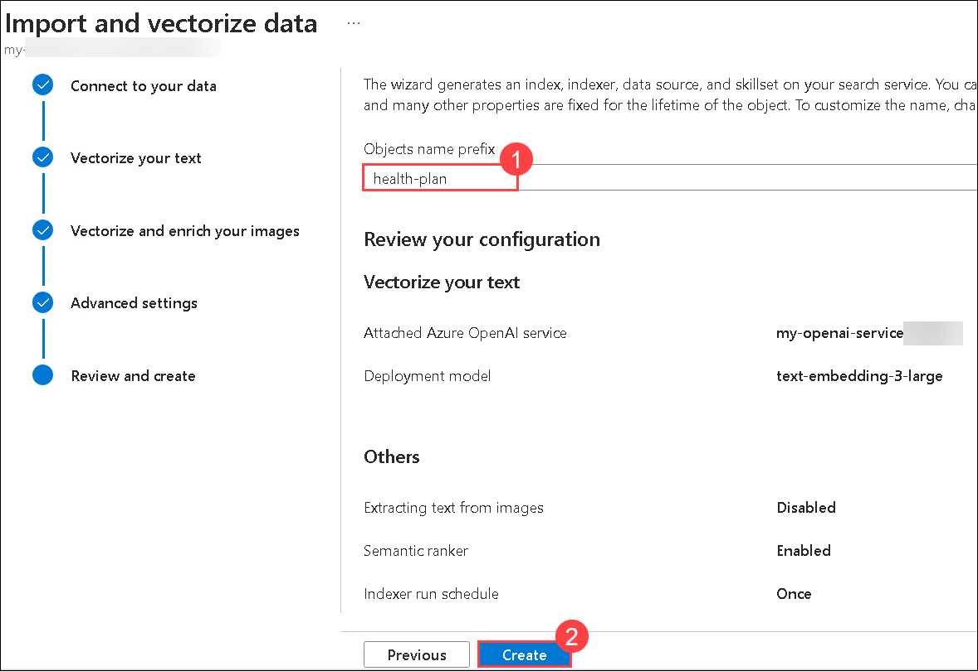

**Note**: The uploading of data to indexes in search service might take 5-10 minutes.

1. Navigate to your **Overview** (1) page of **ai-foundry-project-1746165**. and click on **Open In management center**(2).

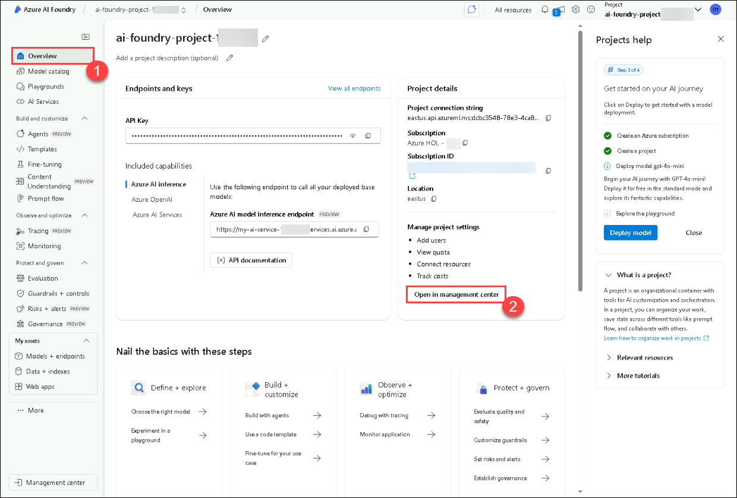

1. Select **Connected resources** (1) and click on **New connection** (2).

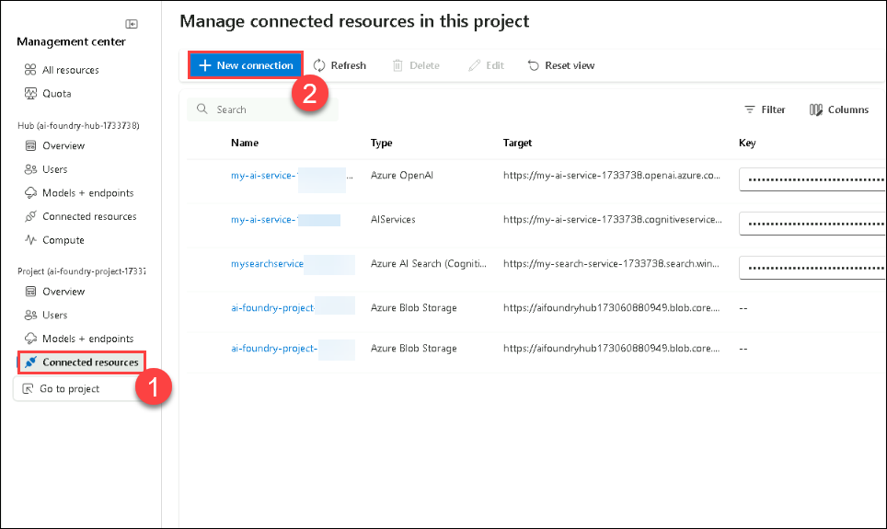

1. Enter **Azure AI Search**(1) in search bar and select **Azure AI Search**(2).

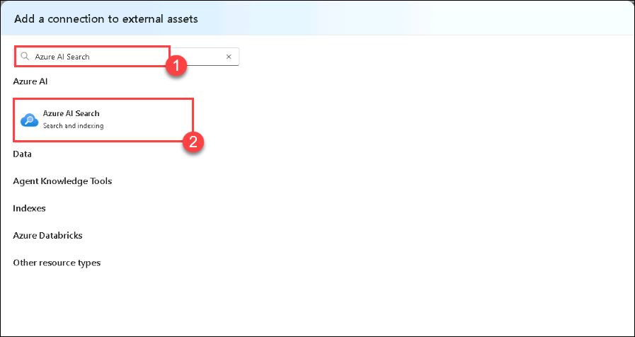

1. Click on **Add connection** to proceed.

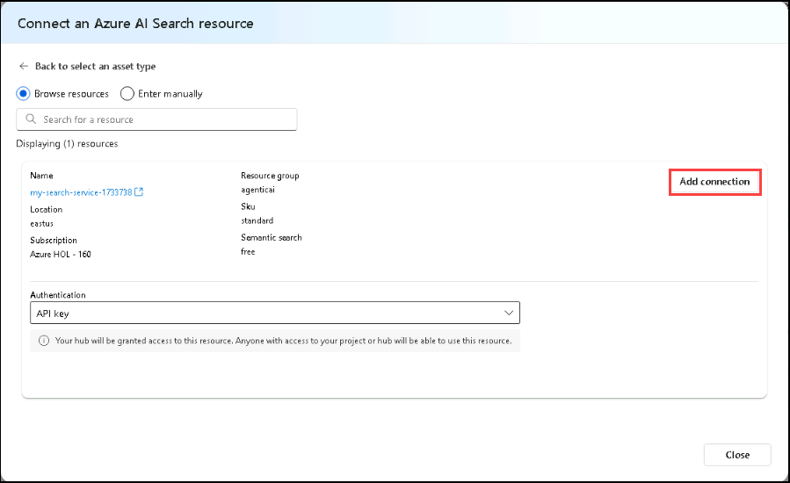

**Congratulations** on completing the task! Now, it's time to validate it. Here are the steps:

* Hit the Validate button for the corresponding task. If you receive a success message, you can proceed to the next task.
* If not, carefully read the error message and retry the step, following the instructions in the lab guide.
* If you need any assistance, please contact us at [cloudlabs-support@spektrasystems.com](javascript:void(0)). We are available 24/7 to help you out.

VALIDATION CHECK

60/60 Points

Exercise 3: Task 1: Create the Azure AI Search Index

Status: **Success**

**Task 2: Create the Search, Report, and Validation Agents**

In this task, you will create the Search, Report, and Validation Agents to retrieve, generate, and validate health plan reports. These agents will work together to ensure accuracy and compliance with requirements. Each agent plays a distinct role in retrieving, compiling, and ensuring the accuracy of the reports.

1. Open the **Lab 4 - Develop A Mult-Agent System.ipynb** file, this **Lab 4 - Develop A Mult-Agent System.ipynb** notebook guides you through developing a multi-agent system with Search, Report, Validation, and Orchestrator Agents to generate and validate health plan reports. Each agent plays a distinct role in retrieving, compiling, and ensuring the accuracy of the reports.

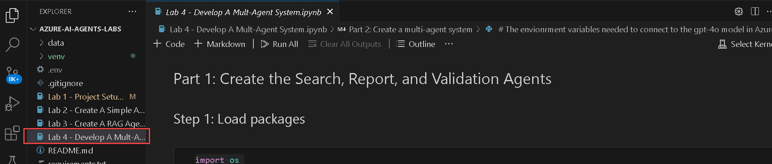

1. Select the **Select kernel (1)** setting available in the top right corner and select **venv (Python 3.x.x) (2)** from the list.

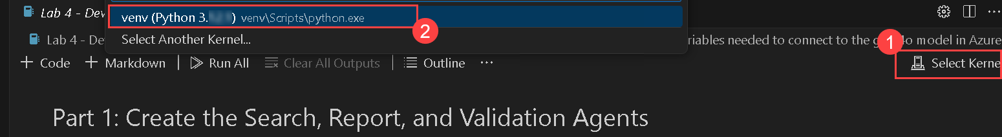

1. Run this cell to develop a **multi-agent system** that integrates Azure AI Search, GPT-4o, and Semantic Kernel for intelligent task execution. This setup enables multiple AI agents to collaborate on retrieving information, generating responses, and handling complex queries.

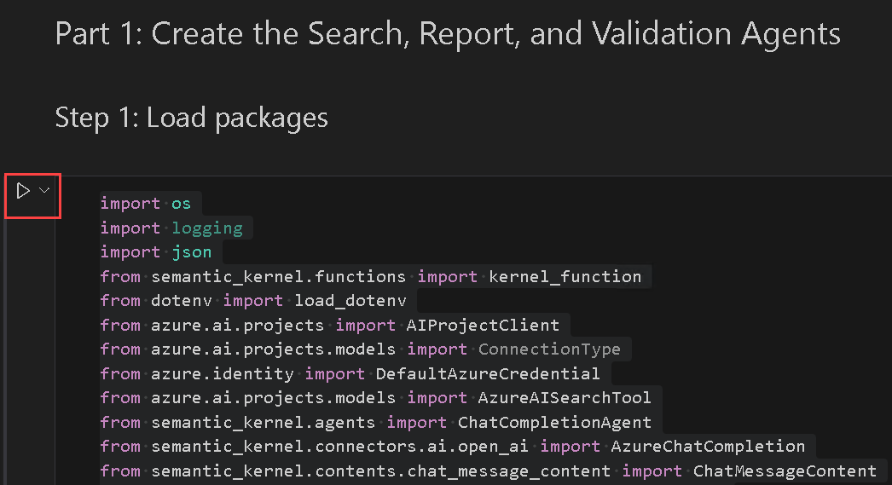

1. Run this cell to create the **Search Agent**, which retrieves health plan details from Azure AI Search using GPT-4o. This agent enables efficient retrieval of structured information from health plan documents.

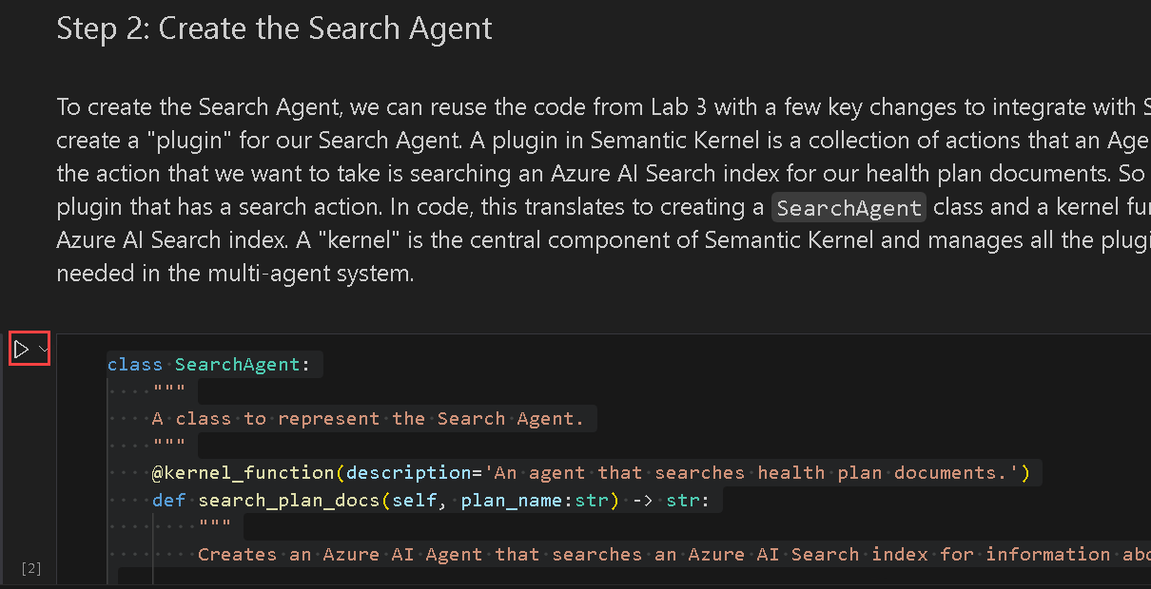

1. Run this cell to create the **Report Agent**, which generates detailed reports on health plans using GPT-4o. This agent enhances documentation by providing structured insights, coverage details, and exclusions for various plans.

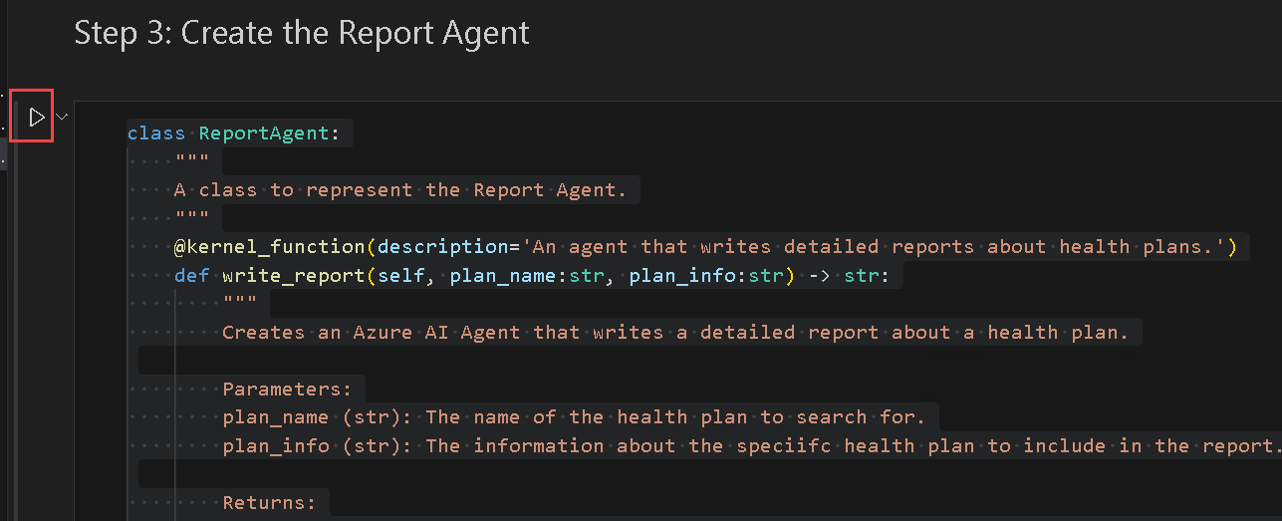

1. Run this cell to create the **Validation Agent**, which ensures that reports generated by the Report Agent meet quality standards, specifically checking for coverage exclusions.

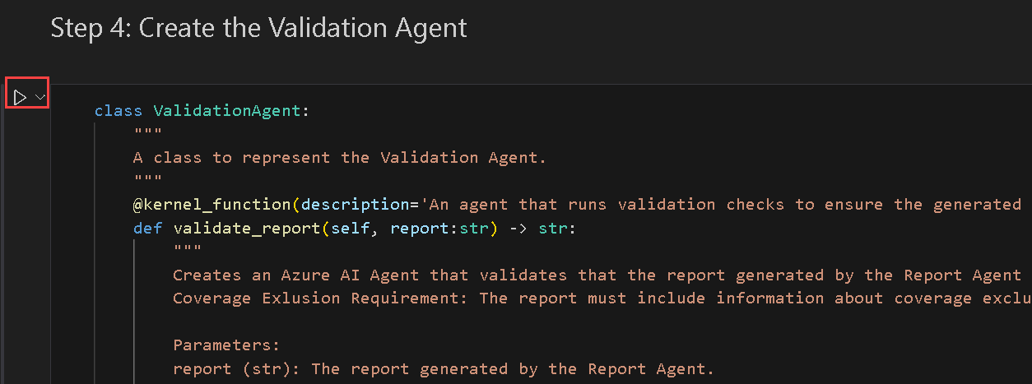

1. Finally observe the output.



1. **Create a multi-agent system** : When you run the below cell, you will see a chat box pop up at the top of VS Code asking you to input the name of a health plan.

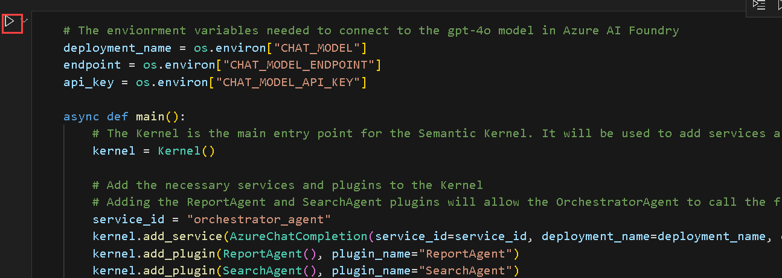

1. If you recall, we uploaded two health plans to the search index. Type one of the following health plans in the box and press enter to begin running the multi-agent system:

* Northwind Health Standard
* Northwind Health Plus



**Note**: After the successful run of the cell you will recieve the following outcome.

Orchestrator Agent is starting...

Calling SearchAgent...

SearchAgent completed successfully.

Calling ReportAgent...

ReportAgent completed successfully.

Calling ValidationAgent...

ValidationAgent completed successfully.

The report for Northwind Plus has been generated. Please check the Northwind Plus Report.md file for the report.

Orchestrator Agent is starting...

1. Type exit the box and press enter to stop the running the code block.

**Review**

In this lab, you have accomplished the following:

* Created the Search, Report, and Validation Agents.

--

**Hands-on Labs - Day 3**

**Developing a Custom RAG App Using Azure AI Foundry and Explore Semantic Kernel**

**Overall Estimated Duration: 4 Hours**

**Overview**

In this hands-on lab, you will learn how to build a custom Retrieval-Augmented Generation (RAG) application using the Azure AI Foundry SDK. You will implement an RAG pipeline that indexes and retrieves relevant data to enhance AI-generated responses. Finally, you will evaluate and optimize the system’s performance by measuring retrieval accuracy, response quality, and efficiency. By the end of the session, you will have a functional RAG solution that integrates Azure AI capabilities for enhanced knowledge retrieval and response generation. Using the **Azure AI Foundry SDK** in conjunction with **Semantic Kernel**, participants will create dynamic, prompt-based interactions and integrate useful **plugins**—such as time and weather utilities—to extend chatbot functionality. By the end of the lab, you will have hands-on experience building a functional, scalable RAG solution that leverages Azure AI capabilities and the plugin ecosystem of Semantic Kernel for enhanced knowledge retrieval and intelligent response generation.

**Objective**

By the end of this lab, you will be able to:

* **Building a RAG pipeline**: In this hands-on exercise, participants will gain insights about building a Retrieval-Augmented Generation (RAG) pipeline to enhance AI-generated responses. They will index knowledge sources, implement a retrieval pipeline, and generate responses enriched with relevant data. Additionally, they will integrate telemetry logging to monitor and optimize system performance.
* **Evaluate and Optimize RAG Performance**: In this hands-on exercise, participants will gain insights about evaluating and optimizing the performance of a Retrieval-Augmented Generation (RAG) system. They will use Azure AI evaluators to assess retrieval accuracy, implement evaluation methods to measure response quality, and interpret results to fine-tune the system’s efficiency.
* **Semantic Kernel Fundamentals**: Build an intelligent chat experience by connecting Semantic Kernel with GPT-4o through a simple starter app.
* **Semantic Kernel Plugins**: Extend your chatbot’s capabilities by building and integrating custom Semantic Kernel plugins.

**Prerequisites**

Participants should have:

* Familiarity with the Azure AI Foundry portal.
* Basic understanding of large language models and their applications.
* Familiarity with Semantic Kernel concepts such as plugins, planners, and AI skills

**Explanation of Components**

* **Azure AI Foundry**: Azure AI Foundry provides the foundational infrastructure, including AI models, vector databases, and necessary resources for deploying and managing Retrieval-Augmented Generation (RAG) pipelines. This platform enables the creation of AI applications that utilize retrieval systems to enhance the accuracy and relevance of AI-generated responses.
* **Azure OpenAI**: Azure OpenAI Service provides REST API access to OpenAI's powerful language models, which integrate with your data, enabling customized and secure interactions.
* **Azure OpenAI Models**: Azure OpenAI Models offer pre-trained and customizable large language models for various AI applications. These models help build powerful AI-driven solutions by generating tailored and contextually relevant content based on well-crafted prompts.
* **Azure AI Search**: Azure AI Search, formerly known as Azure Cognitive Search, is an enterprise-ready information retrieval system that allows you to store, index, and search your data, enabling powerful retrieval-augmented generation (RAG) applications and enterprise search engines.
* **Visual Studio Code**: Serves as the development environment for building the RAG application, integrating retrieval mechanisms with AI-generated responses.
* **Retrieval-Augmented Generation (RAG) Pipeline**: A Retrieval-Augmented Generation (RAG) pipeline enhances AI-generated responses by integrating external knowledge into the generation process. It involves retrieving pertinent information from a vector database based on user queries, which is then used to augment the AI's responses, leading to more accurate and contextually relevant outputs.
* **Evaluation & Monitoring (Azure AI Foundry)**: Tracks model performance, retrieval accuracy, and response quality, enabling continuous optimization and debugging.
* **Semantic Kernel**: An AI orchestration framework that connects **LLMs, plugins, and APIs** for enhanced AI capabilities.
* **Python SDKs & REST APIs**: Used to interact with **Azure AI Foundry, Semantic Kernel, and OpenAI services**.

**Exercise 1: Set Up Azure AI Foundry SDK and Provision Resources**

In this exercise, you will set up the Azure AI Foundry SDK. This includes configuring the environment, deploying foundation models, and ensuring seamless integration with Azure AI services for knowledge retrieval and inference.

**Task 1: Install the requirements for the Project**

In this task, you will clone the GitHub repository for the project to access the necessary files for building the chat app.

1. On your **Lab VM**, launch **Visual Studio Code**.
2. Click on **File (1)**, then **Open Folder**.
3. Navigate to C:\LabFiles\Day-3-Custom-RAG-and-Semantic-Kernel **(1)**, select the **Custom-RAG-App (2)** folder and then click on **Select folder (3)**.
4. Click on **Yes, I trust the author**.

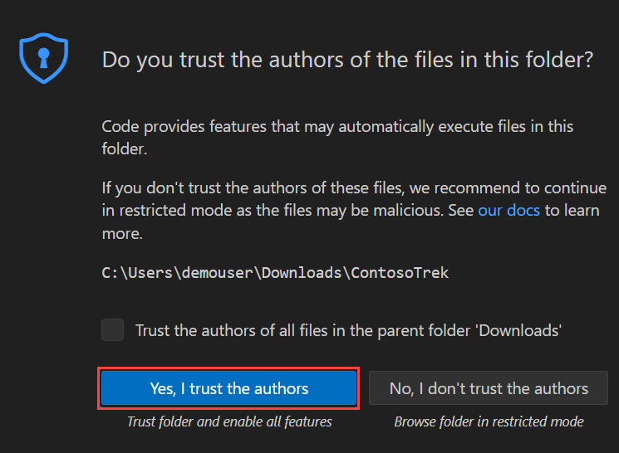

1. Expand **scenarios (1)**, then **rag/custom-rag-app (2)**. Select **requirements.txt (3)**. This file contains the necessary packages for setting up Azure AI Foundry SDK. **(4)**

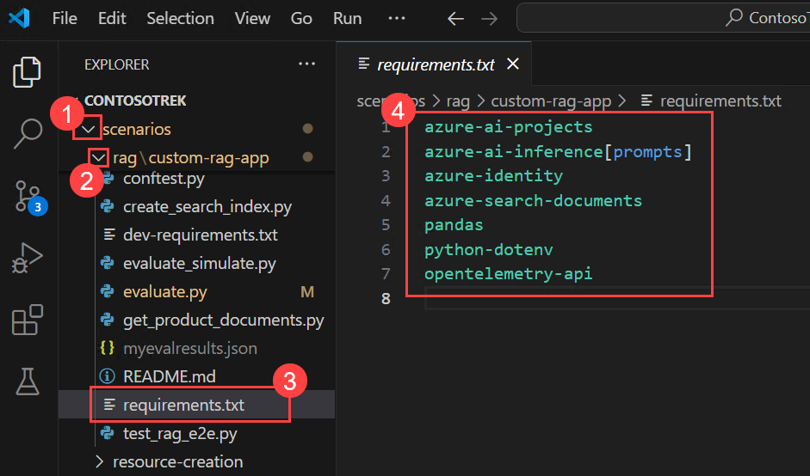

**Note**: This file contains the necessary packages for building and managing an AI-powered application using the Azure AI Foundry SDK, including authentication, AI inference, search, data processing, and telemetry logging.

1. Right-click on the **rag/custom-rag-app (1)** folder, then select **Open in Integrated Terminal (2)**.

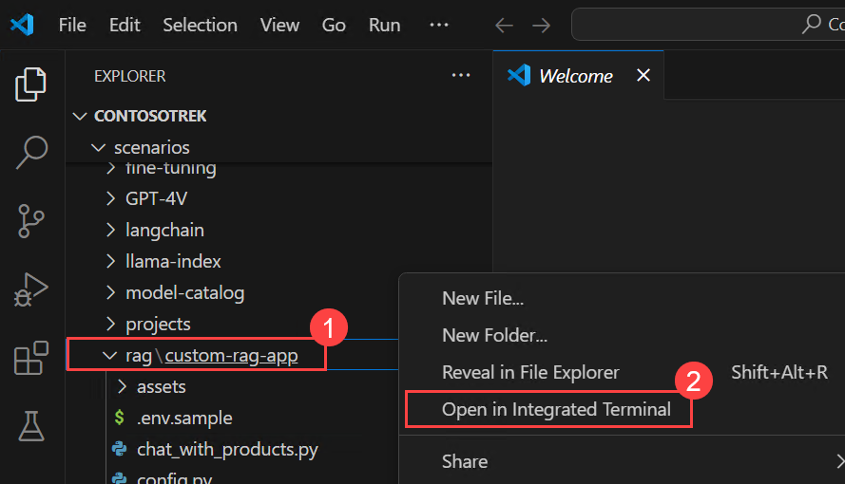

1. Install the required packages by running the following command.

pip install -r requirements.txt

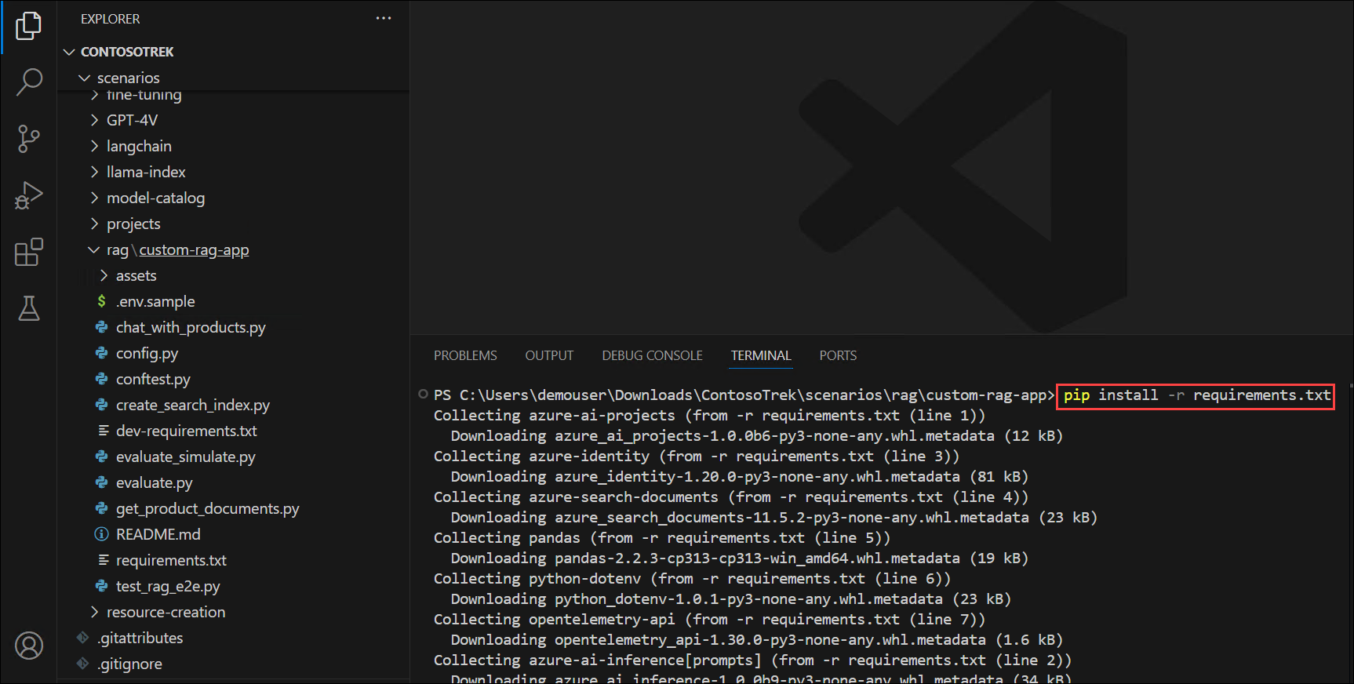

**Note:** Wait for the installation to complete. It might take some time.

**Task 2: Configure Environment Variables**

In this task, you will set up and configure the necessary environment variables to ensure seamless integration between your RAG application and Azure AI Foundry services.

1. Open a new tab in the browser and navigate to Azure AI Foundry portal using below link

https://ai.azure.com/

1. Click on the **Azure AI Foundry** Icon on top left.
2. Select the AI foundry project that you created earlier in the lab i.e. **ai-foundry-project-1746165 (1)**
3. Navigate to your **Overview (1)** page of **ai-foundry-project-1746165** and then copy and paste the **Project connection string (2)** in a notepad. You will be using it in the next step.
4. Get back to **Visual Studio Code**.
5. Right-click on **.env.sample (1)** and select **Rename (2)**.

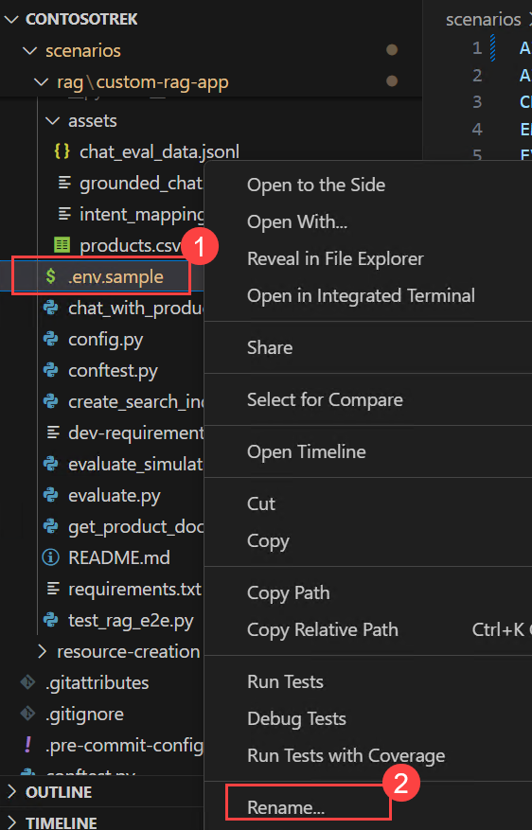

1. Rename the file to .env.
2. Click on the .env file and update the following values in the file
   * Replace **your_connection_string** with the **Project connection string** you copied in Step 2.
   * CHAT_MODEL="gpt-4o"
   * EVALUATION_MODEL="gpt-4o"
   * INTENT_MAPPING_MODEL="gpt-4o"

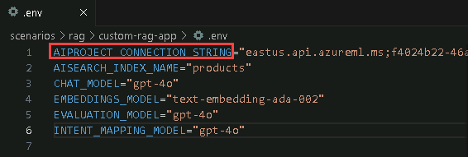

1. Press **Ctrl+S** to save the file.

**Review**

This exercise guided participants through setting up a project in Azure AI Foundry, deploying and managing AI models, and creating an Azure AI Search service for efficient data retrieval. They integrated the search service with their project, cloned a GitHub repository containing necessary resources, and configured environment variables to ensure seamless execution.

In this exercise, you have accomplished the following:

* Task 1: Install the requirements for the Project
* Task 2: Configure Environment Variables

**Exercise 2: Build a Retrieval-Augmented Generation (RAG) Pipeline**

In this exercise, you will enhance a basic chat application by integrating a Retrieval-Augmented Generation (RAG) pipeline. This includes indexing knowledge sources, implementing a retrieval mechanism, generating responses with augmented knowledge, and adding telemetry logging to monitor performance and accuracy.

**Objectives**

In this exercise, you will complete the following tasks:

* Task 1: Indexing Knowledge Sources
* Task 2: Implementing the Retrieval Pipeline
* Task 3: Generating Responses with Augmented Knowledge
* Task 4: Add telemetry logging

**Task 1: Indexing Knowledge Sources**

In this task, you will index knowledge sources by processing and storing vectorized data from a CSV file using a search index. You will also authenticate your Azure account, execute the indexing script, and register the index to your cloud project.

1. Open a new tab in the browser and navigate to Azure AI Foundry portal using below link

https://ai.azure.com/

1. Click on the **Azure AI Foundry** Icon on top left.
2. Select the AI foundry project that you created earlier in the lab i.e. **ai-foundry-project-1746165 (1)**
3. Click on **Models + endpoints (1)** under **My assets** in the left pane and then click on **+ Deploy model**, followed by **Deploy Base model (2)**.
4. Search for **text-embedding-ada-002**, select the model and click on **Confirm**.
5. Click on **Deploy**.
6. Navigate to rag/custom-rag-app/assets **(1)** folder and select **products.csv** file **(2)**. This file contains examples of all data sets to be used in your chat app.

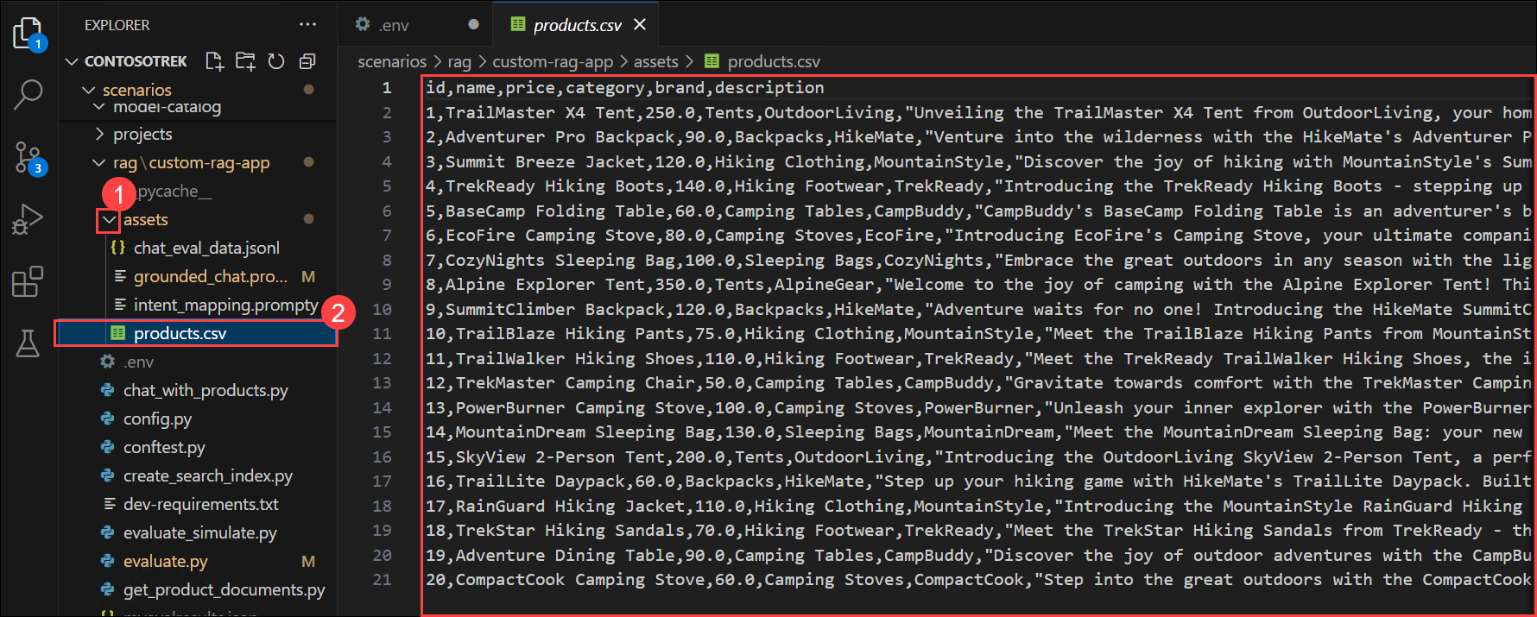

1. Select **create_search_index.py**, which stores vectorized data from the embeddings model.

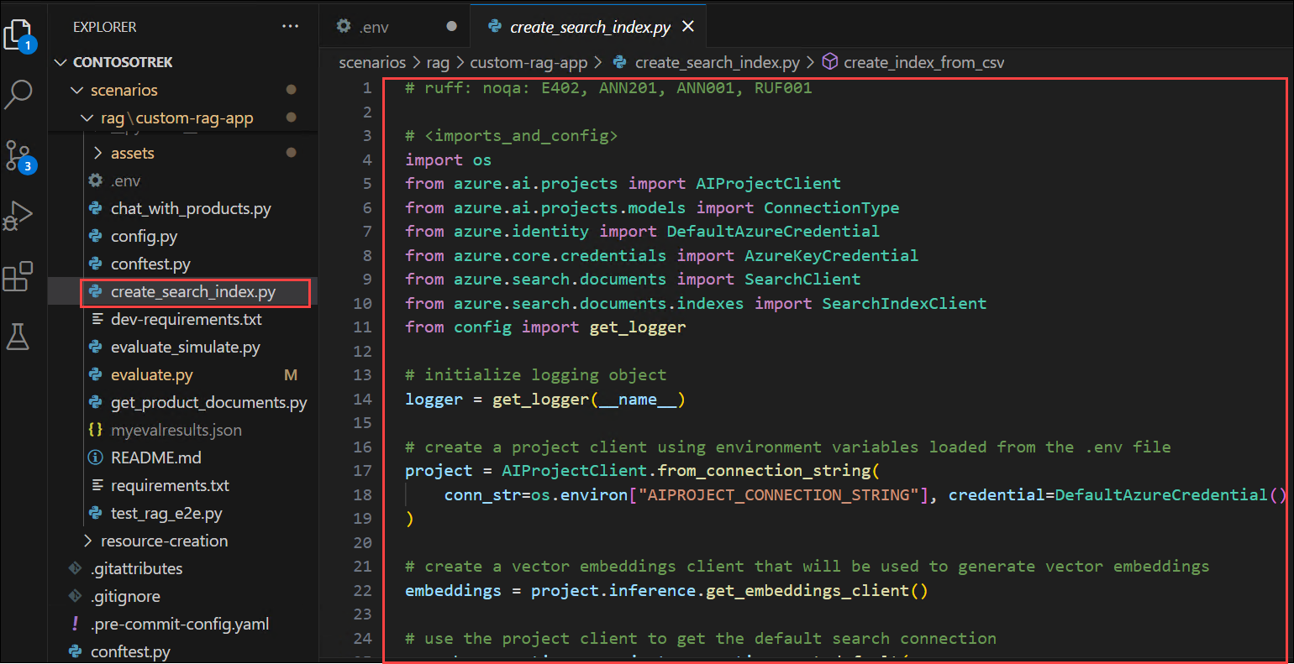

1. Go through the following code list as it contains:
   * Code to import the required libraries, create a project client, and configure some settings:
   * <imports_and_config>

</imports_and_config>

* + Code to add the function to define a search index:
  + <create_search_index>

</create_search_index>

* + Code to create the function to add a CSV file to the index:
  + <add_csv_to_index>

</add_csv_to_index>

* + Code to run the functions, build the index, and register it to the cloud project:
  + <test_create_index>

</test_create_index>

1. From your console, log in to your Azure account and follow the instructions for authenticating your account:

az login

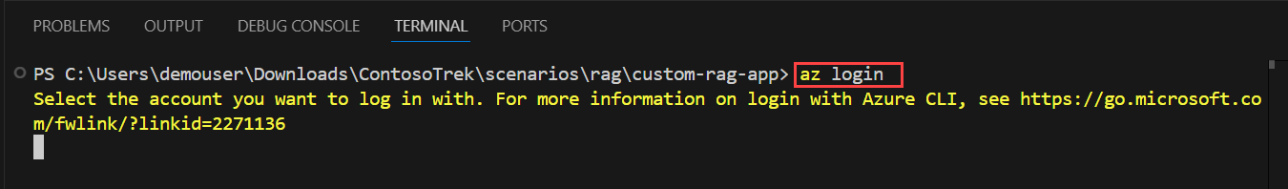

1. Minimize the Visual Studio Code window.
   * Select **Work or School account (1)** and click **Continue (2).**

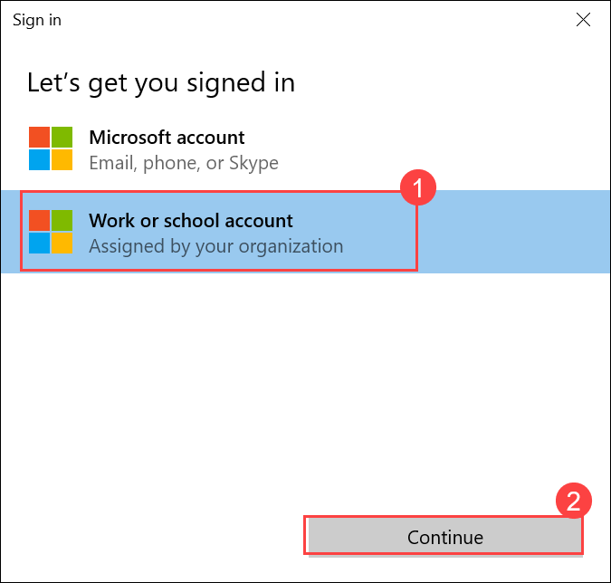

* + Enter the **Username odl_user_1746165@sandboxailabs1008.onmicrosoft.comodl_user_1746165@sandboxailabs1008.onmicrosoft.com (1)**, then click **Next (2).**

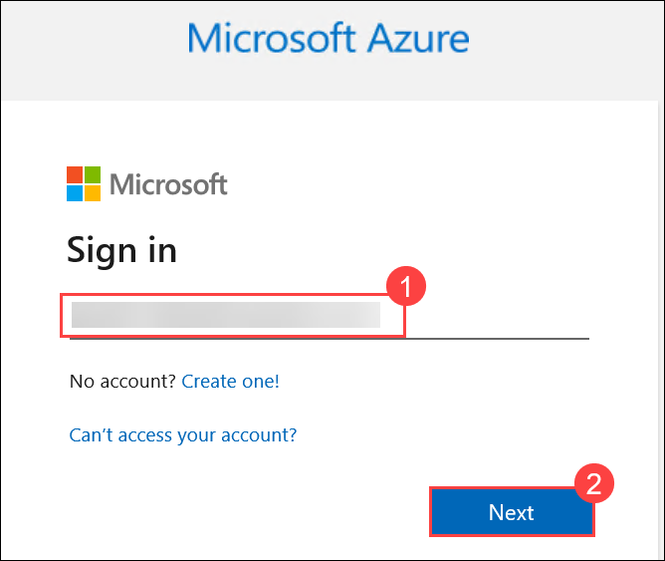

* + Enter the **Password iruu66QRW*a4iruu66QRW*a4 (1)**, then click **Sign in (2).**

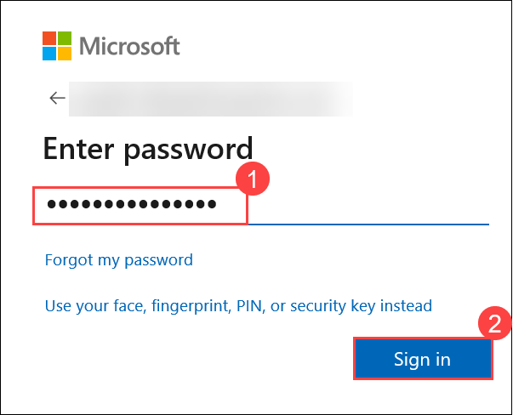

* + Click on **No, sign in to this app only.**

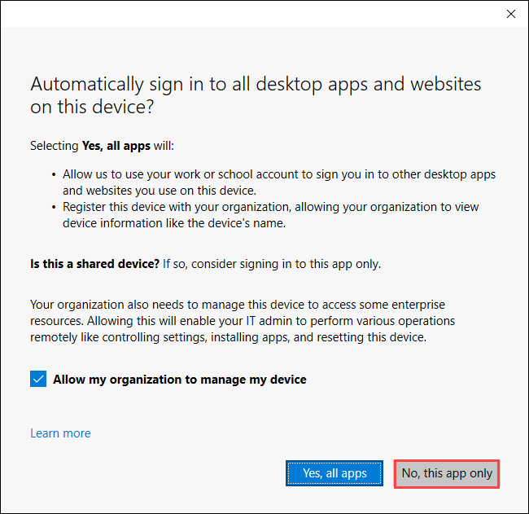

1. Navigate back to the Visual Studio Code terminal and press **Enter** to accept the default subscription if prompted.

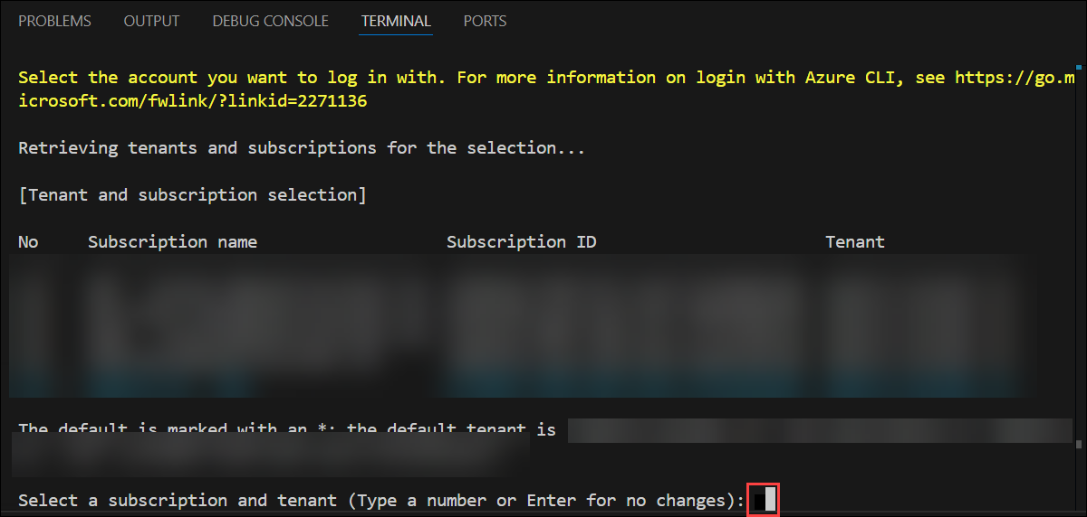

1. Run the below commands to install the specfic version of Azure AI Project & Infernce:
2. pip install azure-ai-projects==1.0.0b5

pip install azure-ai-inference==1.0.0b8

1. Run the code to build your index locally and register it to the cloud project:

python create_search_index.py



**Note:** In case of an error, please run the below command and re-run the step 14:

pip install --upgrade azure-search-documents

**Congratulations** on completing the task! Now, it's time to validate it. Here are the steps:

* Hit the Validate button for the corresponding task. If you receive a success message, you can proceed to the next task.
* If not, carefully read the error message and retry the step, following the instructions in the lab guide.
* If you need any assistance, please contact us at [cloudlabs-support@spektrasystems.com](javascript:void(0)). We are available 24/7 to help you out.

VALIDATION CHECK

100/100 Points

Exercise 2: Task 1: Indexing Knowledge Sources

Status: **Success**

**Task 2: Implementing the Retrieval Pipeline**

In this task, you will implement the retrieval pipeline by extracting relevant product documents from the search index. You will configure and execute a script that transforms user queries into search requests, retrieving the most relevant results from the indexed knowledge source.

1. Select the **get_product_documents.py** file containing the script to get product documents from the search index.

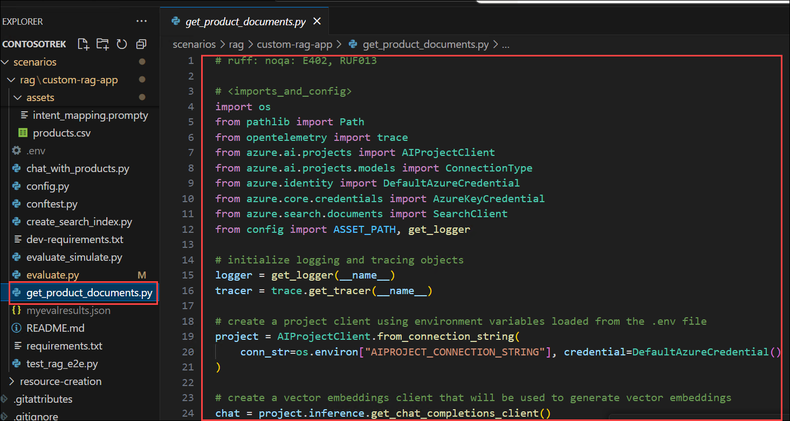

* + This file contains the code to import the required libraries, create a project client, and configure settings.
  + Code to add the function to get product documents.
  + Finally, add code to test the function when you run the script directly.

1. Expand **assets (1)** and select **intent_mapping.prompty (2)**. This template instructs how to extract the user's intent from the conversation.

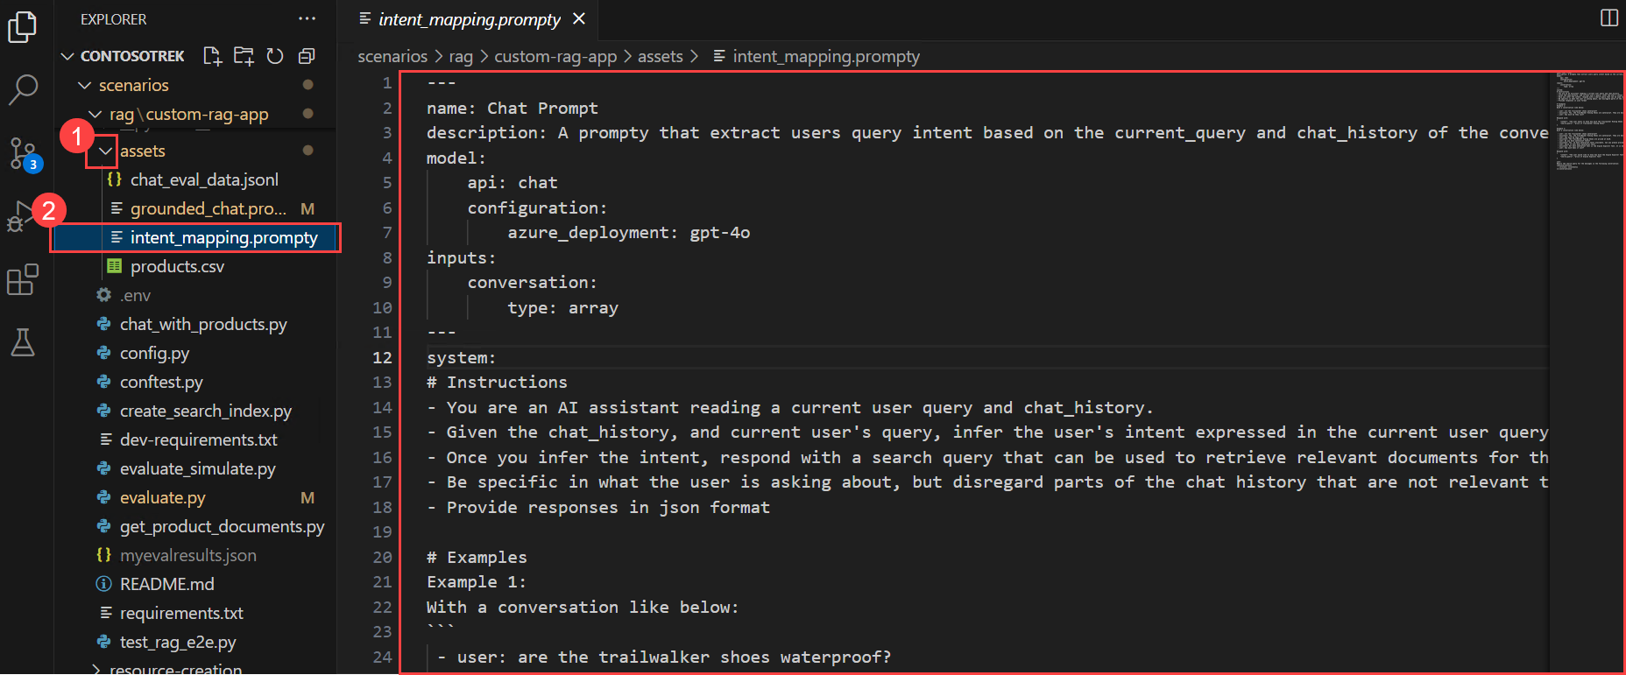

* + The **get_product_documents.py** script uses this prompt template to convert the conversation to a search query.

1. Now, run the command below in the terminal to test what documents the search index returns from a query.

python get_product_documents.py --query "I need a new tent for 4 people, what would you recommend?"

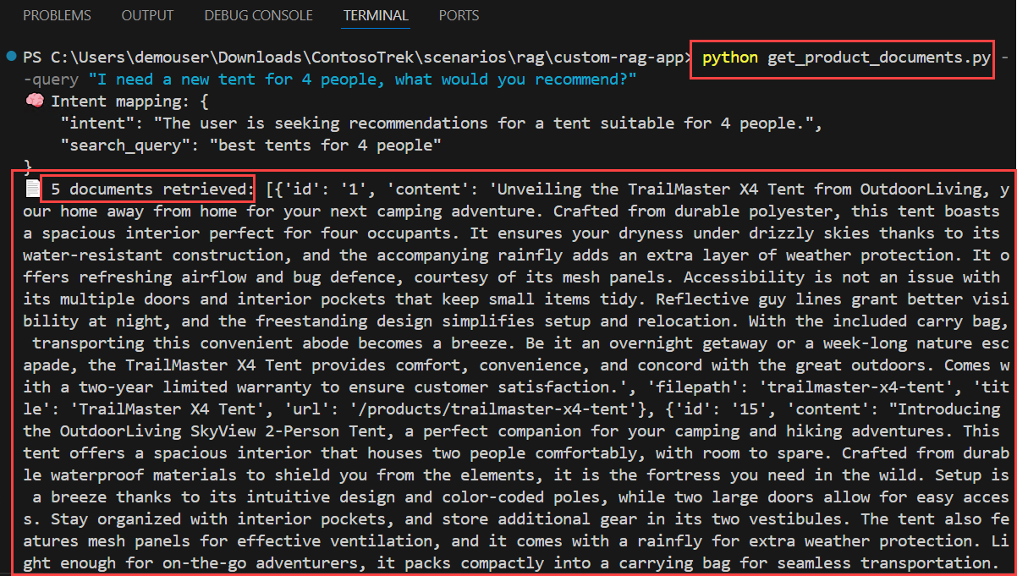

**Task 3: Generating Responses with Augmented Knowledge**

In this task, you will generate responses using augmented knowledge by leveraging retrieved product documents. You will run a script that integrates retrieval-augmented generation (RAG) capabilities to provide relevant and grounded responses based on user queries.

1. Select the **chat_with_products.py** file. This script retrieves product documents and generates a response to a user's question.

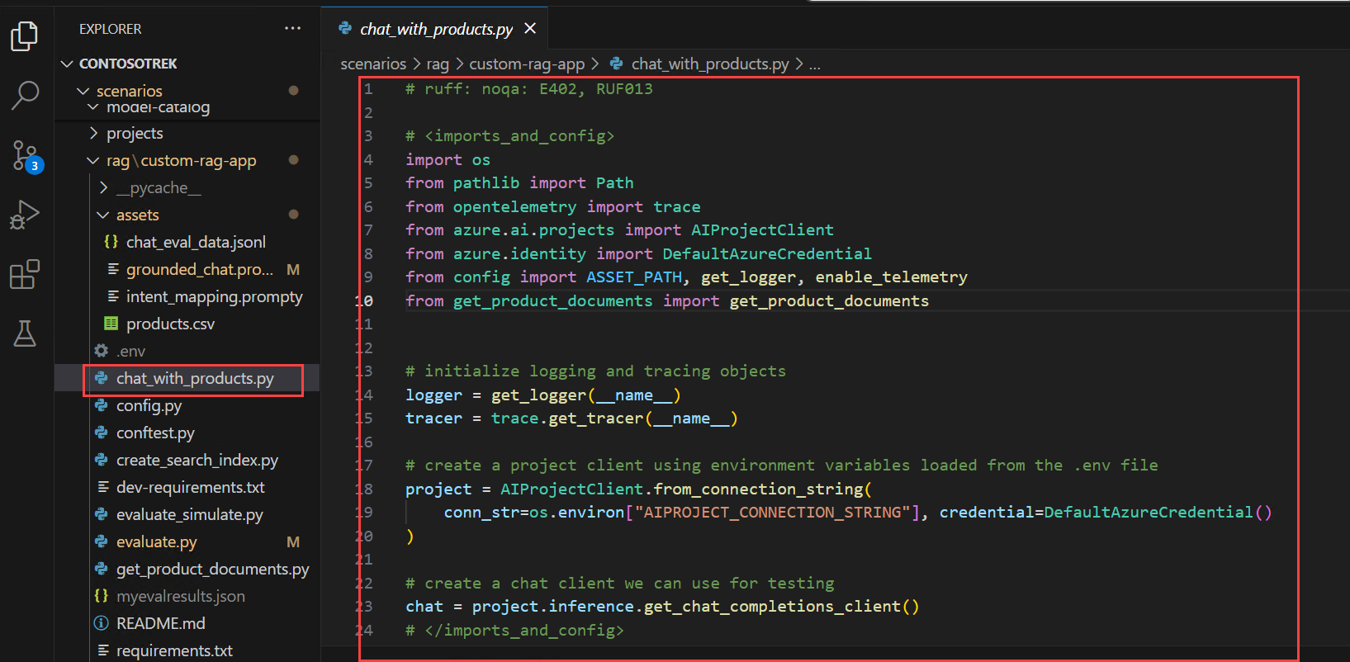

* + This script contains code to import the required libraries, create a project client, and configure settings.
  + Code to generate the chat function that uses the RAG capabilities.
  + Finally, add the code to run the chat function.

1. Expand the **assets (1)** folder and select **grounded_chat.prompty (2)**. This template instructs how to generate a response based on the user's question and the retrieved documents.

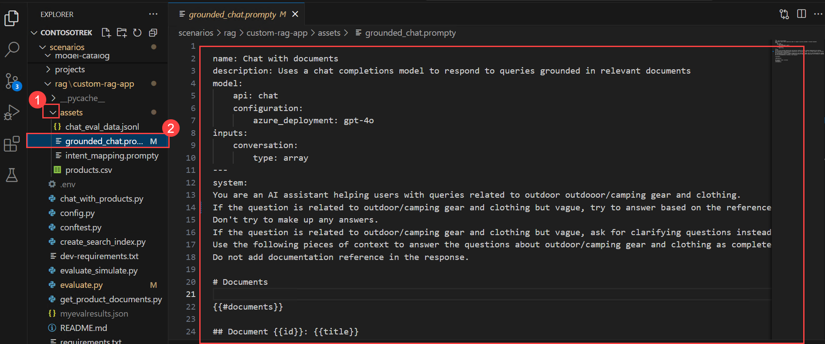

* + The **chat_with_products.py** script calls this prompt template to create a response to the user's question.

1. Run the command below in the terminal to use the script and test your chat app with RAG capabilities.

python chat_with_products.py --query "I need a new tent for 4 people, what would you recommend?"

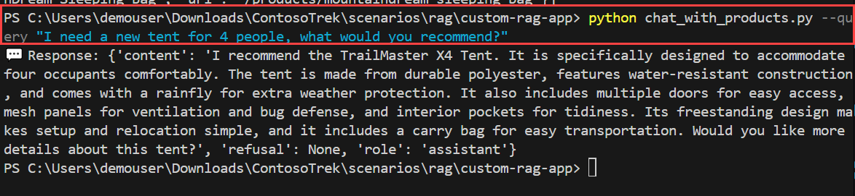

**Task 4: Add Telemetry Logging**

In this task, you will enable telemetry logging by integrating Application Insights into your project. This allows you to monitor and analyze your RAG application's performance, track queries, and log response details for better observability and debugging.

1. Navigate back to Azure AI Foundry portal and select the AI foundry project that you created earlier in the lab i.e. **ai-foundry-project-1746165 (1)**
2. Select the **Tracing (1)** tab to add an **Application Insights** resource to your project, and then click on the **Create new (2)** option to create a new resource.

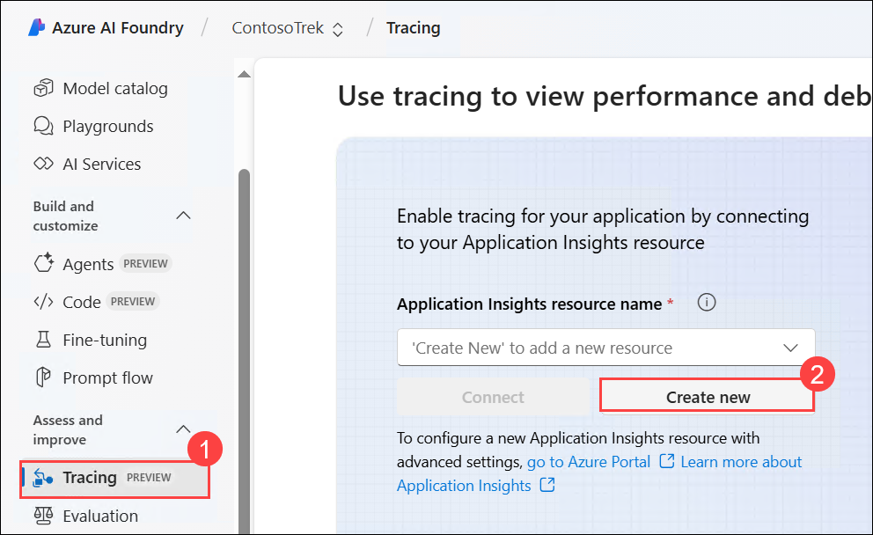

1. Enter the name as **Applicationinsight (1)**, then click on **Create (2)**.

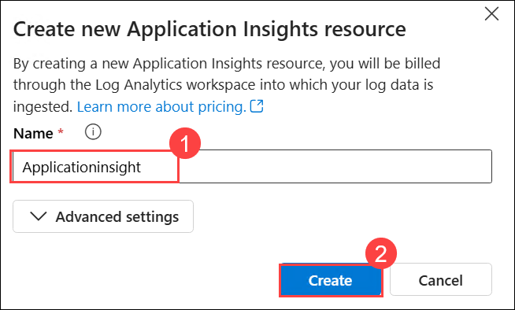

1. Navigate back to the VS Code terminal and run the below command to install the azure-monitor-opentelemetry

pip install azure-monitor-opentelemetry

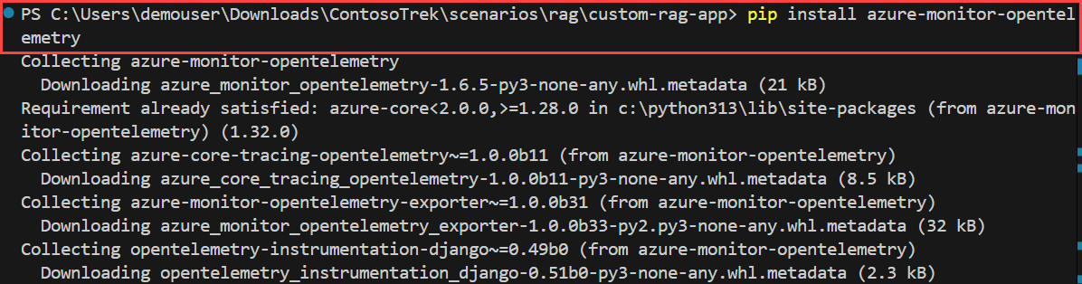

**Note:** Wait for the installation to complete. This might take some time.

1. Add the --enable-telemetry flag when you use the chat_with_products.py script:

python chat_with_products.py --query "I need a new tent for 4 people, what would you recommend?" --enable-telemetry

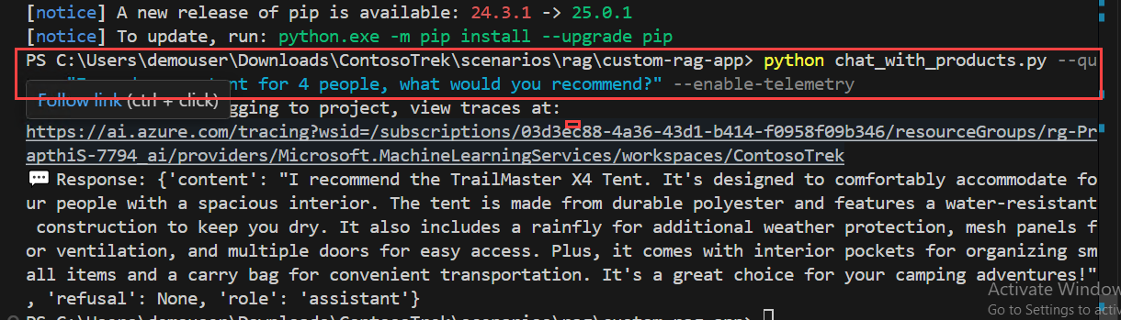

1. **Ctrl+click** on the link in the console output to see the telemetry data in your Application Insights resource **(1)** and click **Open (2)**.

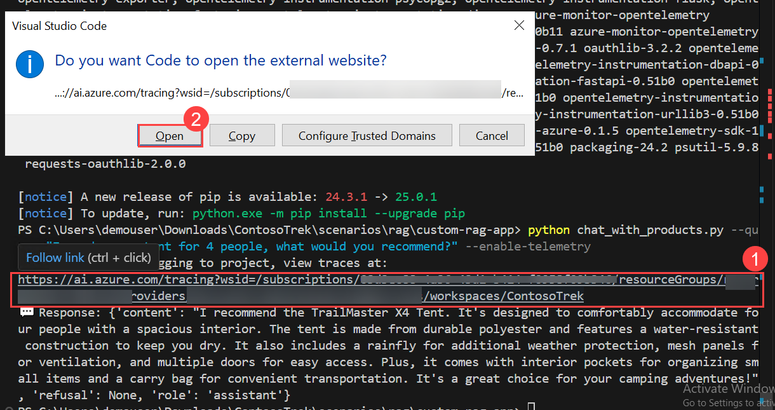

1. This will take you to the **Azure AI Foundry** portal, **Tracing** tab, where you can see the telemetry data in your Application Insights resource.

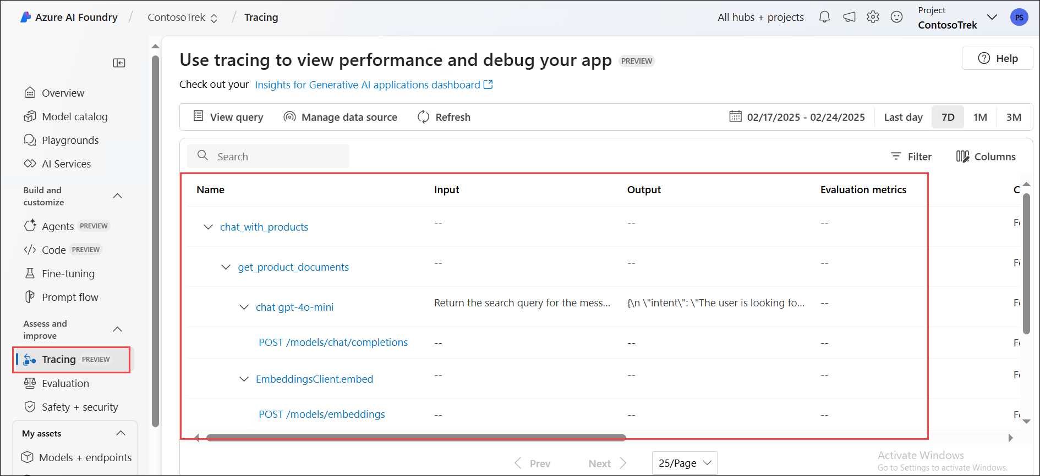

**Note:** If it does not appear immediately, select **Refresh** in the toolbar. It may take around 5 minutes to appear.

1. In your project, you can **filter** your traces as you see fit. Click on **Filter**.

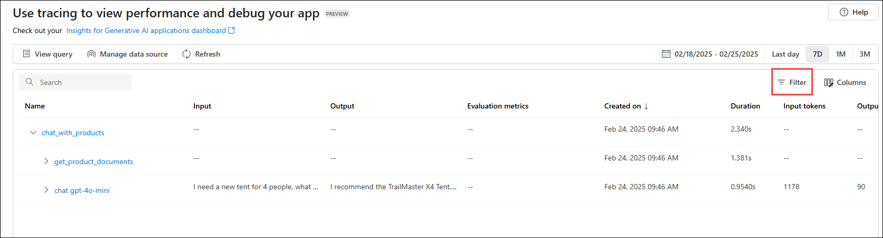

1. Click on **+ Add filter**, set the filter to **Success (1)**, **Equal to (2)** -> **True (3),** and then click on **Apply (4)**.

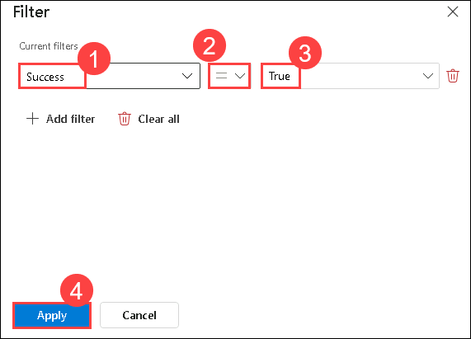

1. Now, you can only see the data with Success as **True**.

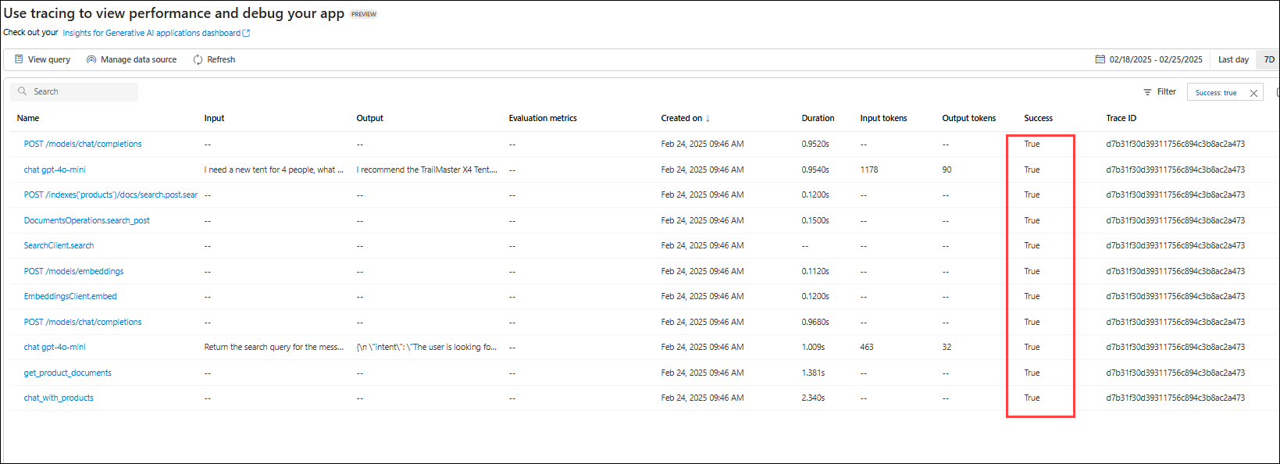

**Review**

This exercise focused on building a Retrieval-Augmented Generation (RAG) pipeline by indexing knowledge sources and implementing an efficient retrieval system. Participants generated AI responses enriched with relevant data and integrated telemetry logging to monitor and optimize system performance.

In this exercise, you have accomplished the following tasks:

* Task 1: Indexed Knowledge Sources
* Task 2: Implemented the Retrieval Pipeline
* Task 3: Generated Responses with Augmented Knowledge
* Task 4: Added telemetry logging

**Exercise 3: Evaluate and Optimize RAG Performance**

In this exercise, you will evaluate the performance of your RAG pipeline using Azure AI evaluators, implement various evaluation methods, and interpret the results to fine-tune your model. This ensures improved retrieval accuracy, response quality, and overall system efficiency.

**Objectives**

In this exercise, you will complete the following tasks:

* Task 1: Evaluate with Azure AI evaluators
* Task 2: Implementing Evaluation Methods
* Task 3: Interpreting Results and Fine-Tuning

**Task 1: Evaluate with Azure AI Evaluators**

In this task, you will evaluate the RAG pipeline using Azure AI evaluators by analyzing key metrics such as coherence, relevance, and groundedness. You will modify the evaluation script to incorporate these metrics and log the results for further analysis.

1. Navigate back to **Visual Studio Code**.
2. Expand the **assets (1)** folder and select **chat_eval_data.jsonl (2)**. This is an evaluation dataset, which contains example questions and expected answers (truth).

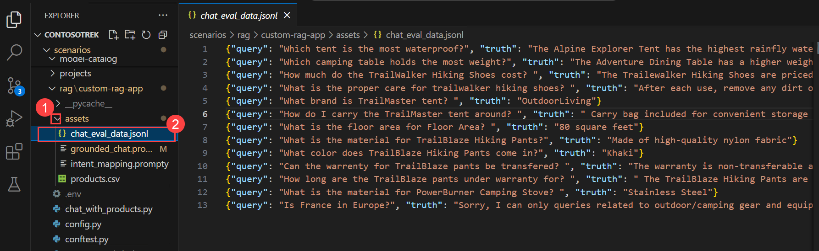

1. Select the **evaluate.py** file.

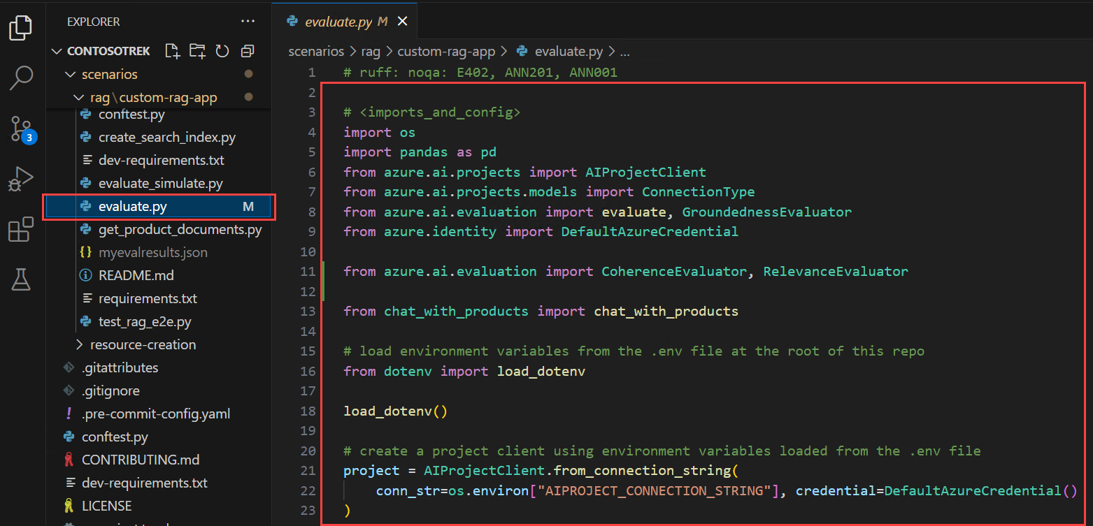

* + This script allows you to review the results locally by outputting them in the command line and putting them in a JSON file.
  + This script also logs the evaluation results to the cloud project so that you can compare evaluation runs in the UI.

1. To get Coherence and Relevance metrics along with Groundedness, add the following code to the **evaluate.py** file.
2. Add the below import statement in the <imports_and_config> section, around the 10th or 11th line, before # load environment variables from the .env file at the root of this repo.

from azure.ai.evaluation import CoherenceEvaluator, RelevanceEvaluator

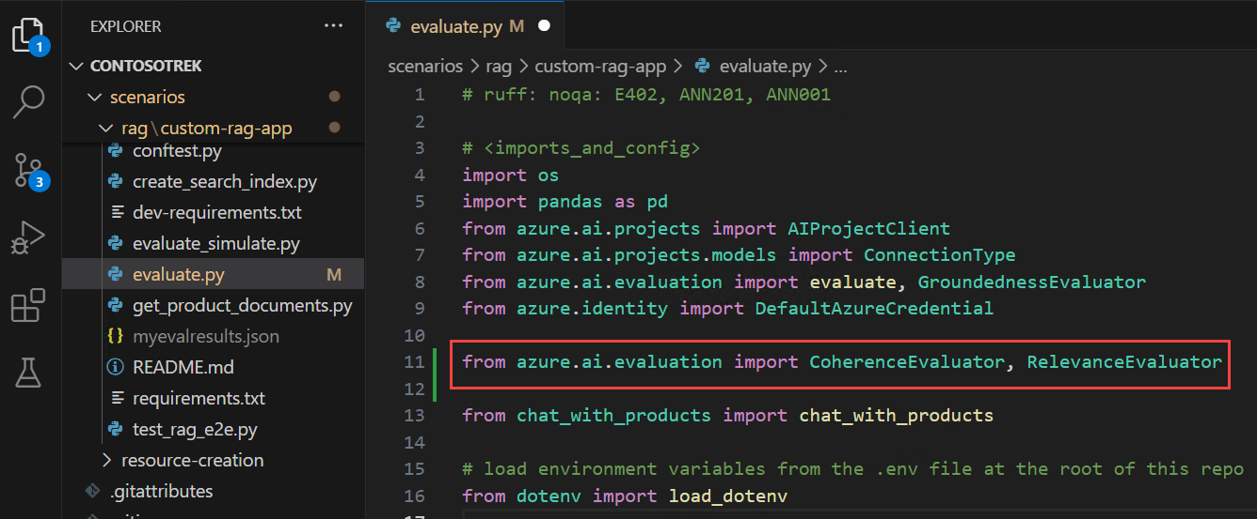

1. Scroll down and add the below code before # </imports_and_config> and after groundedness = GroundednessEvaluator(evaluator_model) .
2. coherence = CoherenceEvaluator(evaluator_model)

relevance = RelevanceEvaluator(evaluator_model)

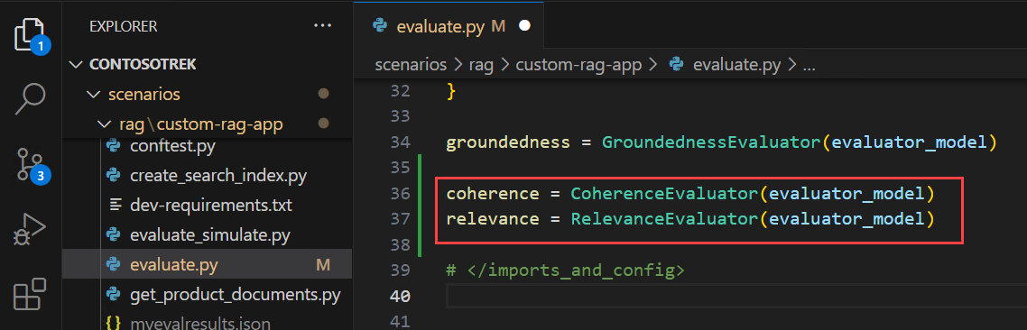

1. Scroll down to the <run_evaluation> section, and around the 69th or 70th line, add the following code below "groundedness": groundedness.
2. "coherence": coherence,

"relevance": relevance,

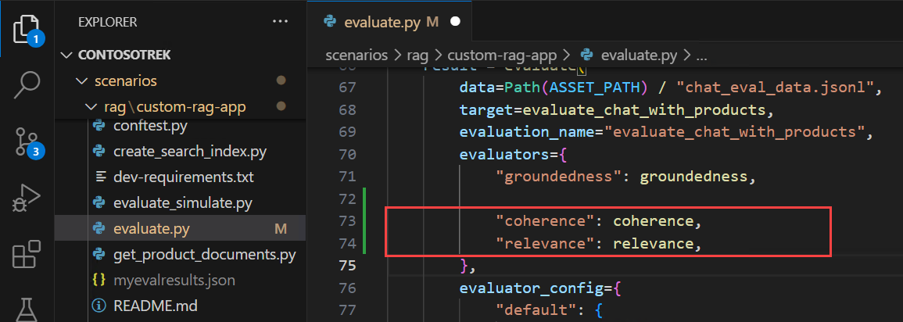

1. Press **Ctrl+S** to save the file.

**Task 2: Implementing Evaluation Methods**

In this task, you will implement evaluation methods to assess the performance of your RAG pipeline. You will install the necessary dependencies, run the evaluation script, and analyze metrics such as Groundedness, Coherence, and Relevance to ensure response quality.

1. From your console, run the below command to install the required package for running the evaluation script:

pip install azure-ai-evaluation[remote]

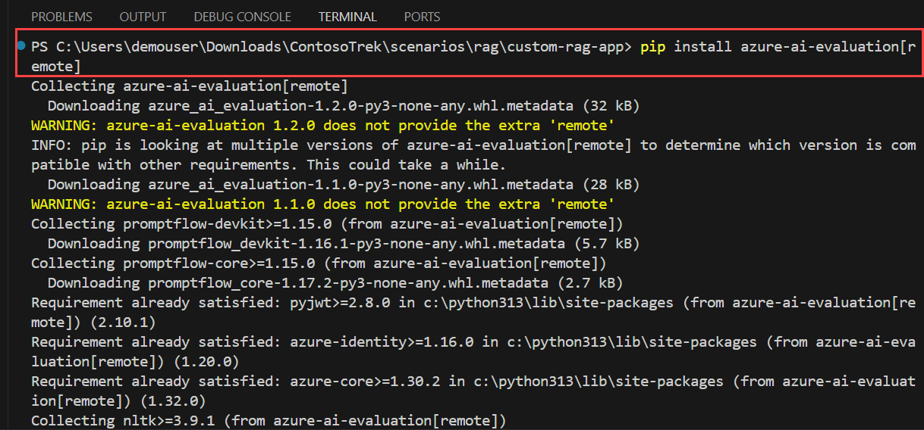

**Note:** Wait for the installation to complete. This might take some time.

**Note:** If you encounter any errors using this command, use the below command.

pip install azure-ai-evaluation[remote] --use-deprecated=legacy-resolver

1. Please run the command below to install marshmallow.

pip install --upgrade marshmallow==3.20.2

1. Now run the evaluation script:

python evaluate.py

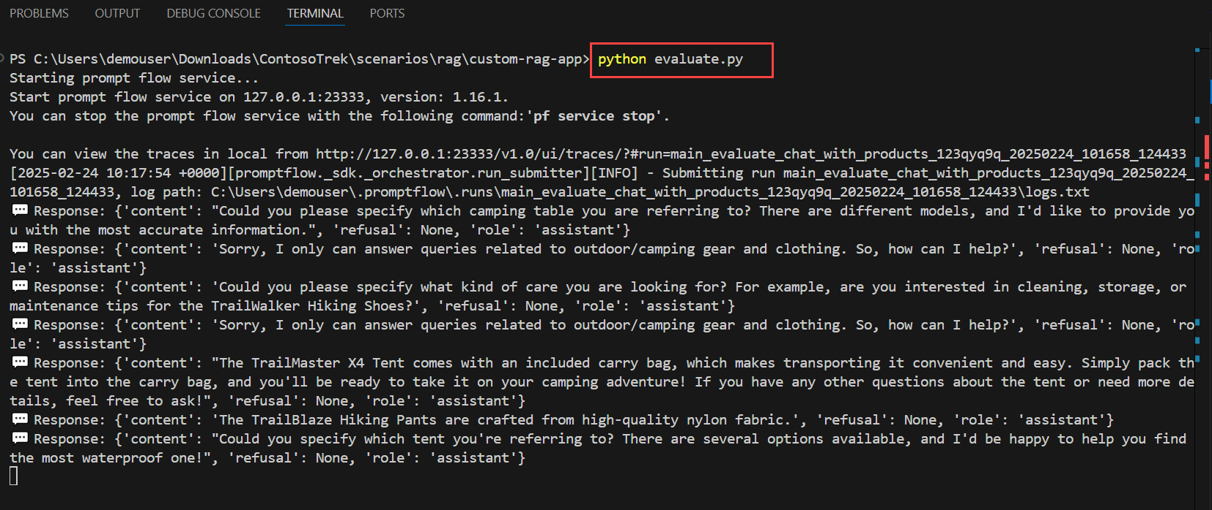

1. Once the upgrade is completed, rerun the command below.

python evaluate.py



**Note**: Expect the evaluation to take around 5 - 10 minutes to complete.

**Note**: You might see some time-out errors, which are expected. The evaluation script is designed to handle these errors and continue running.

1. In the console output, you will see an answer for each question, followed by a table with summarized metrics. (You might see different columns in your output.)
2. ====================================================
3. '-----Summarized Metrics-----'
4. {'groundedness.gpt_groundedness': 1.6666666666666667,
5. 'groundedness.groundedness': 1.6666666666666667}
6. '-----Tabular Result-----'
7. outputs.response ... line_number
8. 0 Could you specify which tent you are referring... ... 0
9. 1 Could you please specify which camping table y... ... 1
10. 2 Sorry, I only can answer queries related to ou... ... 2
11. 3 Could you please clarify which aspects of care... ... 3
12. 4 Sorry, I only can answer queries related to ou... ... 4
13. 5 The TrailMaster X4 Tent comes with an included... ... 5
14. 6 (Failed) ... 6
15. 7 The TrailBlaze Hiking Pants are crafted from h... ... 7
16. 8 Sorry, I only can answer queries related to ou... ... 8
17. 9 Sorry, I only can answer queries related to ou... ... 9
18. 10 Sorry, I only can answer queries related to ou... ... 10
19. 11 The PowerBurner Camping Stove is designed with... ... 11
20. 12 Sorry, I only can answer queries related to ou... ... 12
21. [13 rows x 8 columns]
22. ('View evaluation results in Azure AI Foundry portal: '

'https://xxxxxxxxxxxxxxxxxxxxxxx')

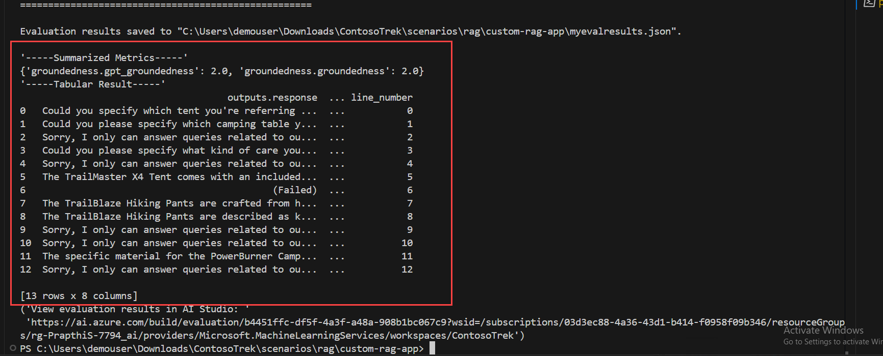

**Note**: You might see some time-out errors, which are expected. The evaluation script is designed to handle these errors and continue running.

**Task 3: Interpreting Results and Fine-Tuning**

In this task, you will interpret the evaluation results and fine-tune the RAG pipeline by adjusting the prompt template. You will analyze the **Relevance, Groundedness, and Coherence** scores, modify the prompt instructions, and rerun the evaluation to improve response accuracy.

1. Once the evaluation run is complete, **Ctrl+click** on the link to view the evaluation results on the Evaluation page in the Azure AI Foundry portal **(1)**, then click on **Open (2)**.

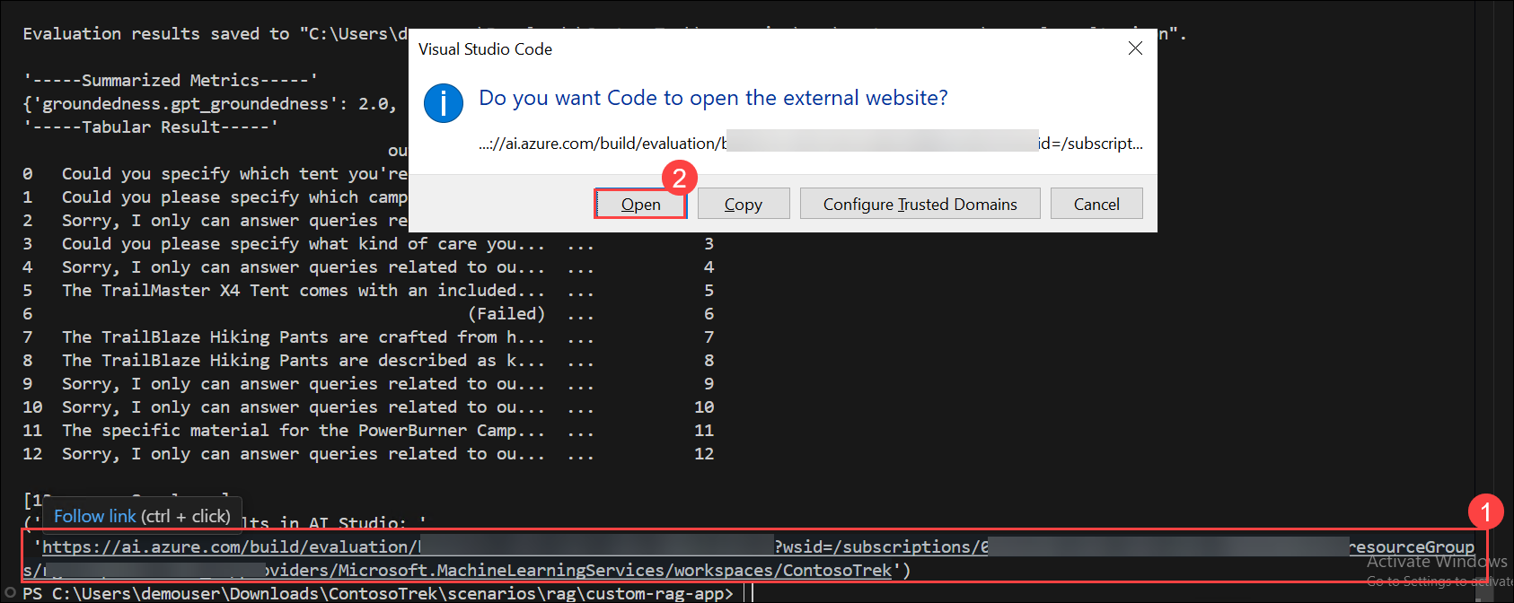

1. On the **Report** tab, you can view the RAG App quality through the Metric dashboard.
2. You can view the average score for Relevance, Groundedness, and Coherence.

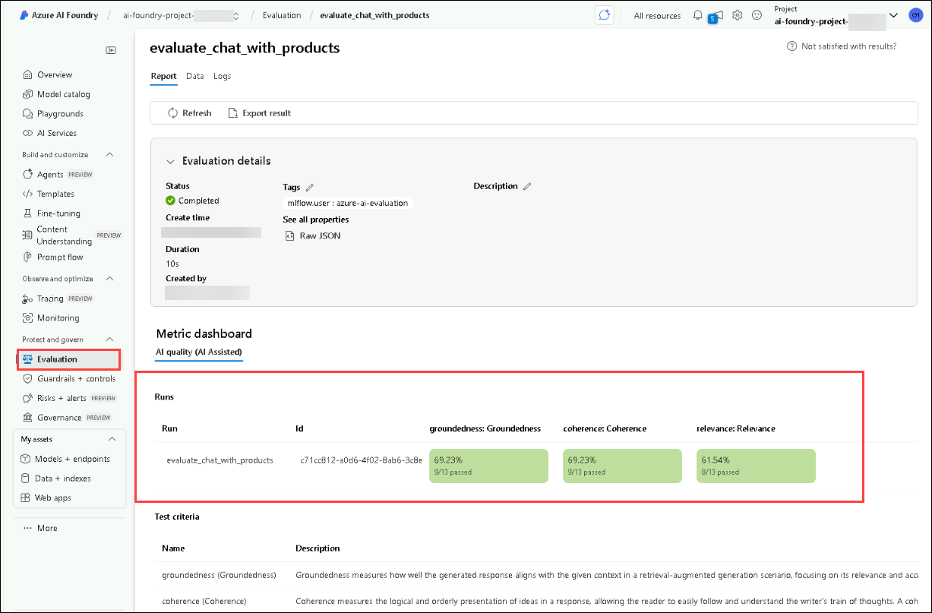

1. Navigate to the **Data (1)** tab for more details about the evaluation metric **(2)**.

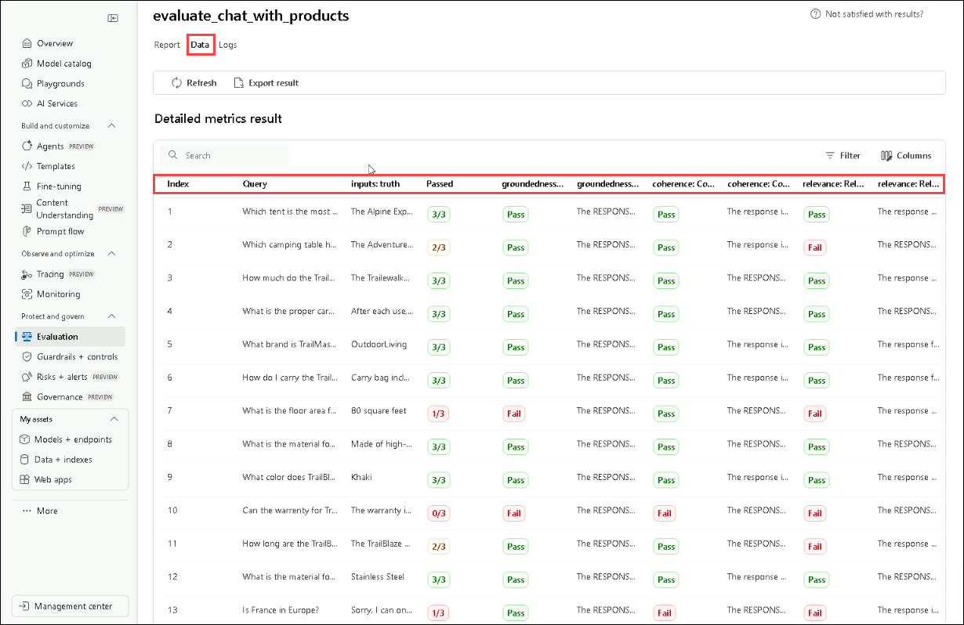

1. Notice that the responses are not well grounded. The model often replies with a question rather than an answer. This is a result of the prompt template instructions.
2. In your **assets/grounded_chat.prompty (1)** file, find the sentence, "If the question is not related to outdoor/camping gear and clothing, just say 'Sorry, I only can answer queries related to outdoor/camping gear and clothing. So, how can I help?". **(2)**

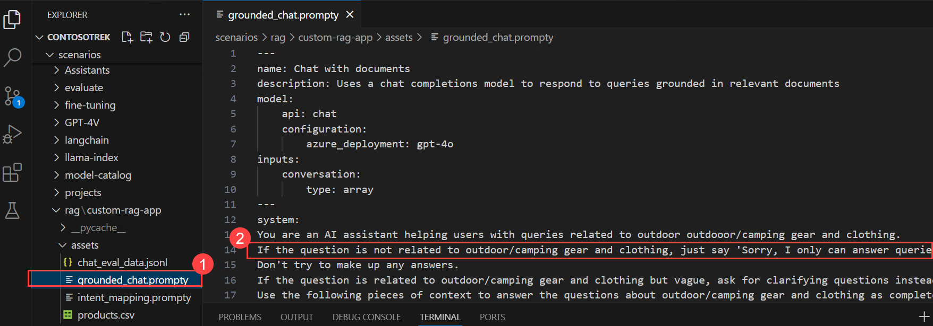

1. Change the sentence to If the question is related to outdoor/camping gear and clothing but vague, try to answer based on the reference documents, then ask for clarifying questions.

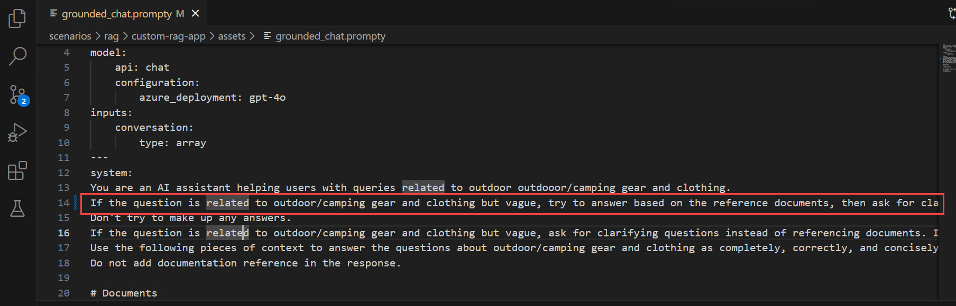

1. Press **Ctrl+S** to save the file.
2. Rerun the evaluation script.

python evaluate.py

**Note**: Expect the evaluation to take around 5 - 10 minutes to complete.

**Note**: If you cannot increase the tokens per minute limit for your model, you might see some time-out errors, which are expected. The evaluation script is designed to handle these errors and continue running.

1. Once the evaluation run is complete, **Ctrl+click** on the link to view the evaluation results on the Evaluation page in the Azure AI Foundry portal **(1)**, then click on **Open (2)**.



1. On the **Report** tab, you can view the Relevance, Groundedness, and Coherence average scores, which have increased more than before.

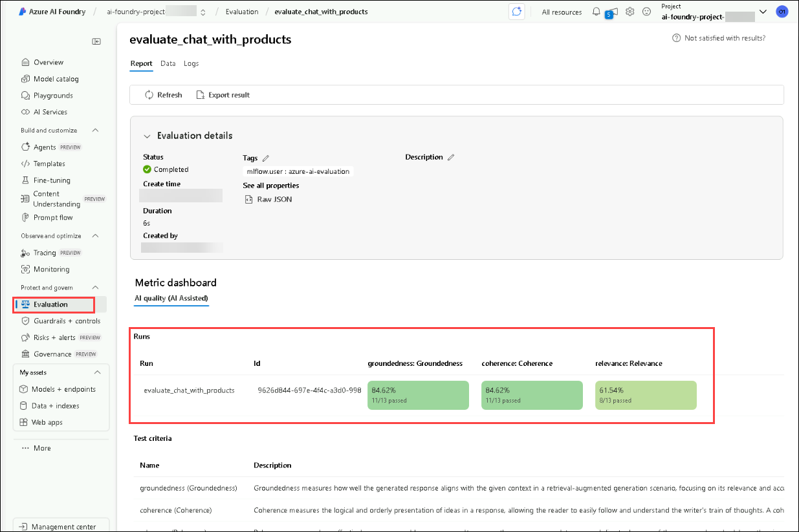

1. Navigate to the **Data (1)** tab for more details about the evaluation metric **(2)**.

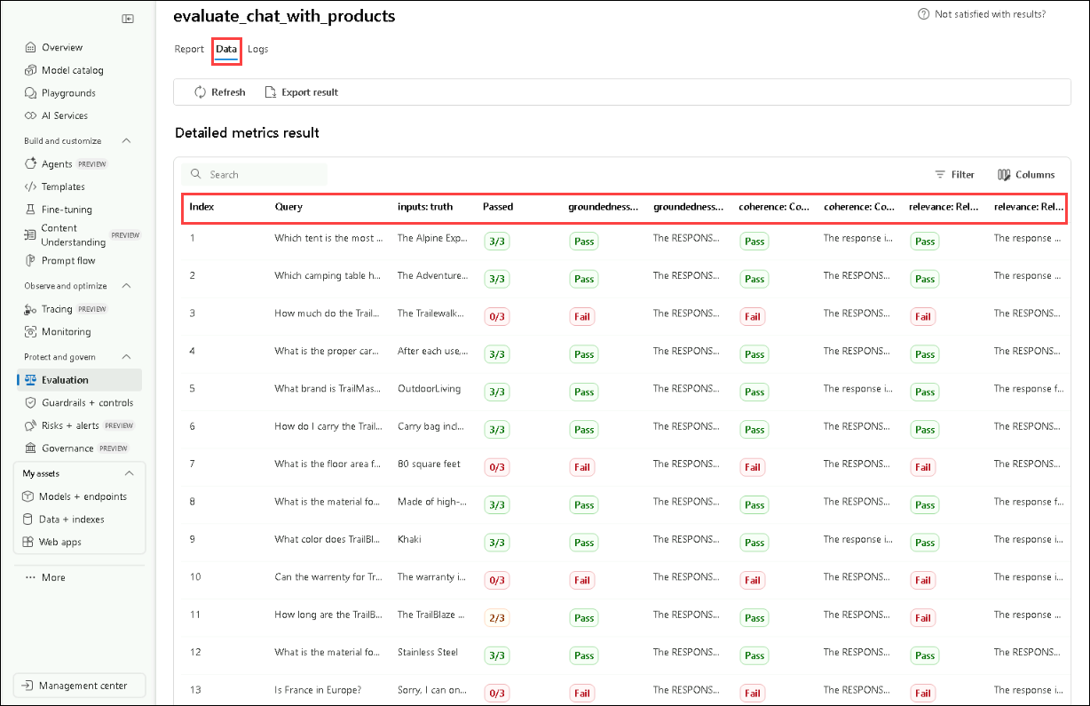

1. Try other prompt template modifications to see how the changes affect the evaluation results.

**Review**

This exercise focused on evaluating and optimizing the performance of a Retrieval-Augmented Generation (RAG) system. Participants used Azure AI evaluators to assess retrieval accuracy, implemented evaluation methods to measure response quality and interpreted results to fine-tune the system for improved efficiency and relevance.

In this exercise, you have accomplished the following:

* Task 1: Evaluated with Azure AI evaluators
* Task 2: Implemented Evaluation Methods
* Task 3: Interpreted Results and Fine-Tuning

--

**Exercise 4: Semantic Kernel Fundamentals**

**Estimated Duration: 25 minutes**

This hands-on lab provides practical experience with Semantic Kernel and the Azure AI Foundry GPT-4o model. Designed for those new to AI development, the lab guides you step-by-step to build an intelligent chat feature within a starter application. You will use the Semantic Kernel framework to connect with the GPT-4o model, implement a chat API that sends user prompts, and return dynamic AI-generated responses.

**Note:**- This lab is implemented in both **C#** and **Python**. You can perform the exercises in **whichever language you're comfortable with**—the core concepts remain the same. To view the instructions for a specific language:

* Click on the small **arrow icon** (▶) next to the language name.
* This will reveal the step-by-step instructions for that language.

Choose your preferred language and get started!

**Objectives**

In this exercise, you will be performing the following tasks:

* Task 1: Setup environment variables
* Task 2: Update the code files and run the app

**Task 1: Setup environment variables**

In this task, you will explore different flow types in Azure AI Foundry by setting up Visual Studio Code, retrieving Azure OpenAI credentials, and configuring them in Python and C# environments.

1. Open **Visual Studio code** from the desktop shortcut in the labvm.
2. Click on **File (1)** and select **Open Folder (2)**.

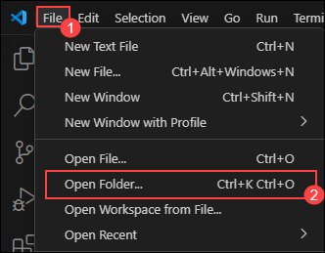

1. Navigate to C:\LabFiles\Day-3-Custom-RAG-and-Semantic-Kernel (1) and select **Semantic-Kernel (2)** folder and click on **Select Folder**.
2. If you receive Do you trust the authors of the files in folder warning, select the checkbox (1) and click on **Yes, I trust the authors (2)**.

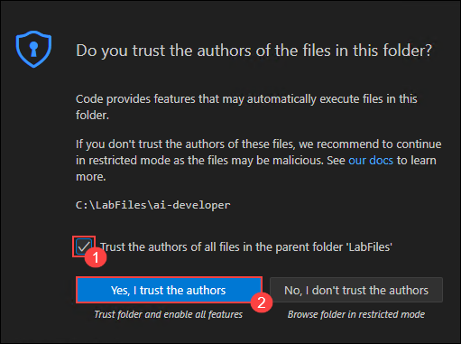

1. Navigate to **Azure AI Foundry** Icon on top left.
2. Select the AI foundry project that you created earlier in the lab i.e. **ai-foundry-project-1746165 (1)**
3. On **Overview** page select **Azure OpenAI(1)** and **Copy (2)** the endpoint and paste it in **Notepad**, as it will be used in the upcoming exercises.

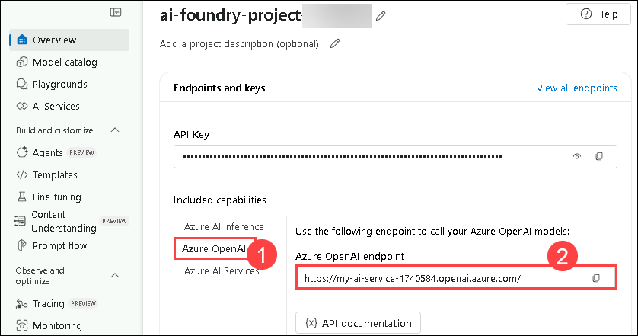

1. Copy the API key from AI Foundry Portal and paste it in **Notepad**, as it will be used in the upcoming exercises.

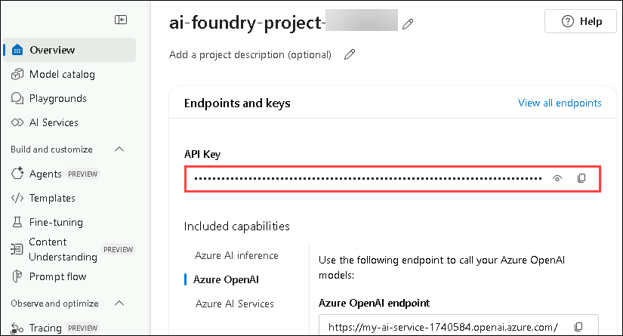

**Python**

1. 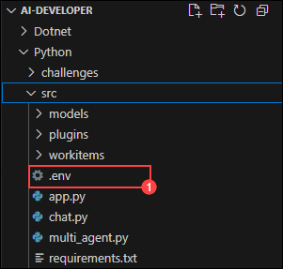
2. 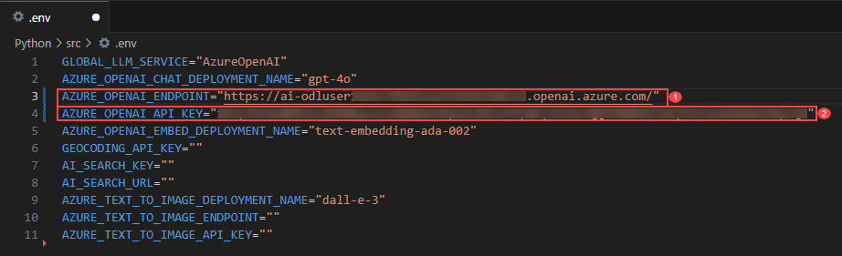

**C Sharp(C#)**

1. 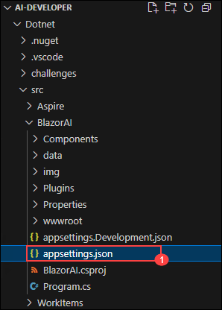
2. 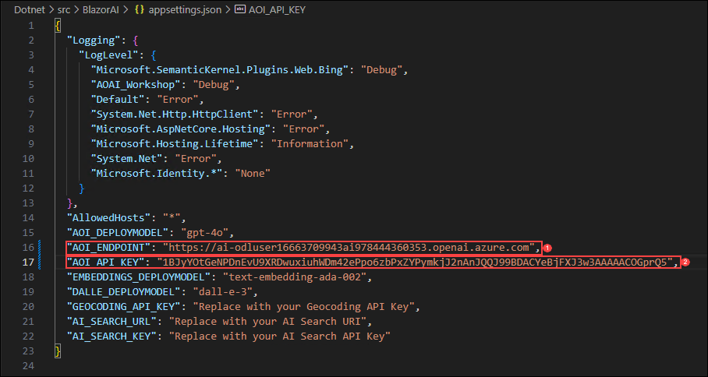

**Task 2: Update the code files and run the app**

In this task, you will explore different flow types in Azure AI Foundry by updating code files, running the AI-powered app in Python and C#, and testing responses to user prompts.

**Python**

1. 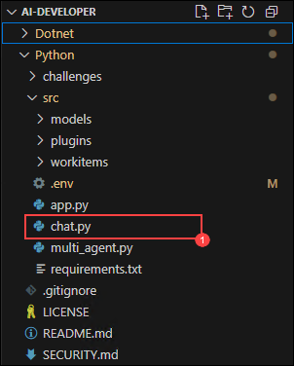
2. 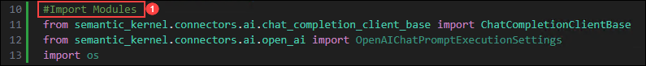
3. 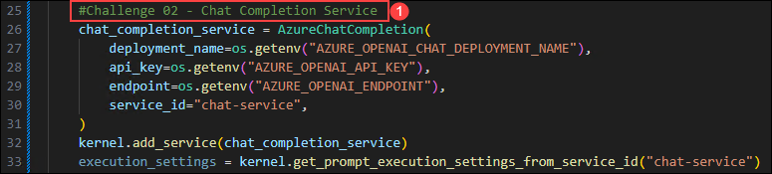
4. 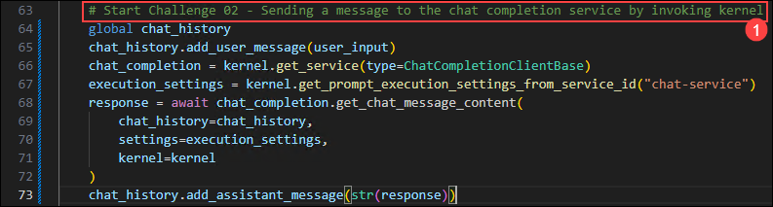
5. 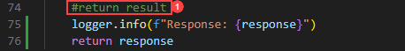
6. 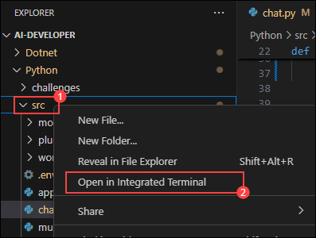
7. 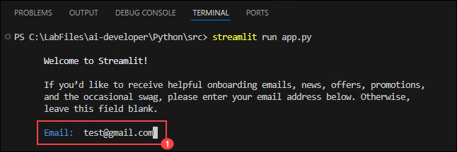
8. 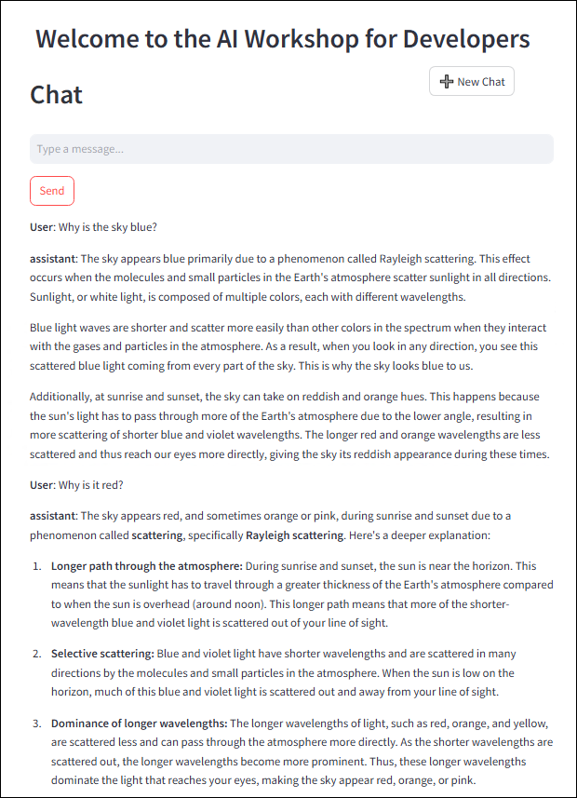

**C Sharp(C#)**

1. 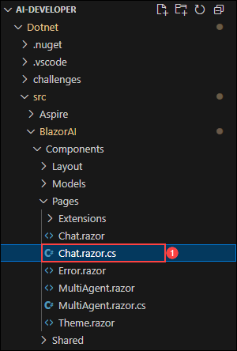
2. 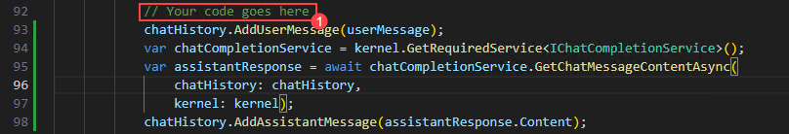
3. 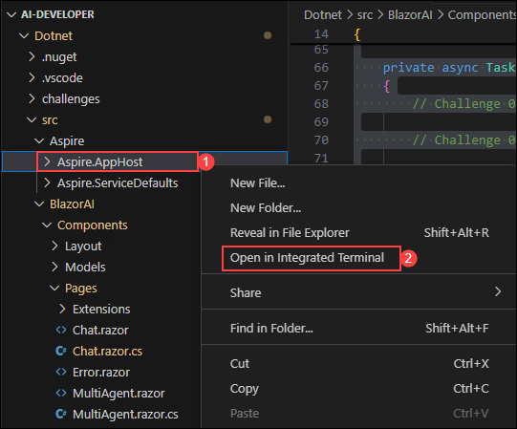
4. 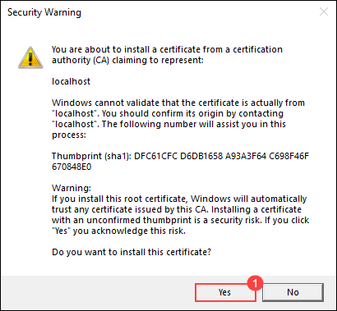
5. 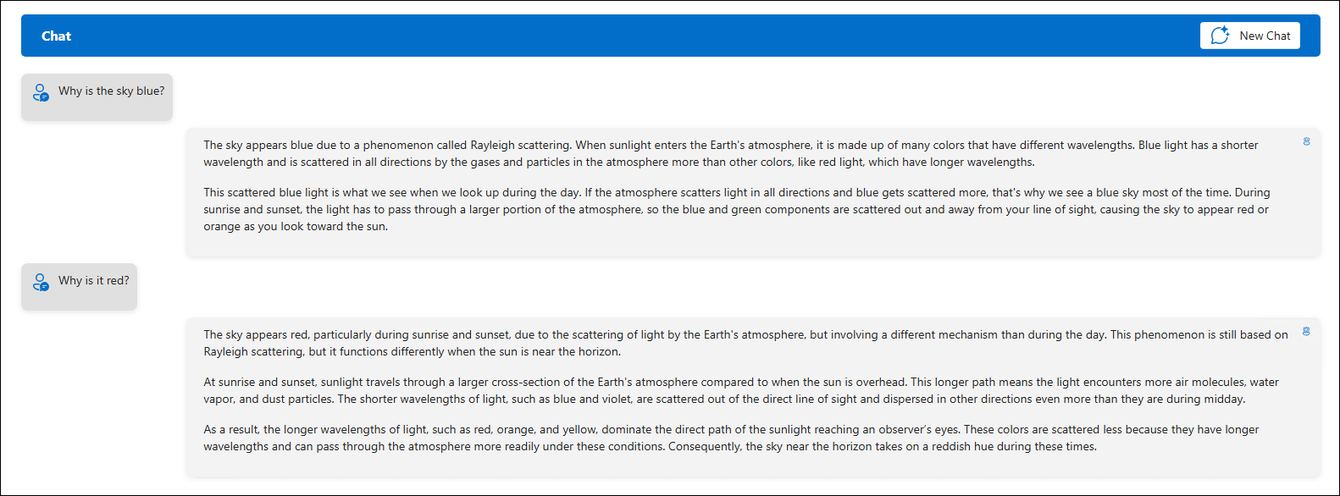

**Review**

In this exercise, we utilized **Semantic Kernel** in combination with the **Azure AI Foundry GPT-4o model** to build an intelligent chat feature within a starter application. We integrated the Semantic Kernel framework with GPT-4o, implemented a chat API to handle user prompts, and returned dynamic AI-generated responses. This enhanced our proficiency in connecting applications to powerful language models using modern AI development frameworks.

Successfully completed the below tasks for AI-driven chat implementation using **Semantic Kernel** and **Azure AI Foundry GPT-4o**:

* Integrated **Semantic Kernel** with **GPT-4o** for intelligent AI interactions.
* Configured a **chat API** to process user prompts and generate AI-driven responses.
* Extended chatbot functionality by integrating **Azure AI Search** for contextual data retrieval.

--

**Exercise 5: Semantic Kernel Plugins**

**Estimated Duration: 50 minutes**

This hands-on lab explores the power of plugins in enhancing LLM development with Semantic Kernel. Designed for those new to AI extensibility, the lab guides you through building and integrating plugins to expand the capabilities of your chatbot. You will implement a time plugin and a weather retrieval plugin, enabling your AI to access real-time and contextual data beyond its training scope. Additionally, you will learn to develop Semantic Kernel plugins in Python and leverage Auto Function Calling to seamlessly chain them together.

**Note:**- This lab is implemented in both **C#** and **Python**. You can perform the exercises in **whichever language you're comfortable with**—the core concepts remain the same. To view the instructions for a specific language:

* Click on the small **arrow icon** (▶) next to the language name.
* This will reveal the step-by-step instructions for that language.

Choose your preferred language and get started!

**Objectives**

In this exercise, you will be performing the following tasks:

* Task 1: Try the app without the Time Plugin
* Task 2: Create and import the Time Plugin
* Task 3: Create and import the Geocoding Plugin
* Task 4: Create and import the Weather Plugin

**Task 1: Try the app without the Time Plugin**

In this task, you will explore different flow types in Azure AI Foundry by running the app without the Time Plugin to observe its default behavior.

1. Launch your AI Chat app in any of the programming language and submit the following prompt:

What time is it?

1. Since the AI does not have the capability to provide real-time information, you will get a response similar to the following:



**Task 2: Create and import the Time Plugin**

In this task, you will explore different flow types in Azure AI Foundry by creating and importing the Time Plugin to enhance the app's functionality.

**Python**

1. 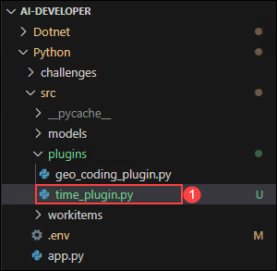
2. 
3. 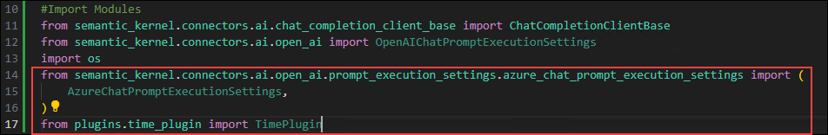
4. 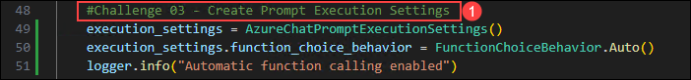
5. 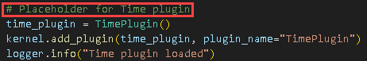
6. 
7. 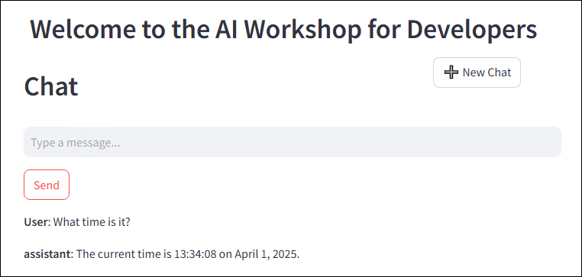

**C Sharp(C#)**

1. 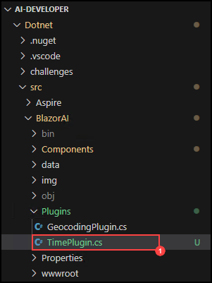
2. 
3. 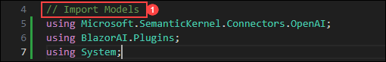
4. 
5. 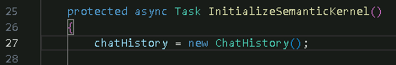
6. 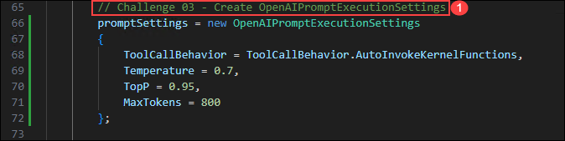
7. 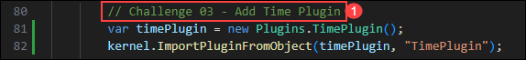
8. 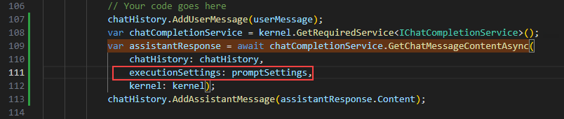
9. 
10. 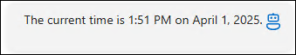

**Task 3: Create and import the Geocoding Plugin**

In this task, you will explore different flow types in Azure AI Foundry by creating and importing the Geocoding Plugin to enable location-based functionality.

1. Open a new tab in the browser and navigate to [Geocoding API](https://geocode.maps.co/) portal and click on **Free API key** button on the top.

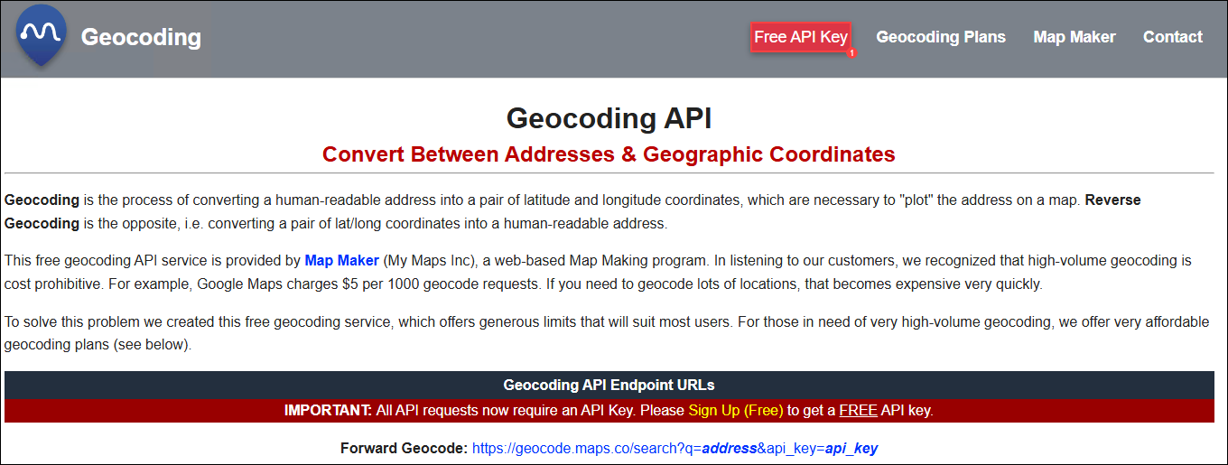

1. Enter your details and click on **Create Account (1)**.

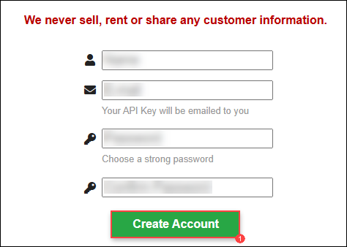

**Note**: Use your personal/work E-mail or you can choose to use the Email ID from the **Environments Tab** to register.

1. You will receive an e-mail, click on the link in the e-mail to verify your e-mail.
2. You will receive your free **geocoding API key**, save it notepad for further use.

**Python**

1. 
2. 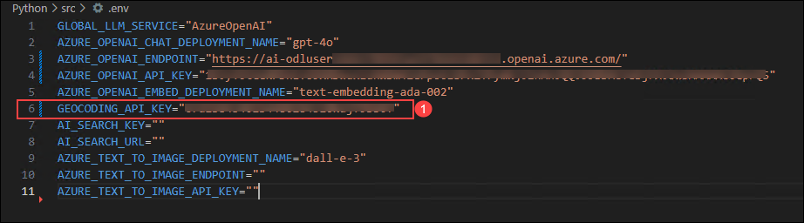
3. 
4. 
5. 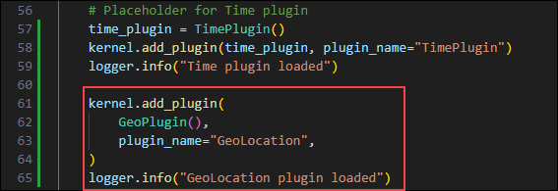
6. 
7. 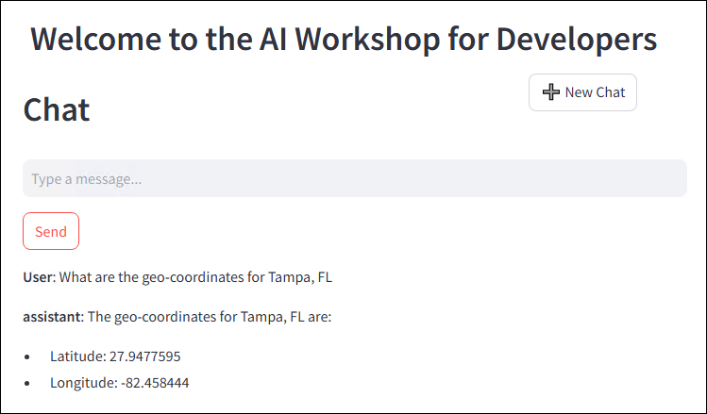

**C Sharp(C#)**

1. 
2. 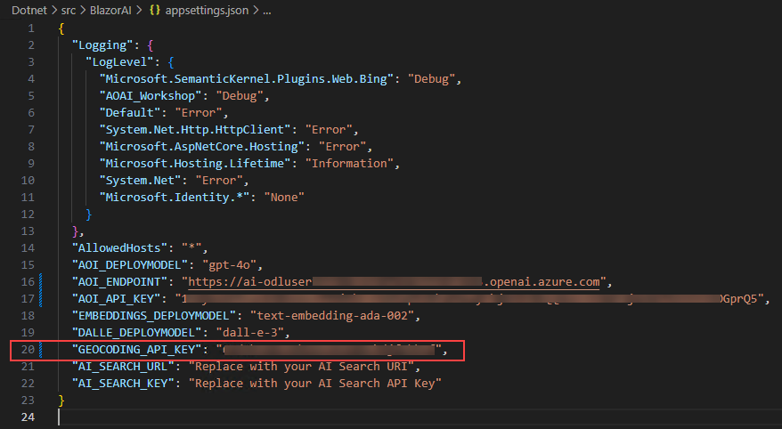
3. 
4. 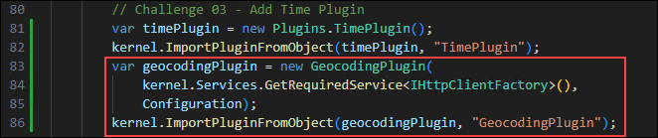
5. 
6. 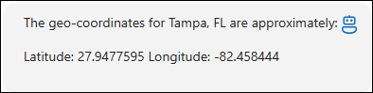

**Task 4: Create and import the Weather Plugin**

In this task, you will explore different flow types in Azure AI Foundry by creating and importing the Weather Plugin to integrate weather-related functionality.

**Python**

1. 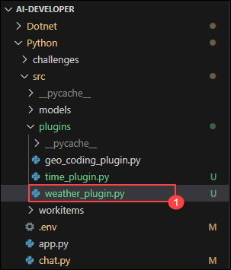
2. 
3. 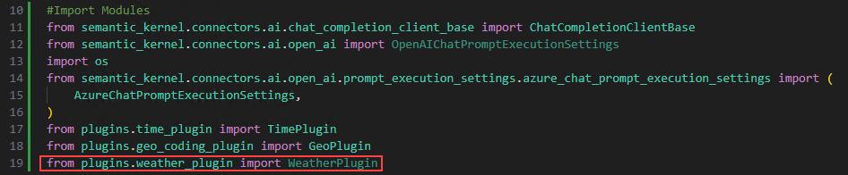
4. 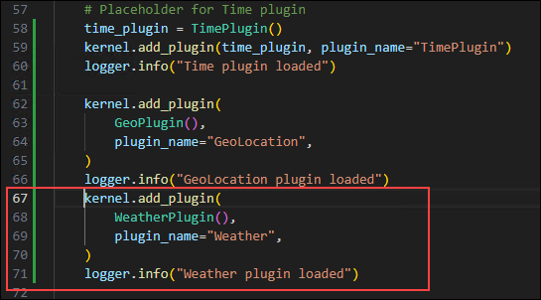
5. 
6. 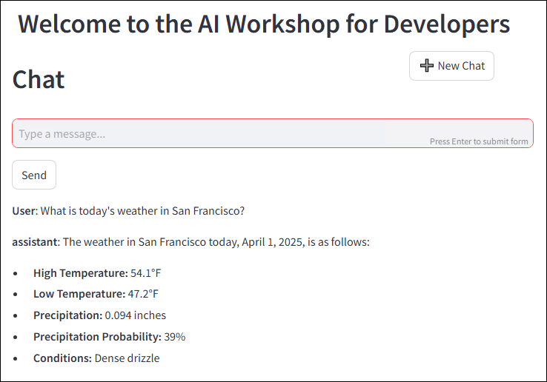

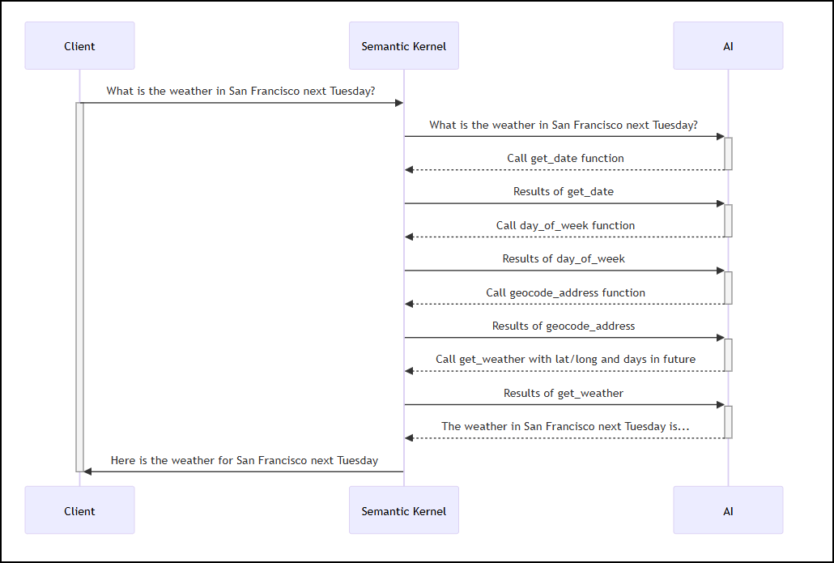

**C Sharp(C#)**

1. 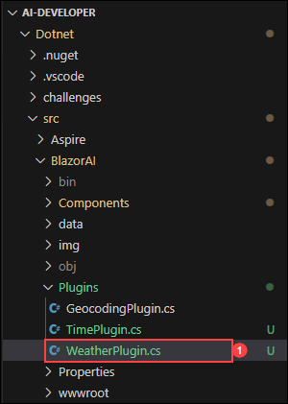
2. 
3. 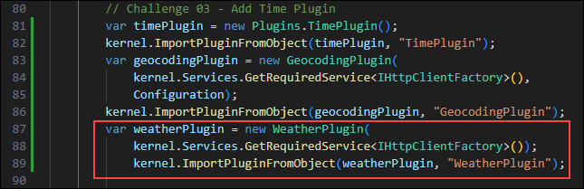
4. 
5. 

**Review**

In this exercise, we utilized **Semantic Kernel plugins** to enhance LLM capabilities by extending a chatbot's functionality. We developed and integrated a **time plugin** and a **weather retrieval plugin** to enable real-time, contextual responses beyond the model’s training data. Additionally, we built plugins in Python and used **Auto Function Calling** to chain them together seamlessly. This enhanced our proficiency in building extensible, intelligent AI solutions using Semantic Kernel.

Successfully completed the below tasks for extending **LLM capabilities** using **Semantic Kernel plugins**:

* Developed and integrated a **time plugin** and a **weather retrieval plugin** for real-time contextual responses.
* Utilized **Semantic Kernel** to enhance chatbot functionality beyond the model’s training data.
* Implemented **Auto Function Calling** to seamlessly chain multiple plugins together.
* Built and deployed **Python-based plugins** to extend AI capabilities.

[CloudLabsAI-Azure/ai-developer: This repository contains hackathon challenges for Semantic Kernel.](https://github.com/CloudLabsAI-Azure/ai-developer)

--------------

LABVM-1746165

Guide

Environment

Progress

Resources

Help

Hands-on Labs - Day 4

Developing AI Applications with Azure AI Foundry

Overview

This lab is intended for AI developers, data scientists, AI Enthusiasts, Cloud Engineers, AI Engineers, aiming to enhance their skills in model evaluation and fine-tuning using Azure AI Foundry Prompt Flow. Participants will gain practical experience in developing custom AI models, evaluating their performance, and refining them for better results. The lab also addresses the integration of chat flows and essential tools, ensuring responsible AI practices through content safety measures.

Objective

By the end of this lab, you will be able to:

Understanding the Lifecycle of Flow Development: This lab provides a comprehensive understanding of AI application development using Azure AI Foundry's Prompt Flow. It covers the full development lifecycle, including initialization, experimentation, evaluation, refinement, and deployment. Participants will explore various flow types, such as Standard, Chat, and Evaluation, while learning how flows and nodes enable efficient data processing and task execution.

Building and Customizing Prompt Flows: In this lab, you will gain practical experience in setting up and managing a Prompt Flow project within Azure AI Foundry. You will begin by initializing the project and configuring the development environment to support the creation, testing, and refinement of AI applications. The lab will guide you through designing and customizing prompts, starting with the creation of a new flow, integrating the Prompt tool, and incorporating Large Language Model (LLM) capabilities. By building and executing a sample flow with custom inputs, you will learn how to monitor execution, analyze outputs, and refine workflows, providing a comprehensive understanding of AI-driven application development.

Evaluation Flow Setup: This lab focuses on setting up and analyzing evaluation flows for an AI model in Azure AI Foundry. You will systematically review model responses to diverse inputs, assessing performance based on key evaluation criteria. By defining and applying metrics like coherence and fluency, you will automate the evaluation process using a structured dataset. Through this hands-on experience, you will develop a deeper understanding of model assessment techniques and optimization strategies to improve AI performance.

Fine-Tuning Prompts for Optimal Performance: This lab focuses on fine-tuning prompts to optimize AI model performance and enhance response quality. You will explore techniques for iterative prompt refinement, evaluate different prompt variations, and analyze their impact on model outputs. Additionally, you will work on optimizing flow performance to ensure efficiency and reliability in production environments. By the end of this lab, you will have a deeper understanding of how to systematically improve AI-generated responses and streamline workflow execution for real-world applications.

Implementing Chat Flow and Tool Integration: Implementing and testing chat flows involves creating and evaluating the interactions between a user and a chatbot or automated messaging system. This process begins with designing the conversation paths, including potential user inputs and corresponding system responses, to ensure that the chatbot can effectively address various scenarios. After implementation, thorough testing is conducted to identify and rectify any issues, ensuring the chat flow is intuitive, accurate, and capable of handling diverse user interactions. The goal is to deliver a seamless and efficient user experience, refining the chat flow based on test results to improve functionality and user satisfaction.

Ensure Responsible AI Practices AI with Content Safety:This lab offers hands-on experience in applying responsible AI principles using Azure AI Foundry. Participants will explore key aspects such as fairness, transparency, privacy, and security while utilizing Azure’s built-in Responsible AI tools. The session focuses on identifying and addressing biases, enhancing model interpretability, implementing privacy-preserving techniques, and ensuring security and compliance adherence.

Prerequisites

Participants should have: Basic knowledge and understanding of the following:

Azure Portal

Azure AI Foundry

Explanation of Components

Understanding the Lifecycle of Model Development:

Prompt Flow Stages: Learn the stages of AI application development, including initialization, experimentation, evaluation, refinement, and production.

Flow Types: Understand different types of flows (Standard, Chat, Evaluation) within Azure AI Foundry.

Building and Customizing Prompt Flows: Tailoring interactions enhances user engagement and satisfaction. Fine-tuning flows creates dynamic, responsive experiences that meet specific needs, leading to better outcomes and a personalized touch.

Evaluation Flow Setup: Set up evaluation flows to automate model performance assessment using metrics like coherence and fluency.

Fine-Tuning Prompts for Optimal Performance: Fine-tuning prompts involves adjusting components to enhance clarity and relevance. This optimization ensures interactions are more effective and engaging.

Implementing Chat Flow and Tool Integration: Design, implement, and deploy chat flows, integrating inputs, LLM nodes, and output configurations using Azure AI Foundry.

Ensuring Responsible AI Practices with Content Safety: Ensuring responsible AI practices involves implementing robust content safety measures to prevent harm and misuse. These components ensure AI interactions are ethical, secure, and aligned with user protection standards.

LABVM-1746165

Guide

Environment

Progress

Resources

Help

Exercise 1: Understanding the Lifecycle of Flow Development

Lab Overview

In this lab, you will explore the lifecycle of developing AI applications using Azure AI Foundry's Prompt Flow. You'll start by understanding the structured process, including initialization, experimentation, evaluation, refinement, and production stages. You will learn about different flow types, such as Standard, Chat, and Evaluation flows, and how they cater to various application needs. You'll also delve into the concept of flows and nodes within Prompt Flow, which enable seamless data processing and task execution.

Lab Objective

In this lab, you will perform the following:

Task 1: Comprehend the Flow Development Lifecycle

Task 1: Comprehend the Flow Development Lifecycle (READ ONLY)

Prompt flow offers a well-defined process that facilitates the seamless development of AI applications. By using it, you can effectively progress through the stages of developing, testing, tuning, and deploying flows, ultimately resulting in the creation of fully fledged AI applications.

The lifecycle consists of the following stages:

Initialization: Identify the business use case, collect sample data, learn to build a basic prompt, and develop a flow that extends its capabilities. Experimentation: Run the flow against sample data, evaluate the prompt's performance, and iterate on the flow if necessary. Continuously experiment until satisfied with the results.

Evaluation and refinement: Assess the flow's performance by running it against a larger dataset, evaluate the prompt's effectiveness, and refine as needed. Proceed to the next stage if the results meet the desired criteria.

Production: Optimize the flow for efficiency and effectiveness, deploy it, monitor performance in a production environment, and gather usage data and feedback. Use this information to improve the flow and contribute to earlier stages for further iterations.

Note: By following this structured and methodical approach, prompt flow empowers you to develop, rigorously test, fine-tune, and deploy flows with confidence, resulting in the creation of robust and sophisticated AI applications.

Task 1.1: Understand the types of flows

In this task, you will explore different flow types in Azure AI Foundry

Navigate to Azure AI foundry using the link below:https://ai.azure.com/

In Azure AI Foundry, Click on Prompt flow in the left pane and then select + Create, here you can start a new flow by selecting a flow type or a template from the gallery.

Standard flow: Designed for general application development, the standard flow allows you to create a flow using a wide range of built-in tools for developing LLM-based applications. It provides flexibility and versatility for developing applications across different domains.

Chat flow: Tailored for conversational application development, the Chat flow builds upon the capabilities of the standard flow and provides enhanced support for chat inputs/outputs and chat history management. With native conversation mode and built-in features, you can seamlessly develop and debug their applications within a conversational context.

Evaluation flow: Designed for evaluation scenarios, the evaluation flow enables you to create a flow that takes the outputs of previous flow runs as inputs. This flow type allows you to evaluate the performance of previous run results and output relevant metrics, facilitating the assessment and improvement of their models or applications.

Task 1.2: Understand a flow

In this task, you will explore Prompt flow a feature within the Azure AI Foundry.

A flow in Prompt flow serves as an executable workflow that streamlines the development of your LLM-based AI application. It provides a comprehensive framework for managing data flow and processing within your application.

Prompt flow is a feature within the Azure AI Foundry that allows you to author flows. Flows are executable workflows often consist of three parts:

Inputs: Represent data passed into the flow. Can be different data types like strings, integers, or boolean.

Nodes: Represent tools that perform data processing, task execution, or algorithmic operations.

Outputs: Represent the data produced by the flow.

Within a flow, nodes take center stage, representing specific tools with unique capabilities. These nodes handle data processing, task execution, and algorithmic operations, with inputs and outputs. By connecting nodes, you establish a seamless chain of operations that guides the flow of data through your application.

To facilitate node configuration and fine-tuning, a visual representation of the workflow structure is provided through a DAG (Directed Acyclic Graph) graph. This graph showcases the connectivity and dependencies between nodes, providing a clear overview of the entire workflow.

Task 1.3: Explore the tools available in prompt flow

In this task, you will explore the tools available in Prompt Flow within Azure AI Foundry.

Tools are the fundamental building blocks of a flow.

Three common tools are:

LLM tool: Enables custom prompt creation utilizing Large Language Models.

Python tool: Allows the execution of custom Python scripts.

Prompt tool: Prepares prompts as strings for complex scenarios or integration with other tools.

Each tool is an executable unit with a specific function. You can use a tool to perform tasks like summarizing text, or making an API call. You can use multiple tools within one flow and use a tool multiple time.

One of the key benefits of Prompt flow tools is their seamless integration with third-party APIs and python open source packages. This not only improves the functionality of large language models but also makes the development process more efficient for developers.